# **PostgreSQL Practice Using SQL Shell**

# Basic of Installation

## Staring

To start SQL Shell, at first install PostgreSQL from official [website](https://www.enterprisedb.com/downloads/postgres-postgresql-downloads). Then find it in start menu or search in search bar. Next, you will find it like this terminal. Hit enter for all, but enter your password that you have set for installation.

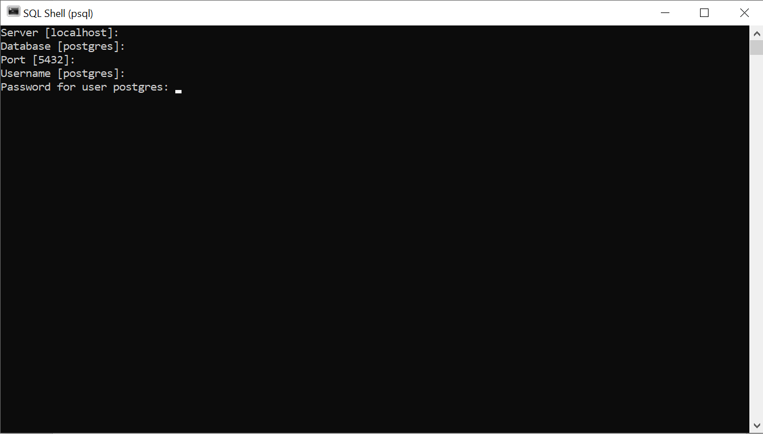

Then you will find it like this.

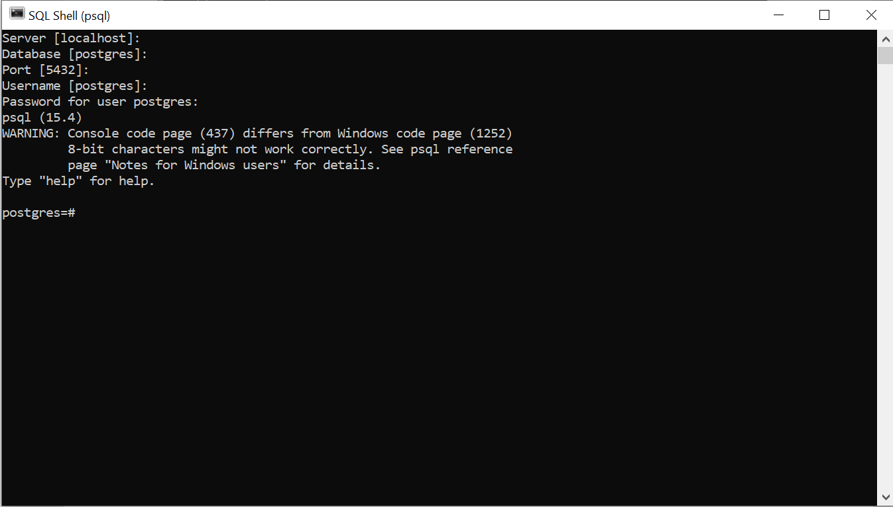

## Check Version

After entering password, you will see the current version of PostgreSQL.

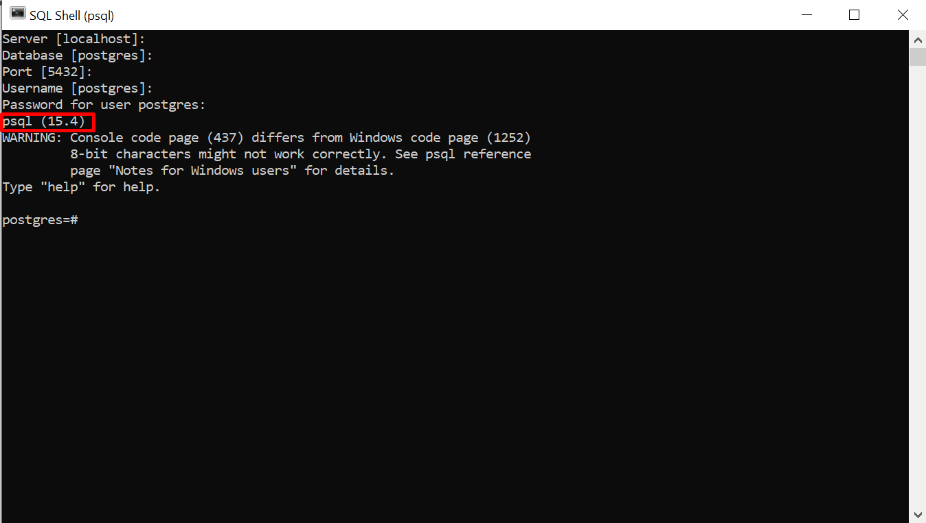

Or you can execute this command to see current version.

SELECT version();

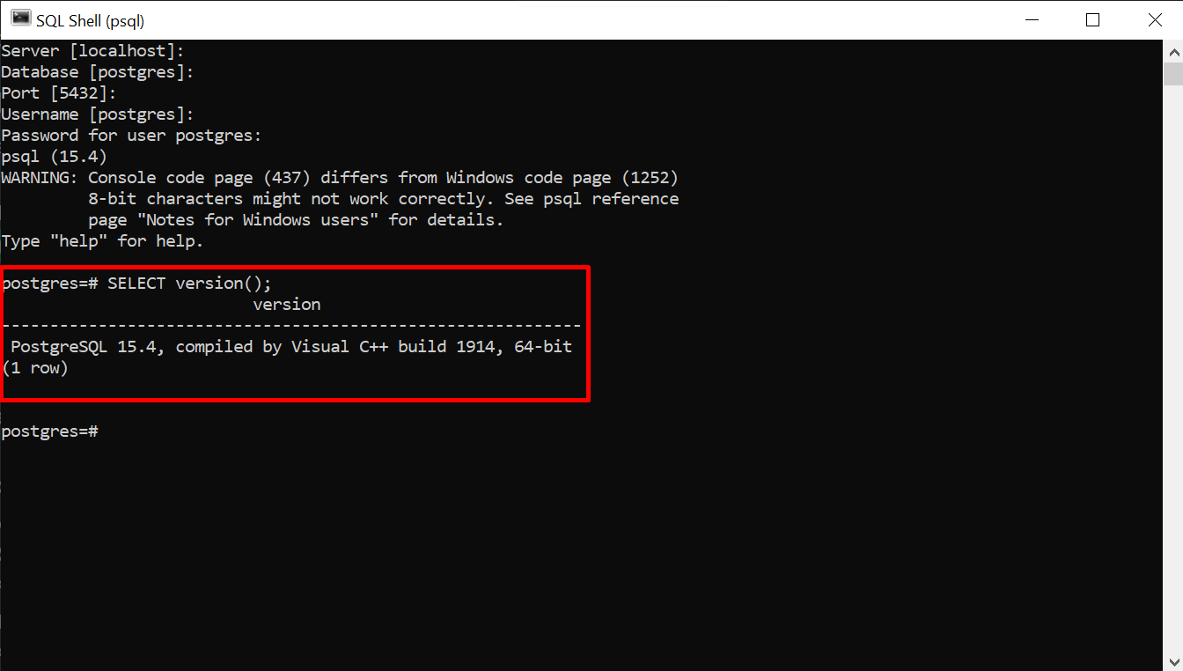

## List of Databases

To see list of database, you can run this command.

\l

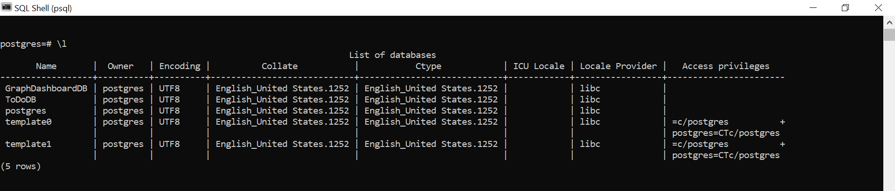

# Create Database

There are many ways to create database. We use simple method.

## To create DB

The basic syntax of CREATE DATABASE statement is as follows −

CREATE DATABASE dbname;

where *dbname* is the name of a database to create. Our database name is TestDB.



To see list of database, you can run this command.

\l

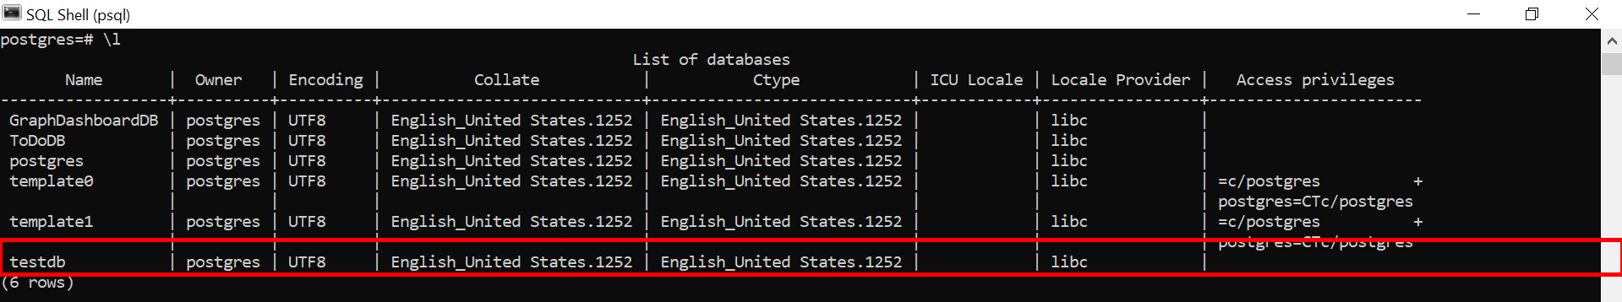

# Create Table

## To create table

To create table CREATE TABLE command is needed, then table name and its field name, data type.

CREATE TABLE cars (  
  brand VARCHAR(255),  
  model VARCHAR(255),  
  year INT  
);

When you execute the above statement, an empty table named cars will be created, and the SQL Shell application will return the following CREATE TABLE:

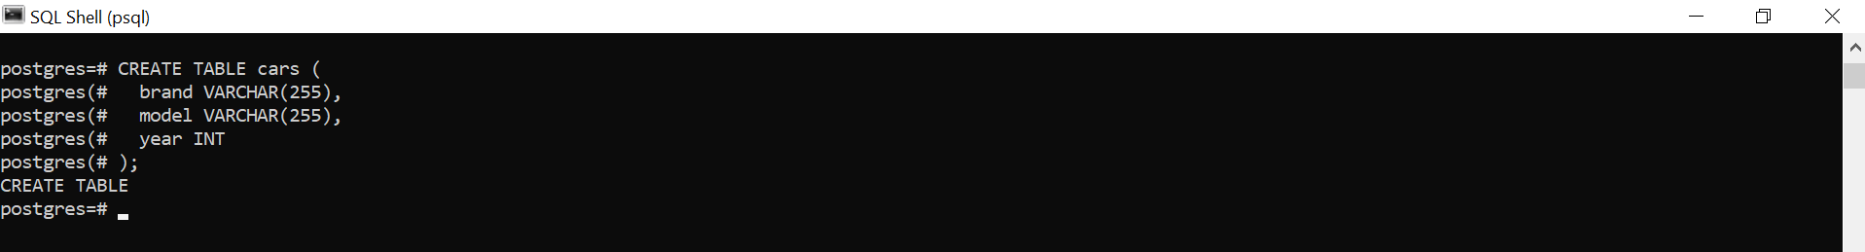

## To see all data of table

You can "display" the empty table you just created with another SQL statement:

SELECT * FROM cars;



# Insert Data

## To insert data in table

To insert data into a table in PostgreSQL, we use the INSERT INTO statement.

The following SQL statement will insert one row of data into the cars table.

INSERT INTO cars (brand, model, year)  
VALUES ('Ford', 'Mustang', 1964);



The SQL Shell application will return the following:

INSERT 0 1

Which means that 1 row was inserted.

**Note:**

As you can see in the SQL statement above, string values must be written with apostrophes.

Numeric values can be written without apostrophes, but you can include them if you want.

To check the result we can display the table with this SQL statement:

SELECT * FROM cars;



## Insert Multiple Rows

To insert multiple rows of data, we use the same INSERT INTO statement, but with multiple values:

INSERT INTO cars (brand, model, year)  
VALUES  
  ('Volvo', 'p1800', 1968),  
  ('BMW', 'M1', 1978),  
  ('Toyota', 'Celica', 1975);

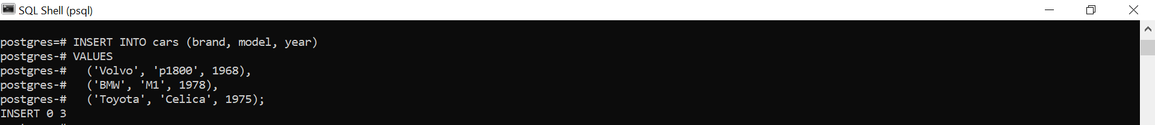

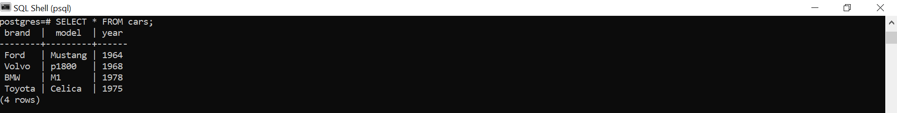

## Select/Fetch Data

To retrieve data from a database, we use the SELECT statement.

### Specify Columns

By specifying the column names, we can choose which columns to select:

SELECT brand, year FROM cars;

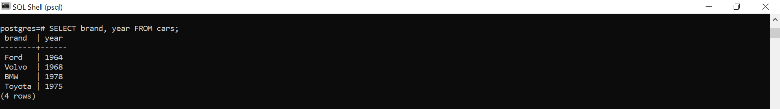

### Return ALL Columns

Specify a * instead of the column names to select all columns:

SELECT * FROM cars;

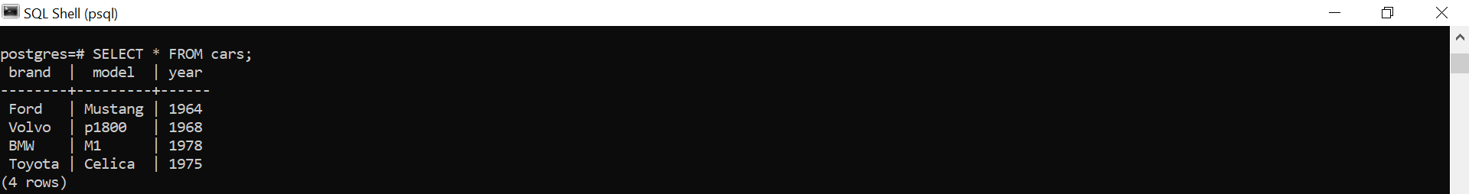

# Add Column

## The ALTER TABLE Statement

To add a column to an existing table, we have to use the ALTER TABLE statement.

The ALTER TABLE statement is used to add, delete, or modify columns in an existing table.

The ALTER TABLE statement is also used to add and drop various constraints on an existing table.

## Add Column

When adding columns we must also specify the data type of the column. Our color column will be a string, and we specify string types with the VARCHAR keyword. we also want to restrict the number of characters to 255:

ALTER TABLE cars  
ADD color VARCHAR(255);



The SQL Shell application will return the following:

ALTER TABLE

To check the result we can display the table with this SQL statement:

SELECT * FROM cars;

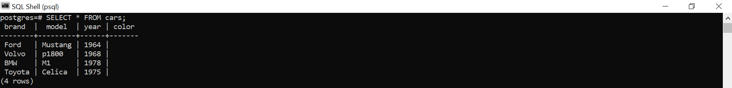

As you can see, the cars table now has a color column. The new column is empty.

## UPDATE

The UPDATE statement is used to modify the value(s) in existing records in a table.

Set the color of the Volvo to 'red':

UPDATE cars  
SET color = 'red'  
WHERE brand = 'Volvo';



WE see that SQL Shell return UPDATE 1, which means that 1 row was affected by the UPDATE statement.

**Note:**

1. Be careful with the WHERE clause, in the example above ALL rows where brand = 'Volvo' gets updated.
2. Be careful when updating records. If you omit the WHERE clause, ALL records will be updated!

To check the result we can display the table with this SQL statement:

SELECT * FROM cars;

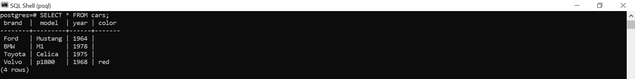

## Update Multiple Columns

To update more than one column, separate the name/value pairs with a comma ,:

Update color and year for the Toyota

UPDATE cars  
SET color = 'white', year = 1970  
WHERE brand = 'Toyota';



To check the result we can display the table with this SQL statement:

SELECT * FROM cars;

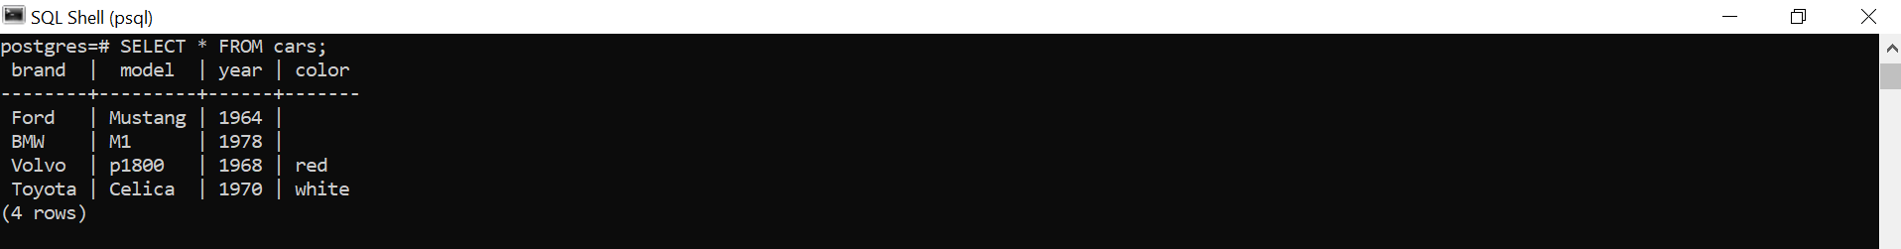

# Alter Column

## The ALTER TABLE Statement

To change the data type, or the size of a table column we have to use the ALTER TABLE statement.

The ALTER TABLE statement is used to add, delete, or modify columns in an existing table.

The ALTER TABLE statement is also used to add and drop various constraints on an existing table.

## Alter Column

We want to change the data type of the year column of the cars table from INT to VARCAHR(4).

To modify a column, use the ALTER COLUMN statement and the TYPE keyword followed by the new data type:

ALTER TABLE cars  
ALTER COLUMN year TYPE VARCHAR(4);



SQL Shell will return ALTER TABLE.

**Note:** Some data types cannot be converted if the column has value. E.g. numbers can always be converted to text, but text cannot always be converted to numbers.

You can see how many table are available in your databases. Just run below command in your SQL Shell.

\dt

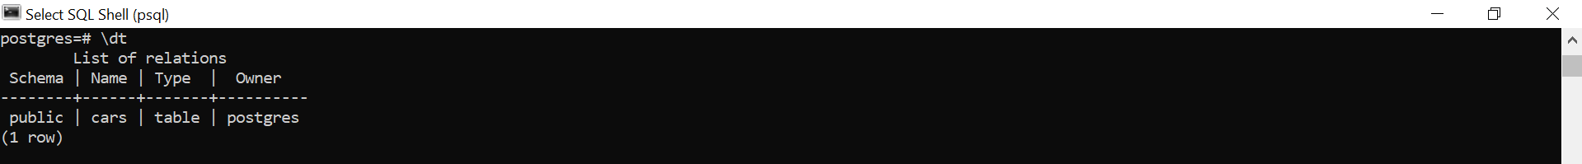

You will find it in pgAdmin 4 that shows year data type is changed.

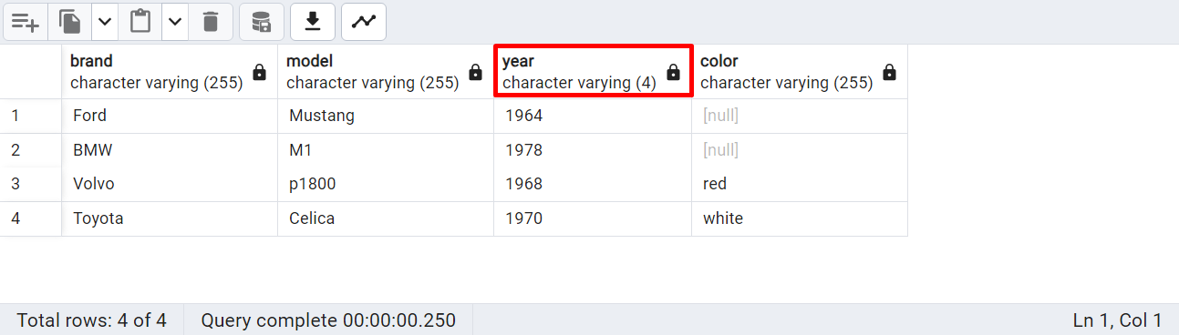

## Change Maximum Allowed Characters

We also want to change the maximum number of characters allowed in the color column of the cars table.

Change the color column from VARCHAR(255) to VARCHAR(30):

ALTER TABLE cars  
ALTER COLUMN color TYPE VARCHAR(30);



SQL Shell also return ALTER TABLE. Your changed is available in pgAdmin 4.

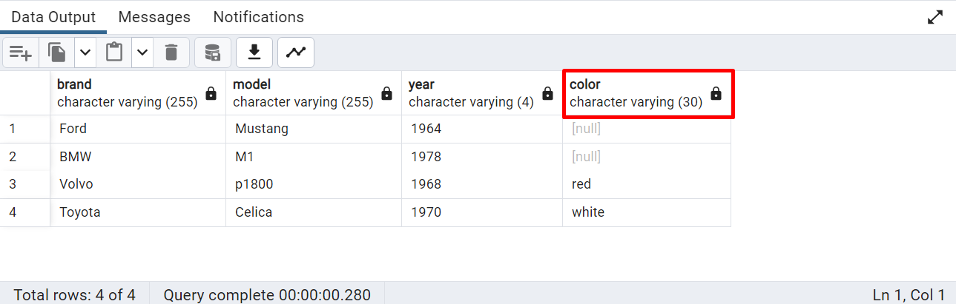

# Drop Column

## The ALTER TABLE Statement

To remove a column from a table, we have to use the ALTER TABLE statement.

The ALTER TABLE statement is used to add, delete, or modify columns in an existing table.

The ALTER TABLE statement is also used to add and drop various constraints on an existing table.

## Drop Column

We want to remove the column named color from the cars table.

To remove a column, use the DROP COLUMN statement:

ALTER TABLE cars  
DROP COLUMN color;



We will not see color column in our table anymore. Just run this command.

SELECT * FROM cars;

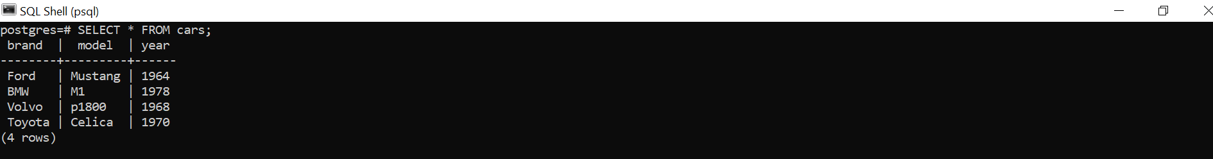

# Delete

## The DELETE Statement

The DELETE statement is used to delete existing records in a table.

**Note:** Be careful when deleting records in a table! Notice the WHERE clause in the DELETE statement. The WHERE clause specifies which record(s) should be deleted.

If you omit the WHERE clause, **all records in the table will be deleted**!.

To to delete the record(s) where brand is 'Volvo', use this statement:

DELETE FROM cars  
WHERE brand = 'Volvo';



DELETE 1, which means that 1 row was deleted.

If you run below command, you will see that deleted row is not shown.

SELECT * FROM cars;

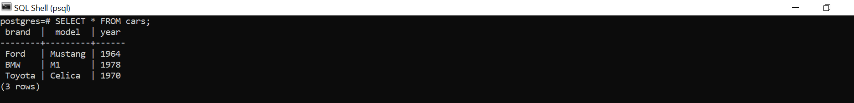

## Delete All Records

It is possible to delete all rows in a table without deleting the table. This means that the table structure, attributes, and indexes will be intact.

The following SQL statement deletes all rows in the cars table, without deleting the table:

DELETE FROM cars;

We will see DELETE 3 SQL shell, which means that 3 row was deleted.

## Truncate Table

Because we omit the WHERE clause in the DELETE statement above, all records will be deleted from the cars table.

The same would have been achieved by using the TRUNCATE TABLE statement:

Delete all records in the cars table:

TRUNCATE TABLE cars;



It also returns TRUNCATE TABLE.

If we run this statement, we will see

SELECT * FROM cars;



# Drop Table

## The DROP TABLE Statement

The DROP TABLE statement is used to drop an existing table in a database.

**Note:** Be careful before dropping a table. Deleting a table will result in loss of all information stored in the table!

The following SQL statement drops the existing table cars:

DROP TABLE cars;



SQL Shell return DROP TABLE, that means cars table is deleted.

If we try to run SELECT * FROM cars; statement in SQL Shell, we will get an error.



# Drop Database

To drop database, run the following command DROP DATABASE.

DROP DATABASE testdb;



SQL Shell returns DROP DATABASE, which means that we are successfully deleted testdb database. To see list of database just run the command

\l

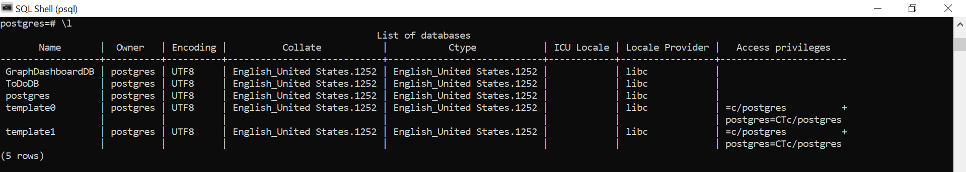

Here, we do not see the deleted database.

**DDL (Data Definition Language) discussion is over.**

**Thanks.**

# Create Demo Database

## Demo Database

Now we want to create more tables with more content to be able to demonstrate more database features. We will create these 6 tables in our PostgreSQL database:

**categories  
customers  
products  
orders  
order_details  
testproducts**

At first, we need a database. So we will create a database called ecommercedb.

## Create Database

To create database, simply run this statement.

CREATE DATABASE ecommercedb;



## See All Database

Now see all database list by running this statement. You will see our newly created database here. You can also see in pgAdmin 4.

\l

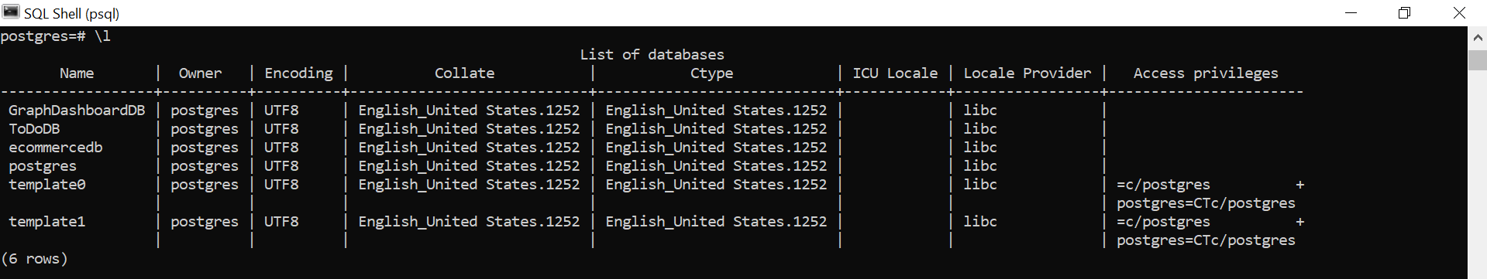

## Select Database

Now we will create all table in our created database. So we need to select the database.

To select database, execute this statement.

\c ecommercedb



Now we are connected with our created database.

# Categories

The following SQL statement will create a table named categories:

## CREATE TABLE categories

CREATE TABLE categories (  
  category_id SERIAL NOT NULL PRIMARY KEY,  
  category_name VARCHAR(255),  
  description VARCHAR(255)  
);



## INSERT INTO categories

The following SQL statement will fill the categories table with content:

INSERT INTO categories (category_name, description)  
VALUES  
  ('Beverages', 'Soft drinks, coffees, teas, beers, and ales'),  
  ('Condiments', 'Sweet and savory sauces, relishes, spreads, and seasonings'),  
  ('Confections', 'Desserts, candies, and sweet breads'),  
  ('Dairy Products', 'Cheeses'),  
  ('Grains/Cereals', 'Breads, crackers, pasta, and cereal'),  
  ('Meat/Poultry', 'Prepared meats'),  
  ('Produce', 'Dried fruit and bean curd'),  
  ('Seafood', 'Seaweed and fish');

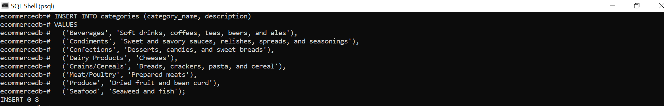

SQL Shell returns INSERT 0 8 that means 8 rows are inserted with data.

# Customers

The following SQL statement will create a table named customers:

## CREATE TABLE customers

CREATE TABLE customers (  
  customer_id SERIAL NOT NULL PRIMARY KEY,  
  customer_name VARCHAR(255),  
  contact_name VARCHAR(255),  
  address VARCHAR(255),  
  city VARCHAR(255),  
  postal_code VARCHAR(255),  
  country VARCHAR(255)  
);

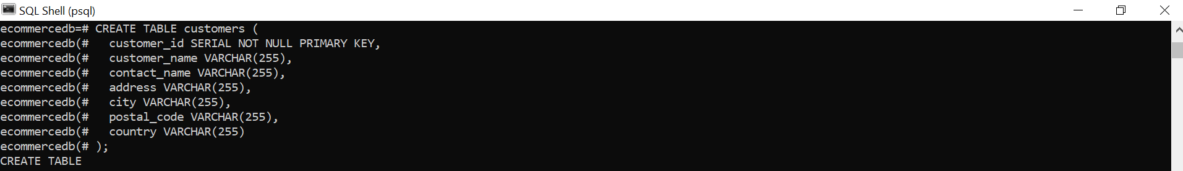

## INSERT INTO customers

The following SQL statement will fill the customers table with content:

INSERT INTO customers (customer_name, contact_name, address, city, postal_code, country)  
VALUES  
  ('Alfreds Futterkiste', 'Maria Anders', 'Obere Str. 57', 'Berlin', '12209', 'Germany'),  
  ('Ana Trujillo Emparedados y helados', 'Ana Trujillo', 'Avda. de la Constitucion 2222', 'Mexico D.F.', '05021', 'Mexico'),  
  ('Antonio Moreno Taquera', 'Antonio Moreno', 'Mataderos 2312', 'Mexico D.F.', '05023', 'Mexico'),  
  ('Around the Horn', 'Thomas Hardy', '120 Hanover Sq.', 'London', 'WA1 1DP', 'UK'),  
  ('Berglunds snabbkoep', 'Christina Berglund', 'Berguvsvegen 8', 'Lulea', 'S-958 22', 'Sweden'),  
  ('Blauer See Delikatessen', 'Hanna Moos', 'Forsterstr. 57', 'Mannheim', '68306', 'Germany'),  
  ('Blondel pere et fils', 'Frederique Citeaux', '24, place Kleber', 'Strasbourg', '67000', 'France'),  
  ('Bolido Comidas preparadas', 'Martin Sommer', 'C/ Araquil, 67', 'Madrid', '28023', 'Spain'),  
  ('Bon app', 'Laurence Lebihans', '12, rue des Bouchers', 'Marseille', '13008', 'France'),  
  ('Bottom-Dollar Marketse', 'Elizabeth Lincoln', '23 Tsawassen Blvd.', 'Tsawassen', 'T2F 8M4', 'Canada'),  
  ('Bs Beverages', 'Victoria Ashworth', 'Fauntleroy Circus', 'London', 'EC2 5NT', 'UK'),  
  ('Cactus Comidas para llevar', 'Patricio Simpson', 'Cerrito 333', 'Buenos Aires', '1010', 'Argentina'),  
  ('Centro comercial Moctezuma', 'Francisco Chang', 'Sierras de Granada 9993', 'Mexico D.F.', '05022', 'Mexico'),  
  ('Chop-suey Chinese', 'Yang Wang', 'Hauptstr. 29', 'Bern', '3012', 'Switzerland'),  
  ('Comercio Mineiro', 'Pedro Afonso', 'Av. dos Lusiadas, 23', 'Sao Paulo', '05432-043', 'Brazil'),  
  ('Consolidated Holdings', 'Elizabeth Brown', 'Berkeley Gardens 12 Brewery ', 'London', 'WX1 6LT', 'UK'),  
  ('Drachenblut Delikatessend', 'Sven Ottlieb', 'Walserweg 21', 'Aachen', '52066', 'Germany'),  
  ('Du monde entier', 'Janine Labrune', '67, rue des Cinquante Otages', 'Nantes', '44000', 'France'),  
  ('Eastern Connection', 'Ann Devon', '35 King George', 'London', 'WX3 6FW', 'UK'),  
  ('Ernst Handel', 'Roland Mendel', 'Kirchgasse 6', 'Graz', '8010', 'Austria'),  
  ('Familia Arquibaldo', 'Aria Cruz', 'Rua Oros, 92', 'Sao Paulo', '05442-030', 'Brazil'),  
  ('FISSA Fabrica Inter. Salchichas S.A.', 'Diego Roel', 'C/ Moralzarzal, 86', 'Madrid', '28034', 'Spain'),  
  ('Folies gourmandes', 'Martine Rance', '184, chaussee de Tournai', 'Lille', '59000', 'France'),  
  ('Folk och fe HB', 'Maria Larsson', 'Akergatan 24', 'Brecke', 'S-844 67', 'Sweden'),  
  ('Frankenversand', 'Peter Franken', 'Berliner Platz 43', 'Munchen', '80805', 'Germany'),  
  ('France restauration', 'Carine Schmitt', '54, rue Royale', 'Nantes', '44000', 'France'),  
  ('Franchi S.p.A.', 'Paolo Accorti', 'Via Monte Bianco 34', 'Torino', '10100', 'Italy'),  
  ('Furia Bacalhau e Frutos do Mar', 'Lino Rodriguez ', 'Jardim das rosas n. 32', 'Lisboa', '1675', 'Portugal'),  
  ('Galeria del gastronomo', 'Eduardo Saavedra', 'Rambla de Cataluna, 23', 'Barcelona', '08022', 'Spain'),  
  ('Godos Cocina Tipica', 'Jose Pedro Freyre', 'C/ Romero, 33', 'Sevilla', '41101', 'Spain'),  
  ('Gourmet Lanchonetes', 'Andre Fonseca', 'Av. Brasil, 442', 'Campinas', '04876-786', 'Brazil'),  
  ('Great Lakes Food Market', 'Howard Snyder', '2732 Baker Blvd.', 'Eugene', '97403', 'USA'),  
  ('GROSELLA-Restaurante', 'Manuel Pereira', '5th Ave. Los Palos Grandes', 'Caracas', '1081', 'Venezuela'),  
  ('Hanari Carnes', 'Mario Pontes', 'Rua do Paco, 67', 'Rio de Janeiro', '05454-876', 'Brazil'),  
  ('HILARION-Abastos', 'Carlos Hernandez', 'Carrera 22 con Ave. Carlos Soublette #8-35', 'San Cristobal', '5022', 'Venezuela'),  
  ('Hungry Coyote Import Store', 'Yoshi Latimer', 'City Center Plaza 516 Main St.', 'Elgin', '97827', 'USA'),  
  ('Hungry Owl All-Night Grocers', 'Patricia McKenna', '8 Johnstown Road', 'Cork', '', 'Ireland'),  
  ('Island Trading', 'Helen Bennett', 'Garden House Crowther Way', 'Cowes', 'PO31 7PJ', 'UK'),  
  ('Koniglich Essen', 'Philip Cramer', 'Maubelstr. 90', 'Brandenburg', '14776', 'Germany'),  
  ('La corne d abondance', 'Daniel Tonini', '67, avenue de l Europe', 'Versailles', '78000', 'France'),  
  ('La maison d Asie', 'Annette Roulet', '1 rue Alsace-Lorraine', 'Toulouse', '31000', 'France'),  
  ('Laughing Bacchus Wine Cellars', 'Yoshi Tannamuri', '1900 Oak St.', 'Vancouver', 'V3F 2K1', 'Canada'),  
  ('Lazy K Kountry Store', 'John Steel', '12 Orchestra Terrace', 'Walla Walla', '99362', 'USA'),  
  ('Lehmanns Marktstand', 'Renate Messner', 'Magazinweg 7', 'Frankfurt a.M. ', '60528', 'Germany'),  
  ('Lets Stop N Shop', 'Jaime Yorres', '87 Polk St. Suite 5', 'San Francisco', '94117', 'USA'),  
  ('LILA-Supermercado', 'Carlos Gonzalez', 'Carrera 52 con Ave. Bolivar #65-98 Llano Largo', 'Barquisimeto', '3508', 'Venezuela'),  
  ('LINO-Delicateses', 'Felipe Izquierdo', 'Ave. 5 de Mayo Porlamar', 'I. de Margarita', '4980', 'Venezuela'),  
  ('Lonesome Pine Restaurant', 'Fran Wilson', '89 Chiaroscuro Rd.', 'Portland', '97219', 'USA'),  
  ('Magazzini Alimentari Riuniti', 'Giovanni Rovelli', 'Via Ludovico il Moro 22', 'Bergamo', '24100', 'Italy'),  
  ('Maison Dewey', 'Catherine Dewey', 'Rue Joseph-Bens 532', 'Bruxelles', 'B-1180', 'Belgium'),  
  ('Mere Paillarde', 'Jean Fresniere', '43 rue St. Laurent', 'Montreal', 'H1J 1C3', 'Canada'),  
  ('Morgenstern Gesundkost', 'Alexander Feuer', 'Heerstr. 22', 'Leipzig', '04179', 'Germany'),  
  ('North/South', 'Simon Crowther', 'South House 300 Queensbridge', 'London', 'SW7 1RZ', 'UK'),  
  ('Oceano Atlantico Ltda.', 'Yvonne Moncada', 'Ing. Gustavo Moncada 8585 Piso 20-A', 'Buenos Aires', '1010', 'Argentina'),  
  ('Old World Delicatessen', 'Rene Phillips', '2743 Bering St.', 'Anchorage', '99508', 'USA'),  
  ('Ottilies Keseladen', 'Henriette Pfalzheim', 'Mehrheimerstr. 369', 'Koln', '50739', 'Germany'),  
  ('Paris specialites', 'Marie Bertrand', '265, boulevard Charonne', 'Paris', '75012', 'France'),  
  ('Pericles Comidas clasicas', 'Guillermo Fernandez', 'Calle Dr. Jorge Cash 321', 'Mexico D.F.', '05033', 'Mexico'),  
  ('Piccolo und mehr', 'Georg Pipps', 'Geislweg 14', 'Salzburg', '5020', 'Austria'),  
  ('Princesa Isabel Vinhoss', 'Isabel de Castro', 'Estrada da saude n. 58', 'Lisboa', '1756', 'Portugal'),  
  ('Que Delicia', 'Bernardo Batista', 'Rua da Panificadora, 12', 'Rio de Janeiro', '02389-673', 'Brazil'),  
  ('Queen Cozinha', 'Lucia Carvalho', 'Alameda dos Canarios, 891', 'Sao Paulo', '05487-020', 'Brazil'),  
  ('QUICK-Stop', 'Horst Kloss', 'Taucherstrasse 10', 'Cunewalde', '01307', 'Germany'),  
  ('Rancho grande', 'Sergio Gutiarrez', 'Av. del Libertador 900', 'Buenos Aires', '1010', 'Argentina'),  
  ('Rattlesnake Canyon Grocery', 'Paula Wilson', '2817 Milton Dr.', 'Albuquerque', '87110', 'USA'),  
  ('Reggiani Caseifici', 'Maurizio Moroni', 'Strada Provinciale 124', 'Reggio Emilia', '42100', 'Italy'),  
  ('Ricardo Adocicados', 'Janete Limeira', 'Av. Copacabana, 267', 'Rio de Janeiro', '02389-890', 'Brazil'),  
  ('Richter Supermarkt', 'Michael Holz', 'Grenzacherweg 237', 'Genève', '1203', 'Switzerland'),  
  ('Romero y tomillo', 'Alejandra Camino', 'Gran Via, 1', 'Madrid', '28001', 'Spain'),  
  ('Santa Gourmet', 'Jonas Bergulfsen', 'Erling Skakkes gate 78', 'Stavern', '4110', 'Norway'),  
  ('Save-a-lot Markets', 'Jose Pavarotti', '187 Suffolk Ln.', 'Boise', '83720', 'USA'),  
  ('Seven Seas Imports', 'Hari Kumar', '90 Wadhurst Rd.', 'London', 'OX15 4NB', 'UK'),  
  ('Simons bistro', 'Jytte Petersen', 'Vinbeltet 34', 'Kobenhavn', '1734', 'Denmark'),  
  ('Specialites du monde', 'Dominique Perrier', '25, rue Lauriston', 'Paris', '75016', 'France'),  
  ('Split Rail Beer & Ale', 'Art Braunschweiger', 'P.O. Box 555', 'Lander', '82520', 'USA'),  
  ('Supremes delices', 'Pascale Cartrain', 'Boulevard Tirou, 255', 'Charleroi', 'B-6000', 'Belgium'),  
  ('The Big Cheese', 'Liz Nixon', '89 Jefferson Way Suite 2', 'Portland', '97201', 'USA'),  
  ('The Cracker Box', 'Liu Wong', '55 Grizzly Peak Rd.', 'Butte', '59801', 'USA'),  
  ('Toms Spezialiteten', 'Karin Josephs', 'Luisenstr. 48', 'Manster', '44087', 'Germany'),  
  ('Tortuga Restaurante', 'Miguel Angel Paolino', 'Avda. Azteca 123', 'Mexico D.F.', '05033', 'Mexico'),  
  ('Tradicao Hipermercados', 'Anabela Domingues', 'Av. Ines de Castro, 414', 'Sao Paulo', '05634-030', 'Brazil'),  
  ('Trails Head Gourmet Provisioners', 'Helvetius Nagy', '722 DaVinci Blvd.', 'Kirkland', '98034', 'USA'),  
  ('Vaffeljernet', 'Palle Ibsen', 'Smagsloget 45', 'Arhus', '8200', 'Denmark'),  
  ('Victuailles en stock', 'Mary Saveley', '2, rue du Commerce', 'Lyon', '69004', 'France'),  
  ('Vins et alcools Chevalier', 'Paul Henriot', '59 rue de l Abbaye', 'Reims', '51100', 'France'),  
  ('Die Wandernde Kuh', 'Rita Moller', 'Adenauerallee 900', 'Stuttgart', '70563', 'Germany'),  
  ('Wartian Herkku', 'Pirkko Koskitalo', 'Torikatu 38', 'Oulu', '90110', 'Finland'),  
  ('Wellington Importadora', 'Paula Parente', 'Rua do Mercado, 12', 'Resende', '08737-363', 'Brazil'),  
  ('White Clover Markets', 'Karl Jablonski', '305 - 14th Ave. S. Suite 3B', 'Seattle', '98128', 'USA'),  
  ('Wilman Kala', 'Matti Karttunen', 'Keskuskatu 45', 'Helsinki', '21240', 'Finland'),  
  ('Wolski', 'Zbyszek', 'ul. Filtrowa 68', 'Walla', '01-012', 'Poland');

If you write above statement in your SQL Shell, you will see that it returns INSERT 0 91 .



Which means we have inserted 91 row in our customers table.

# Products

The following SQL statement will create a table named products:

## CREATE TABLE products

CREATE TABLE products (  
  product_id SERIAL NOT NULL PRIMARY KEY,  
  product_name VARCHAR(255),  
  category_id INT,  
  unit VARCHAR(255),  
  price DECIMAL(10, 2)  
);

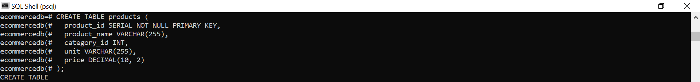

## INSERT INTO products

The following SQL statement will fill the products table with content:

INSERT INTO products (product_id, product_name, category_id, unit, price)  
VALUES  
  (1, 'Chais', 1, '10 boxes x 20 bags', 18),  
  (2, 'Chang', 1, '24 - 12 oz bottles', 19),  
  (3, 'Aniseed Syrup', 2, '12 - 550 ml bottles', 10),  
  (4, 'Chef Antons Cajun Seasoning', 2, '48 - 6 oz jars', 22),  
  (5, 'Chef Antons Gumbo Mix', 2, '36 boxes', 21.35),  
  (6, 'Grandmas Boysenberry Spread', 2, '12 - 8 oz jars', 25),  
  (7, 'Uncle Bobs Organic Dried Pears', 7, '12 - 1 lb pkgs.', 30),  
  (8, 'Northwoods Cranberry Sauce', 2, '12 - 12 oz jars', 40),  
  (9, 'Mishi Kobe Niku', 6, '18 - 500 g pkgs.', 97),  
  (10, 'Ikura', 8, '12 - 200 ml jars', 31),  
  (11, 'Queso Cabrales', 4, '1 kg pkg.', 21),  
  (12, 'Queso Manchego La Pastora', 4, '10 - 500 g pkgs.', 38),  
  (13, 'Konbu', 8, '2 kg box', 6),  
  (14, 'Tofu', 7, '40 - 100 g pkgs.', 23.25),  
  (15, 'Genen Shouyu', 2, '24 - 250 ml bottles', 15.5),  
  (16, 'Pavlova', 3, '32 - 500 g boxes', 17.45),  
  (17, 'Alice Mutton', 6, '20 - 1 kg tins', 39),  
  (18, 'Carnarvon Tigers', 8, '16 kg pkg.', 62.5),  
  (19, 'Teatime Chocolate Biscuits', 3, '10 boxes x 12 pieces', 9.2),  
  (20, 'Sir Rodneys Marmalade', 3, '30 gift boxes', 81),  
  (21, 'Sir Rodneys Scones', 3, '24 pkgs. x 4 pieces', 10),  
  (22, 'Gustafs Kneckebrod', 5, '24 - 500 g pkgs.', 21),  
  (23, 'Tunnbrod', 5, '12 - 250 g pkgs.', 9),  
  (24, 'Guarani Fantastica', 1, '12 - 355 ml cans', 4.5),  
  (25, 'NuNuCa Nui-Nougat-Creme', 3, '20 - 450 g glasses', 14),  
  (26, 'Gumber Gummiberchen', 3, '100 - 250 g bags', 31.23),  
  (27, 'Schoggi Schokolade', 3, '100 - 100 g pieces', 43.9),  
  (28, 'Rassle Sauerkraut', 7, '25 - 825 g cans', 45.6),  
  (29, 'Thoringer Rostbratwurst', 6, '50 bags x 30 sausgs.', 123.79),  
  (30, 'Nord-Ost Matjeshering', 8, '10 - 200 g glasses', 25.89),  
  (31, 'Gorgonzola Telino', 4, '12 - 100 g pkgs', 12.5),  
  (32, 'Mascarpone Fabioli', 4, '24 - 200 g pkgs.', 32),  
  (33, 'Geitost', 4, '500 g', 2.5),  
  (34, 'Sasquatch Ale', 1, '24 - 12 oz bottles', 14),  
  (35, 'Steeleye Stout', 1, '24 - 12 oz bottles', 18),  
  (36, 'Inlagd Sill', 8, '24 - 250 g jars', 19),  
  (37, 'Gravad lax', 8, '12 - 500 g pkgs.', 26),  
  (38, 'Cote de Blaye', 1, '12 - 75 cl bottles', 263.5),  
  (39, 'Chartreuse verte', 1, '750 cc per bottle', 18),  
  (40, 'Boston Crab Meat', 8, '24 - 4 oz tins', 18.4),  
  (41, 'Jacks New England Clam Chowder', 8, '12 - 12 oz cans', 9.65),  
  (42, 'Singaporean Hokkien Fried Mee', 5, '32 - 1 kg pkgs.', 14),  
  (43, 'Ipoh Coffee', 1, '16 - 500 g tins', 46),  
  (44, 'Gula Malacca', 2, '20 - 2 kg bags', 19.45),  
  (45, 'Rogede sild', 8, '1k pkg.', 9.5),  
  (46, 'Spegesild', 8, '4 - 450 g glasses', 12),  
  (47, 'Zaanse koeken', 3, '10 - 4 oz boxes', 9.5),  
  (48, 'Chocolade', 3, '10 pkgs.', 12.75),  
  (49, 'Maxilaku', 3, '24 - 50 g pkgs.', 20),  
  (50, 'Valkoinen suklaa', 3, '12 - 100 g bars', 16.25),  
  (51, 'Manjimup Dried Apples', 7, '50 - 300 g pkgs.', 53),  
  (52, 'Filo Mix', 5, '16 - 2 kg boxes', 7),  
  (53, 'Perth Pasties', 6, '48 pieces', 32.8),  
  (54, 'Tourtiare', 6, '16 pies', 7.45),  
  (55, 'Pate chinois', 6, '24 boxes x 2 pies', 24),  
  (56, 'Gnocchi di nonna Alice', 5, '24 - 250 g pkgs.', 38),  
  (57, 'Ravioli Angelo', 5, '24 - 250 g pkgs.', 19.5),  
  (58, 'Escargots de Bourgogne', 8, '24 pieces', 13.25),  
  (59, 'Raclette Courdavault', 4, '5 kg pkg.', 55),  
  (60, 'Camembert Pierrot', 4, '15 - 300 g rounds', 34),  
  (61, 'Sirop d arable', 2, '24 - 500 ml bottles', 28.5),  
  (62, 'Tarte au sucre', 3, '48 pies', 49.3),  
  (63, 'Vegie-spread', 2, '15 - 625 g jars', 43.9),  
  (64, 'Wimmers gute Semmelknadel', 5, '20 bags x 4 pieces', 33.25),  
  (65, 'Louisiana Fiery Hot Pepper Sauce', 2, '32 - 8 oz bottles', 21.05),  
  (66, 'Louisiana Hot Spiced Okra', 2, '24 - 8 oz jars', 17),  
  (67, 'Laughing Lumberjack Lager', 1, '24 - 12 oz bottles', 14),  
  (68, 'Scottish Longbreads', 3, '10 boxes x 8 pieces', 12.5),  
  (69, 'Gudbrandsdalsost', 4, '10 kg pkg.', 36),  
  (70, 'Outback Lager', 1, '24 - 355 ml bottles', 15),  
  (71, 'Flotemysost', 4, '10 - 500 g pkgs.', 21.5),  
  (72, 'Mozzarella di Giovanni', 4, '24 - 200 g pkgs.', 34.8),  
  (73, 'Red Kaviar', 8, '24 - 150 g jars', 15),  
  (74, 'Longlife Tofu', 7, '5 kg pkg.', 10),  
  (75, 'Rhenbreu Klosterbier', 1, '24 - 0.5 l bottles', 7.75),  
  (76, 'Lakkalikeeri', 1, '500 ml ', 18),  
  (77, 'Original Frankfurter gr�ne Soae', 2, '12 boxes', 13);

If you write above statement in your SQL Shell, you will see that it returns INSERT 0 77. Which means that we have inserted 77 rows in our products table.



# Orders

The following SQL statement will create a table named orders:

## CREATE TABLE orders

CREATE TABLE orders (  
  order_id SERIAL NOT NULL PRIMARY KEY,  
  customer_id INT,  
  order_date DATE  
);



## INSERT INTO orders

The following SQL statement will fill the orders table with content:

INSERT INTO orders (order_id, customer_id, order_date)  
VALUES  
  (10248, 90, '2021-07-04'),   
  (10249, 81, '2021-07-05'),   
  (10250, 34, '2021-07-08'),   
  (10251, 84, '2021-07-08'),   
  (10252, 76, '2021-07-09'),   
  (10253, 34, '2021-07-10'),   
  (10254, 14, '2021-07-11'),   
  (10255, 68, '2021-07-12'),   
  (10256, 88, '2021-07-15'),   
  (10257, 35, '2021-07-16'),   
  (10258, 20, '2021-07-17'),   
  (10259, 13, '2021-07-18'),   
  (10260, 55, '2021-07-19'),   
  (10261, 61, '2021-07-19'),   
  (10262, 65, '2021-07-22'),   
  (10263, 20, '2021-07-23'),   
  (10264, 24, '2021-07-24'),   
  (10265, 7, '2021-07-25'),   
  (10266, 87, '2021-07-26'),   
  (10267, 25, '2021-07-29'),   
  (10268, 33, '2021-07-30'),   
  (10269, 89, '2021-07-31'),   
  (10270, 87, '2021-08-01'),   
  (10271, 75, '2021-08-01'),   
  (10272, 65, '2021-08-02'),   
  (10273, 63, '2021-08-05'),   
  (10274, 85, '2021-08-06'),   
  (10275, 49, '2021-08-07'),   
  (10276, 80, '2021-08-08'),   
  (10277, 52, '2021-08-09'),   
  (10278, 5, '2021-08-12'),   
  (10279, 44, '2021-08-13'),   
  (10280, 5, '2021-08-14'),   
  (10281, 69, '2021-08-14'),   
  (10282, 69, '2021-08-15'),   
  (10283, 46, '2021-08-16'),   
  (10284, 44, '2021-08-19'),   
  (10285, 63, '2021-08-20'),   
  (10286, 63, '2021-08-21'),   
  (10287, 67, '2021-08-22'),   
  (10288, 66, '2021-08-23'),   
  (10289, 11, '2021-08-26'),   
  (10290, 15, '2021-08-27'),   
  (10291, 61, '2021-08-27'),   
  (10292, 81, '2021-08-28'),   
  (10293, 80, '2021-08-29'),   
  (10294, 65, '2021-08-30'),   
  (10295, 85, '2021-09-02'),   
  (10296, 46, '2021-09-03'),   
  (10297, 7, '2021-09-04'),   
  (10298, 37, '2021-09-05'),   
  (10299, 67, '2021-09-06'),   
  (10300, 49, '2021-09-09'),   
  (10301, 86, '2021-09-09'),   
  (10302, 76, '2021-09-10'),   
  (10303, 30, '2021-09-11'),   
  (10304, 80, '2021-09-12'),   
  (10305, 55, '2021-09-13'),   
  (10306, 69, '2021-09-16'),   
  (10307, 48, '2021-09-17'),   
  (10308, 2, '2021-09-18'),   
  (10309, 37, '2021-09-19'),   
  (10310, 77, '2021-09-20'),   
  (10311, 18, '2021-09-20'),   
  (10312, 86, '2021-09-23'),   
  (10313, 63, '2021-09-24'),   
  (10314, 65, '2021-09-25'),   
  (10315, 38, '2021-09-26'),   
  (10316, 65, '2021-09-27'),   
  (10317, 48, '2021-09-30'),   
  (10318, 38, '2021-10-01'),   
  (10319, 80, '2021-10-02'),   
  (10320, 87, '2021-10-03'),   
  (10321, 38, '2021-10-03'),   
  (10322, 58, '2021-10-04'),   
  (10323, 39, '2021-10-07'),   
  (10324, 71, '2021-10-08'),   
  (10325, 39, '2021-10-09'),   
  (10326, 8, '2021-10-10'),   
  (10327, 24, '2021-10-11'),   
  (10328, 28, '2021-10-14'),   
  (10329, 75, '2021-10-15'),   
  (10330, 46, '2021-10-16'),   
  (10331, 9, '2021-10-16'),   
  (10332, 51, '2021-10-17'),   
  (10333, 87, '2021-10-18'),   
  (10334, 84, '2021-10-21'),   
  (10335, 37, '2021-10-22'),   
  (10336, 60, '2021-10-23'),   
  (10337, 25, '2021-10-24'),   
  (10338, 55, '2021-10-25'),   
  (10339, 51, '2021-10-28'),   
  (10340, 9, '2021-10-29'),   
  (10341, 73, '2021-10-29'),   
  (10342, 25, '2021-10-30'),   
  (10343, 44, '2021-10-31'),   
  (10344, 89, '2021-11-01'),   
  (10345, 63, '2021-11-04'),   
  (10346, 65, '2021-11-05'),   
  (10347, 21, '2021-11-06'),   
  (10348, 86, '2021-11-07'),   
  (10349, 75, '2021-11-08'),   
  (10350, 41, '2021-11-11'),   
  (10351, 20, '2021-11-11'),   
  (10352, 28, '2021-11-12'),   
  (10353, 59, '2021-11-13'),   
  (10354, 58, '2021-11-14'),   
  (10355, 4, '2021-11-15'),   
  (10356, 86, '2021-11-18'),   
  (10357, 46, '2021-11-19'),   
  (10358, 41, '2021-11-20'),   
  (10359, 72, '2021-11-21'),   
  (10360, 7, '2021-11-22'),   
  (10361, 63, '2021-11-22'),   
  (10362, 9, '2021-11-25'),   
  (10363, 17, '2021-11-26'),   
  (10364, 19, '2021-11-26'),   
  (10365, 3, '2021-11-27'),   
  (10366, 29, '2021-11-28'),   
  (10367, 83, '2021-11-28'),   
  (10368, 20, '2021-11-29'),   
  (10369, 75, '2021-12-02'),   
  (10370, 14, '2021-12-03'),   
  (10371, 41, '2021-12-03'),   
  (10372, 62, '2021-12-04'),   
  (10373, 37, '2021-12-05'),   
  (10374, 91, '2021-12-05'),   
  (10375, 36, '2021-12-06'),   
  (10376, 51, '2021-12-09'),   
  (10377, 72, '2021-12-09'),   
  (10378, 24, '2021-12-10'),   
  (10379, 61, '2021-12-11'),   
  (10380, 37, '2021-12-12'),   
  (10381, 46, '2021-12-12'),   
  (10382, 20, '2021-12-13'),   
  (10383, 4, '2021-12-16'),   
  (10384, 5, '2021-12-16'),   
  (10385, 75, '2021-12-17'),   
  (10386, 21, '2021-12-18'),   
  (10387, 70, '2021-12-18'),   
  (10388, 72, '2021-12-19'),   
  (10389, 10, '2021-12-20'),   
  (10390, 20, '2021-12-23'),   
  (10391, 17, '2021-12-23'),   
  (10392, 59, '2021-12-24'),   
  (10393, 71, '2021-12-25'),   
  (10394, 36, '2021-12-25'),   
  (10395, 35, '2021-12-26'),   
  (10396, 25, '2021-12-27'),   
  (10397, 60, '2021-12-27'),   
  (10398, 71, '2021-12-30'),   
  (10399, 83, '2021-12-31'),   
  (10400, 19, '2022-01-01'),   
  (10401, 65, '2022-01-01'),   
  (10402, 20, '2022-01-02'),   
  (10403, 20, '2022-01-03'),   
  (10404, 49, '2022-01-03'),   
  (10405, 47, '2022-01-06'),   
  (10406, 62, '2022-01-07'),   
  (10407, 56, '2022-01-07'),   
  (10408, 23, '2022-01-08'),   
  (10409, 54, '2022-01-09'),   
  (10410, 10, '2022-01-10'),   
  (10411, 10, '2022-01-10'),   
  (10412, 87, '2022-01-13'),   
  (10413, 41, '2022-01-14'),   
  (10414, 21, '2022-01-14'),   
  (10415, 36, '2022-01-15'),   
  (10416, 87, '2022-01-16'),   
  (10417, 73, '2022-01-16'),   
  (10418, 63, '2022-01-17'),   
  (10419, 68, '2022-01-20'),   
  (10420, 88, '2022-01-21'),   
  (10421, 61, '2022-01-21'),   
  (10422, 27, '2022-01-22'),   
  (10423, 31, '2022-01-23'),   
  (10424, 51, '2022-01-23'),   
  (10425, 41, '2022-01-24'),   
  (10426, 29, '2022-01-27'),   
  (10427, 59, '2022-01-27'),   
  (10428, 66, '2022-01-28'),   
  (10429, 37, '2022-01-29'),   
  (10430, 20, '2022-01-30'),   
  (10431, 10, '2022-01-30'),   
  (10432, 75, '2022-01-31'),   
  (10433, 60, '2022-02-03'),   
  (10434, 24, '2022-02-03'),   
  (10435, 16, '2022-02-04'),   
  (10436, 7, '2022-02-05'),   
  (10437, 87, '2022-02-05'),   
  (10438, 79, '2022-02-06'),   
  (10439, 51, '2022-02-07'),   
  (10440, 71, '2022-02-10'),   
  (10441, 55, '2022-02-10'),   
  (10442, 20, '2022-02-11'),   
  (10443, 66, '2022-02-12'),   
  (10444, 5, '2022-02-12'),   
  (10445, 5, '2022-02-13'),   
  (10446, 79, '2022-02-14'),   
  (10447, 67, '2022-02-14'),   
  (10448, 64, '2022-02-17'),   
  (10449, 7, '2022-02-18'),   
  (10450, 84, '2022-02-19'),   
  (10451, 63, '2022-02-19'),   
  (10452, 71, '2022-02-20'),   
  (10453, 4, '2022-02-21'),   
  (10454, 41, '2022-02-21'),   
  (10455, 87, '2022-02-24'),   
  (10456, 39, '2022-02-25'),   
  (10457, 39, '2022-02-25'),   
  (10458, 76, '2022-02-26'),   
  (10459, 84, '2022-02-27'),   
  (10460, 24, '2022-02-28'),   
  (10461, 46, '2022-02-28'),   
  (10462, 16, '2022-03-03'),   
  (10463, 76, '2022-03-04'),   
  (10464, 28, '2022-03-04'),   
  (10465, 83, '2022-03-05'),   
  (10466, 15, '2022-03-06'),   
  (10467, 49, '2022-03-06'),   
  (10468, 39, '2022-03-07'),   
  (10469, 89, '2022-03-10'),   
  (10470, 9, '2022-03-11'),   
  (10471, 11, '2022-03-11'),   
  (10472, 72, '2022-03-12'),   
  (10473, 38, '2022-03-13'),   
  (10474, 58, '2022-03-13'),   
  (10475, 76, '2022-03-14'),   
  (10476, 35, '2022-03-17'),   
  (10477, 60, '2022-03-17'),   
  (10478, 84, '2022-03-18'),   
  (10479, 65, '2022-03-19'),   
  (10480, 23, '2022-03-20'),   
  (10481, 67, '2022-03-20'),   
  (10482, 43, '2022-03-21'),   
  (10483, 89, '2022-03-24'),   
  (10484, 11, '2022-03-24'),   
  (10485, 47, '2022-03-25'),   
  (10486, 35, '2022-03-26'),   
  (10487, 62, '2022-03-26'),   
  (10488, 25, '2022-03-27'),   
  (10489, 59, '2022-03-28'),   
  (10490, 35, '2022-03-31'),   
  (10491, 28, '2022-03-31'),   
  (10492, 10, '2022-04-01'),   
  (10493, 41, '2022-04-02'),   
  (10494, 15, '2022-04-02'),   
  (10495, 42, '2022-04-03'),   
  (10496, 81, '2022-04-04'),   
  (10497, 44, '2022-04-04'),   
  (10498, 35, '2022-04-07'),   
  (10499, 46, '2022-04-08'),   
  (10500, 41, '2022-04-09'),   
  (10501, 6, '2022-04-09'),   
  (10502, 58, '2022-04-10'),   
  (10503, 37, '2022-04-11'),   
  (10504, 89, '2022-04-11'),   
  (10505, 51, '2022-04-14'),   
  (10506, 39, '2022-04-15'),   
  (10507, 3, '2022-04-15'),   
  (10508, 56, '2022-04-16'),   
  (10509, 6, '2022-04-17'),   
  (10510, 71, '2022-04-18'),   
  (10511, 9, '2022-04-18'),   
  (10512, 21, '2022-04-21'),   
  (10513, 86, '2022-04-22'),   
  (10514, 20, '2022-04-22'),   
  (10515, 63, '2022-04-23'),   
  (10516, 37, '2022-04-24'),   
  (10517, 53, '2022-04-24'),   
  (10518, 80, '2022-04-25'),   
  (10519, 14, '2022-04-28'),   
  (10520, 70, '2022-04-29'),   
  (10521, 12, '2022-04-29'),   
  (10522, 44, '2022-04-30'),   
  (10523, 72, '2022-05-01'),   
  (10524, 5, '2022-05-01'),   
  (10525, 9, '2022-05-02'),   
  (10526, 87, '2022-05-05'),   
  (10527, 63, '2022-05-05'),   
  (10528, 32, '2022-05-06'),   
  (10529, 50, '2022-05-07'),   
  (10530, 59, '2022-05-08'),   
  (10531, 54, '2022-05-08'),   
  (10532, 19, '2022-05-09'),   
  (10533, 24, '2022-05-12'),   
  (10534, 44, '2022-05-12'),   
  (10535, 3, '2022-05-13'),   
  (10536, 44, '2022-05-14'),   
  (10537, 68, '2022-05-14'),   
  (10538, 11, '2022-05-15'),   
  (10539, 11, '2022-05-16'),   
  (10540, 63, '2022-05-19'),   
  (10541, 34, '2022-05-19'),   
  (10542, 39, '2022-05-20'),   
  (10543, 46, '2022-05-21'),   
  (10544, 48, '2022-05-21'),   
  (10545, 43, '2022-05-22'),   
  (10546, 84, '2022-05-23'),   
  (10547, 72, '2022-05-23'),   
  (10548, 79, '2022-05-26'),   
  (10549, 63, '2022-05-27'),   
  (10550, 30, '2022-05-28'),   
  (10551, 28, '2022-05-28'),   
  (10552, 35, '2022-05-29'),   
  (10553, 87, '2022-05-30'),   
  (10554, 56, '2022-05-30'),   
  (10555, 71, '2022-06-02'),   
  (10556, 73, '2022-06-03'),   
  (10557, 44, '2022-06-03'),   
  (10558, 4, '2022-06-04'),   
  (10559, 7, '2022-06-05'),   
  (10560, 25, '2022-06-06'),   
  (10561, 24, '2022-06-06'),   
  (10562, 66, '2022-06-09'),   
  (10563, 67, '2022-06-10'),   
  (10564, 65, '2022-06-10'),   
  (10565, 51, '2022-06-11'),   
  (10566, 7, '2022-06-12'),   
  (10567, 37, '2022-06-12'),   
  (10568, 29, '2022-06-13'),   
  (10569, 65, '2022-06-16'),   
  (10570, 51, '2022-06-17'),   
  (10571, 20, '2022-06-17'),   
  (10572, 5, '2022-06-18'),   
  (10573, 3, '2022-06-19'),   
  (10574, 82, '2022-06-19'),   
  (10575, 52, '2022-06-20'),   
  (10576, 80, '2022-06-23'),   
  (10577, 82, '2022-06-23'),   
  (10578, 11, '2022-06-24'),   
  (10579, 45, '2022-06-25'),   
  (10580, 56, '2022-06-26'),   
  (10581, 21, '2022-06-26'),   
  (10582, 6, '2022-06-27'),   
  (10583, 87, '2022-06-30'),   
  (10584, 7, '2022-06-30'),   
  (10585, 88, '2022-07-01'),   
  (10586, 66, '2022-07-02'),   
  (10587, 61, '2022-07-02'),   
  (10588, 63, '2022-07-03'),   
  (10589, 32, '2022-07-04'),   
  (10590, 51, '2022-07-07'),   
  (10591, 83, '2022-07-07'),   
  (10592, 44, '2022-07-08'),   
  (10593, 44, '2022-07-09'),   
  (10594, 55, '2022-07-09'),   
  (10595, 20, '2022-07-10'),   
  (10596, 89, '2022-07-11'),   
  (10597, 59, '2022-07-11'),   
  (10598, 65, '2022-07-14'),   
  (10599, 11, '2022-07-15'),   
  (10600, 36, '2022-07-16'),   
  (10601, 35, '2022-07-16'),   
  (10602, 83, '2022-07-17'),   
  (10603, 71, '2022-07-18'),   
  (10604, 28, '2022-07-18'),   
  (10605, 51, '2022-07-21'),   
  (10606, 81, '2022-07-22'),   
  (10607, 71, '2022-07-22'),   
  (10608, 79, '2022-07-23'),   
  (10609, 18, '2022-07-24'),   
  (10610, 41, '2022-07-25'),   
  (10611, 91, '2022-07-25'),   
  (10612, 71, '2022-07-28'),   
  (10613, 35, '2022-07-29'),   
  (10614, 6, '2022-07-29'),   
  (10615, 90, '2022-07-30'),   
  (10616, 32, '2022-07-31'),   
  (10617, 32, '2022-07-31'),   
  (10618, 51, '2022-08-01'),   
  (10619, 51, '2022-08-04'),   
  (10620, 42, '2022-08-05'),   
  (10621, 38, '2022-08-05'),   
  (10622, 67, '2022-08-06'),   
  (10623, 25, '2022-08-07'),   
  (10624, 78, '2022-08-07'),   
  (10625, 2, '2022-08-08'),   
  (10626, 5, '2022-08-11'),   
  (10627, 71, '2022-08-11'),   
  (10628, 7, '2022-08-12'),   
  (10629, 30, '2022-08-12'),   
  (10630, 39, '2022-08-13'),   
  (10631, 41, '2022-08-14'),   
  (10632, 86, '2022-08-14'),   
  (10633, 20, '2022-08-15'),   
  (10634, 23, '2022-08-15'),   
  (10635, 49, '2022-08-18'),   
  (10636, 87, '2022-08-19'),   
  (10637, 62, '2022-08-19'),   
  (10638, 47, '2022-08-20'),   
  (10639, 70, '2022-08-20'),   
  (10640, 86, '2022-08-21'),   
  (10641, 35, '2022-08-22'),   
  (10642, 73, '2022-08-22'),   
  (10643, 1, '2022-08-25'),   
  (10644, 88, '2022-08-25'),   
  (10645, 34, '2022-08-26'),   
  (10646, 37, '2022-08-27'),   
  (10647, 61, '2022-08-27'),   
  (10648, 67, '2022-08-28'),   
  (10649, 50, '2022-08-28'),   
  (10650, 21, '2022-08-29'),   
  (10651, 86, '2022-09-01'),   
  (10652, 31, '2022-09-01'),   
  (10653, 25, '2022-09-02'),   
  (10654, 5, '2022-09-02'),   
  (10655, 66, '2022-09-03'),   
  (10656, 32, '2022-09-04'),   
  (10657, 71, '2022-09-04'),   
  (10658, 63, '2022-09-05'),   
  (10659, 62, '2022-09-05'),   
  (10660, 36, '2022-09-08'),   
  (10661, 37, '2022-09-09'),   
  (10662, 48, '2022-09-09'),   
  (10663, 9, '2022-09-10'),   
  (10664, 28, '2022-09-10'),   
  (10665, 48, '2022-09-11'),   
  (10666, 68, '2022-09-12'),   
  (10667, 20, '2022-09-12'),   
  (10668, 86, '2022-09-15'),   
  (10669, 73, '2022-09-15'),   
  (10670, 25, '2022-09-16'),   
  (10671, 26, '2022-09-17'),   
  (10672, 5, '2022-09-17'),   
  (10673, 90, '2022-09-18'),   
  (10674, 38, '2022-09-18'),   
  (10675, 25, '2022-09-19'),   
  (10676, 80, '2022-09-22'),   
  (10677, 3, '2022-09-22'),   
  (10678, 71, '2022-09-23'),   
  (10679, 7, '2022-09-23'),   
  (10680, 55, '2022-09-24'),   
  (10681, 32, '2022-09-25'),   
  (10682, 3, '2022-09-25'),   
  (10683, 18, '2022-09-26'),   
  (10684, 56, '2022-09-26'),   
  (10685, 31, '2022-09-29'),   
  (10686, 59, '2022-09-30'),   
  (10687, 37, '2022-09-30'),   
  (10688, 83, '2022-10-01'),   
  (10689, 5, '2022-10-01'),   
  (10690, 34, '2022-10-02'),   
  (10691, 63, '2022-10-03'),   
  (10692, 1, '2022-10-03'),   
  (10693, 89, '2022-10-06'),   
  (10694, 63, '2022-10-06'),   
  (10695, 90, '2022-10-07'),   
  (10696, 89, '2022-10-08'),   
  (10697, 47, '2022-10-08'),   
  (10698, 20, '2022-10-09'),   
  (10699, 52, '2022-10-09'),   
  (10700, 71, '2022-10-10'),   
  (10701, 37, '2022-10-13'),   
  (10702, 1, '2022-10-13'),   
  (10703, 24, '2022-10-14'),   
  (10704, 62, '2022-10-14'),   
  (10705, 35, '2022-10-15'),   
  (10706, 55, '2022-10-16'),   
  (10707, 4, '2022-10-16'),   
  (10708, 77, '2022-10-17'),   
  (10709, 31, '2022-10-17'),   
  (10710, 27, '2022-10-20'),   
  (10711, 71, '2022-10-21'),   
  (10712, 37, '2022-10-21'),   
  (10713, 71, '2022-10-22'),   
  (10714, 71, '2022-10-22'),   
  (10715, 9, '2022-10-23'),   
  (10716, 64, '2022-10-24'),   
  (10717, 25, '2022-10-24'),   
  (10718, 39, '2022-10-27'),   
  (10719, 45, '2022-10-27'),   
  (10720, 61, '2022-10-28'),   
  (10721, 63, '2022-10-29'),   
  (10722, 71, '2022-10-29'),   
  (10723, 89, '2022-10-30'),   
  (10724, 51, '2022-10-30'),   
  (10725, 21, '2022-10-31'),   
  (10726, 19, '2022-11-03'),   
  (10727, 66, '2022-11-03'),   
  (10728, 62, '2022-11-04'),   
  (10729, 47, '2022-11-04'),   
  (10730, 9, '2022-11-05'),   
  (10731, 14, '2022-11-06'),   
  (10732, 9, '2022-11-06'),   
  (10733, 5, '2022-11-07'),   
  (10734, 31, '2022-11-07'),   
  (10735, 45, '2022-11-10'),   
  (10736, 37, '2022-11-11'),   
  (10737, 85, '2022-11-11'),   
  (10738, 74, '2022-11-12'),   
  (10739, 85, '2022-11-12'),   
  (10740, 89, '2022-11-13'),   
  (10741, 4, '2022-11-14'),   
  (10742, 10, '2022-11-14'),   
  (10743, 4, '2022-11-17'),   
  (10744, 83, '2022-11-17'),   
  (10745, 63, '2022-11-18'),   
  (10746, 14, '2022-11-19'),   
  (10747, 59, '2022-11-19'),   
  (10748, 71, '2022-11-20'),   
  (10749, 38, '2022-11-20'),   
  (10750, 87, '2022-11-21'),   
  (10751, 68, '2022-11-24'),   
  (10752, 53, '2022-11-24'),   
  (10753, 27, '2022-11-25'),   
  (10754, 49, '2022-11-25'),   
  (10755, 9, '2022-11-26'),   
  (10756, 75, '2022-11-27'),   
  (10757, 71, '2022-11-27'),   
  (10758, 68, '2022-11-28'),   
  (10759, 2, '2022-11-28'),   
  (10760, 50, '2022-12-01'),   
  (10761, 65, '2022-12-02'),   
  (10762, 24, '2022-12-02'),   
  (10763, 23, '2022-12-03'),   
  (10764, 20, '2022-12-03'),   
  (10765, 63, '2022-12-04'),   
  (10766, 56, '2022-12-05'),   
  (10767, 76, '2022-12-05'),   
  (10768, 4, '2022-12-08'),   
  (10769, 83, '2022-12-08'),   
  (10770, 34, '2022-12-09'),   
  (10771, 20, '2022-12-10'),   
  (10772, 44, '2022-12-10'),   
  (10773, 20, '2022-12-11'),   
  (10774, 24, '2022-12-11'),   
  (10775, 78, '2022-12-12'),   
  (10776, 20, '2022-12-15'),   
  (10777, 31, '2022-12-15'),   
  (10778, 5, '2022-12-16'),   
  (10779, 52, '2022-12-16'),   
  (10780, 46, '2022-12-16'),   
  (10781, 87, '2022-12-17'),   
  (10782, 12, '2022-12-17'),   
  (10783, 34, '2022-12-18'),   
  (10784, 49, '2022-12-18'),   
  (10785, 33, '2022-12-18'),   
  (10786, 62, '2022-12-19'),   
  (10787, 41, '2022-12-19'),   
  (10788, 63, '2022-12-22'),   
  (10789, 23, '2022-12-22'),   
  (10790, 31, '2022-12-22'),   
  (10791, 25, '2022-12-23'),   
  (10792, 91, '2022-12-23'),   
  (10793, 4, '2022-12-24'),   
  (10794, 61, '2022-12-24'),   
  (10795, 20, '2022-12-24'),   
  (10796, 35, '2022-12-25'),   
  (10797, 17, '2022-12-25'),   
  (10798, 38, '2022-12-26'),   
  (10799, 39, '2022-12-26'),   
  (10800, 72, '2022-12-26'),   
  (10801, 8, '2022-12-29'),   
  (10802, 73, '2022-12-29'),   
  (10803, 88, '2022-12-30'),   
  (10804, 72, '2022-12-30'),   
  (10805, 77, '2022-12-30'),   
  (10806, 84, '2022-12-31'),   
  (10807, 27, '2022-12-31'),   
  (10808, 60, '2023-01-01'),   
  (10809, 88, '2023-01-01'),   
  (10810, 42, '2023-01-01'),   
  (10811, 47, '2023-01-02'),   
  (10812, 66, '2023-01-02'),   
  (10813, 67, '2023-01-05'),   
  (10814, 84, '2023-01-05'),   
  (10815, 71, '2023-01-05'),   
  (10816, 32, '2023-01-06'),   
  (10817, 39, '2023-01-06'),   
  (10818, 49, '2023-01-07'),   
  (10819, 12, '2023-01-07'),   
  (10820, 65, '2023-01-07'),   
  (10821, 75, '2023-01-08'),   
  (10822, 82, '2023-01-08'),   
  (10823, 46, '2023-01-09'),   
  (10824, 24, '2023-01-09'),   
  (10825, 17, '2023-01-09'),   
  (10826, 7, '2023-01-12'),   
  (10827, 9, '2023-01-12'),   
  (10828, 64, '2023-01-13'),   
  (10829, 38, '2023-01-13'),   
  (10830, 81, '2023-01-13'),   
  (10831, 70, '2023-01-14'),   
  (10832, 41, '2023-01-14'),   
  (10833, 56, '2023-01-15'),   
  (10834, 81, '2023-01-15'),   
  (10835, 1, '2023-01-15'),   
  (10836, 20, '2023-01-16'),   
  (10837, 5, '2023-01-16'),   
  (10838, 47, '2023-01-19'),   
  (10839, 81, '2023-01-19'),   
  (10840, 47, '2023-01-19'),   
  (10841, 76, '2023-01-20'),   
  (10842, 80, '2023-01-20'),   
  (10843, 84, '2023-01-21'),   
  (10844, 59, '2023-01-21'),   
  (10845, 63, '2023-01-21'),   
  (10846, 76, '2023-01-22'),   
  (10847, 71, '2023-01-22'),   
  (10848, 16, '2023-01-23'),   
  (10849, 39, '2023-01-23'),   
  (10850, 84, '2023-01-23'),   
  (10851, 67, '2023-01-26'),   
  (10852, 65, '2023-01-26'),   
  (10853, 6, '2023-01-27'),   
  (10854, 20, '2023-01-27'),   
  (10855, 55, '2023-01-27'),   
  (10856, 3, '2023-01-28'),   
  (10857, 5, '2023-01-28'),   
  (10858, 40, '2023-01-29'),   
  (10859, 25, '2023-01-29'),   
  (10860, 26, '2023-01-29'),   
  (10861, 89, '2023-01-30'),   
  (10862, 44, '2023-01-30'),   
  (10863, 35, '2023-02-02'),   
  (10864, 4, '2023-02-02'),   
  (10865, 63, '2023-02-02'),   
  (10866, 5, '2023-02-03'),   
  (10867, 48, '2023-02-03'),   
  (10868, 62, '2023-02-04'),   
  (10869, 72, '2023-02-04'),   
  (10870, 91, '2023-02-04'),   
  (10871, 9, '2023-02-05'),   
  (10872, 30, '2023-02-05'),   
  (10873, 90, '2023-02-06'),   
  (10874, 30, '2023-02-06'),   
  (10875, 5, '2023-02-06'),   
  (10876, 9, '2023-02-09'),   
  (10877, 67, '2023-02-09'),   
  (10878, 63, '2023-02-10'),   
  (10879, 90, '2023-02-10'),   
  (10880, 24, '2023-02-10'),   
  (10881, 12, '2023-02-11'),   
  (10882, 71, '2023-02-11'),   
  (10883, 48, '2023-02-12'),   
  (10884, 45, '2023-02-12'),   
  (10885, 76, '2023-02-12'),   
  (10886, 34, '2023-02-13'),   
  (10887, 29, '2023-02-13'),   
  (10888, 30, '2023-02-16'),   
  (10889, 65, '2023-02-16'),   
  (10890, 18, '2023-02-16'),   
  (10891, 44, '2023-02-17'),   
  (10892, 50, '2023-02-17'),   
  (10893, 39, '2023-02-18'),   
  (10894, 71, '2023-02-18'),   
  (10895, 20, '2023-02-18'),   
  (10896, 50, '2023-02-19'),   
  (10897, 37, '2023-02-19'),   
  (10898, 54, '2023-02-20'),   
  (10899, 46, '2023-02-20'),   
  (10900, 88, '2023-02-20'),   
  (10901, 35, '2023-02-23'),   
  (10902, 24, '2023-02-23'),   
  (10903, 34, '2023-02-24'),   
  (10904, 89, '2023-02-24'),   
  (10905, 88, '2023-02-24'),   
  (10906, 91, '2023-02-25'),   
  (10907, 74, '2023-02-25'),   
  (10908, 66, '2023-02-26'),   
  (10909, 70, '2023-02-26'),   
  (10910, 90, '2023-02-26'),   
  (10911, 30, '2023-02-26'),   
  (10912, 37, '2023-02-26'),   
  (10913, 62, '2023-02-26'),   
  (10914, 62, '2023-02-27'),   
  (10915, 80, '2023-02-27'),   
  (10916, 64, '2023-02-27'),   
  (10917, 69, '2023-03-02'),   
  (10918, 10, '2023-03-02'),   
  (10919, 47, '2023-03-02'),   
  (10920, 4, '2023-03-03'),   
  (10921, 83, '2023-03-03'),   
  (10922, 34, '2023-03-03'),   
  (10923, 41, '2023-03-03'),   
  (10924, 5, '2023-03-04'),   
  (10925, 34, '2023-03-04'),   
  (10926, 2, '2023-03-04'),   
  (10927, 40, '2023-03-05'),   
  (10928, 29, '2023-03-05'),   
  (10929, 25, '2023-03-05'),   
  (10930, 76, '2023-03-06'),   
  (10931, 68, '2023-03-06'),   
  (10932, 9, '2023-03-06'),   
  (10933, 38, '2023-03-06'),   
  (10934, 44, '2023-03-09'),   
  (10935, 88, '2023-03-09'),   
  (10936, 32, '2023-03-09'),   
  (10937, 12, '2023-03-10'),   
  (10938, 63, '2023-03-10'),   
  (10939, 49, '2023-03-10'),   
  (10940, 9, '2023-03-11'),   
  (10941, 71, '2023-03-11'),   
  (10942, 66, '2023-03-11'),   
  (10943, 11, '2023-03-11'),   
  (10944, 10, '2023-03-12'),   
  (10945, 52, '2023-03-12'),   
  (10946, 83, '2023-03-12'),   
  (10947, 11, '2023-03-13'),   
  (10948, 30, '2023-03-13'),   
  (10949, 10, '2023-03-13'),   
  (10950, 49, '2023-03-16'),   
  (10951, 68, '2023-03-16'),   
  (10952, 1, '2023-03-16'),   
  (10953, 4, '2023-03-16'),   
  (10954, 47, '2023-03-17'),   
  (10955, 24, '2023-03-17'),   
  (10956, 6, '2023-03-17'),   
  (10957, 35, '2023-03-18'),   
  (10958, 54, '2023-03-18'),   
  (10959, 31, '2023-03-18'),   
  (10960, 35, '2023-03-19'),   
  (10961, 62, '2023-03-19'),   
  (10962, 63, '2023-03-19'),   
  (10963, 28, '2023-03-19'),   
  (10964, 74, '2023-03-20'),   
  (10965, 55, '2023-03-20'),   
  (10966, 14, '2023-03-20'),   
  (10967, 79, '2023-03-23'),   
  (10968, 20, '2023-03-23'),   
  (10969, 15, '2023-03-23'),   
  (10970, 8, '2023-03-24'),   
  (10971, 26, '2023-03-24'),   
  (10972, 40, '2023-03-24'),   
  (10973, 40, '2023-03-24'),   
  (10974, 75, '2023-03-25'),   
  (10975, 10, '2023-03-25'),   
  (10976, 35, '2023-03-25'),   
  (10977, 24, '2023-03-26'),   
  (10978, 50, '2023-03-26'),   
  (10979, 20, '2023-03-26'),   
  (10980, 24, '2023-03-27'),   
  (10981, 34, '2023-03-27'),   
  (10982, 10, '2023-03-27'),   
  (10983, 71, '2023-03-27'),   
  (10984, 71, '2023-03-30'),   
  (10985, 37, '2023-03-30'),   
  (10986, 54, '2023-03-30'),   
  (10987, 19, '2023-03-31'),   
  (10988, 65, '2023-03-31'),   
  (10989, 61, '2023-03-31'),   
  (10990, 20, '2023-04-01'),   
  (10991, 63, '2023-04-01'),   
  (10992, 77, '2023-04-01'),   
  (10993, 24, '2023-04-01'),   
  (10994, 83, '2023-04-02'),   
  (10995, 58, '2023-04-02'),   
  (10996, 63, '2023-04-02'),   
  (10997, 46, '2023-04-03'),   
  (10998, 91, '2023-04-03'),   
  (10999, 56, '2023-04-03'),   
  (11000, 65, '2023-04-06'),   
  (11001, 24, '2023-04-06'),   
  (11002, 71, '2023-04-06'),   
  (11003, 78, '2023-04-06'),   
  (11004, 50, '2023-04-07'),   
  (11005, 90, '2023-04-07'),   
  (11006, 32, '2023-04-07'),   
  (11007, 60, '2023-04-08'),   
  (11008, 20, '2023-04-08'),   
  (11009, 30, '2023-04-08'),   
  (11010, 66, '2023-04-09'),   
  (11011, 1, '2023-04-09'),   
  (11012, 25, '2023-04-09'),   
  (11013, 69, '2023-04-09'),   
  (11014, 47, '2023-04-10'),   
  (11015, 70, '2023-04-10'),   
  (11016, 4, '2023-04-10'),   
  (11017, 20, '2023-04-13'),   
  (11018, 48, '2023-04-13'),   
  (11019, 64, '2023-04-13'),   
  (11020, 56, '2023-04-14'),   
  (11021, 63, '2023-04-14'),   
  (11022, 34, '2023-04-14'),   
  (11023, 11, '2023-04-14'),   
  (11024, 19, '2023-04-15'),   
  (11025, 87, '2023-04-15'),   
  (11026, 27, '2023-04-15'),   
  (11027, 10, '2023-04-16'),   
  (11028, 39, '2023-04-16'),   
  (11029, 14, '2023-04-16'),   
  (11030, 71, '2023-04-17'),   
  (11031, 71, '2023-04-17'),   
  (11032, 89, '2023-04-17'),   
  (11033, 68, '2023-04-17'),   
  (11034, 55, '2023-04-20'),   
  (11035, 76, '2023-04-20'),   
  (11036, 17, '2023-04-20'),   
  (11037, 30, '2023-04-21'),   
  (11038, 76, '2023-04-21'),   
  (11039, 47, '2023-04-21'),   
  (11040, 32, '2023-04-22'),   
  (11041, 14, '2023-04-22'),   
  (11042, 15, '2023-04-22'),   
  (11043, 74, '2023-04-22'),   
  (11044, 91, '2023-04-23'),   
  (11045, 10, '2023-04-23'),   
  (11046, 86, '2023-04-23'),   
  (11047, 19, '2023-04-24'),   
  (11048, 10, '2023-04-24'),   
  (11049, 31, '2023-04-24'),   
  (11050, 24, '2023-04-27'),   
  (11051, 41, '2023-04-27'),   
  (11052, 34, '2023-04-27'),   
  (11053, 59, '2023-04-27'),   
  (11054, 12, '2023-04-28'),   
  (11055, 35, '2023-04-28'),   
  (11056, 19, '2023-04-28'),   
  (11057, 53, '2023-04-29'),   
  (11058, 6, '2023-04-29'),   
  (11059, 67, '2023-04-29'),   
  (11061, 32, '2023-04-30'),   
  (11062, 66, '2023-04-30'),   
  (11063, 37, '2023-04-30'),   
  (11064, 71, '2023-05-01'),   
  (11065, 46, '2023-05-01'),   
  (11066, 89, '2023-05-01'),   
  (11067, 17, '2023-05-04'),   
  (11068, 62, '2023-05-04'),   
  (11069, 80, '2023-05-04'),   
  (11070, 44, '2023-05-05'),   
  (11071, 46, '2023-05-05'),   
  (11072, 20, '2023-05-05'),   
  (11073, 58, '2023-05-05'),   
  (11074, 73, '2023-05-06'),   
  (11075, 68, '2023-05-06'),   
  (11076, 9, '2023-05-06'),   
  (11077, 65, '2023-05-06');

If you write above statement in your SQL Shell, you will see that it returns INSERT 0 830. Which means that we have inserted 830 rows in our orders table.



# Order_Details

The following SQL statement will create a table named order_details:

## CREATE TABLE order_details

CREATE TABLE order_details (  
  order_detail_id SERIAL NOT NULL PRIMARY KEY,  
  order_id INT,  
  product_id INT,  
  quantity INT  
);

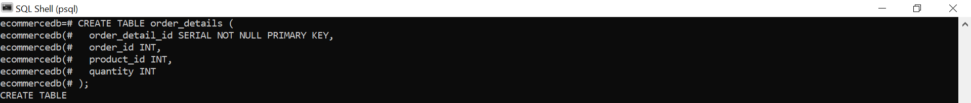

## INSERT INTO order_details

The following SQL statement will fill the order_details table with content:

INSERT INTO order_details (order_id, product_id, quantity)  
VALUES  
  (10248, 11, 12),  
  (10248, 42, 10),  
  (10248, 72, 5),  
  (10249, 14, 9),  
  (10249, 51, 40),  
  (10250, 41, 10),  
  (10250, 51, 35),  
  (10250, 65, 15),  
  (10251, 22, 6),  
  (10251, 57, 15),  
  (10251, 65, 20),  
  (10252, 20, 40),  
  (10252, 33, 25),  
  (10252, 60, 40),  
  (10253, 31, 20),  
  (10253, 39, 42),  
  (10253, 49, 40),  
  (10254, 24, 15),  
  (10254, 55, 21),  
  (10254, 74, 21),  
  (10255, 2, 20),  
  (10255, 16, 35),  
  (10255, 36, 25),  
  (10255, 59, 30),  
  (10256, 53, 15),  
  (10256, 77, 12),  
  (10257, 27, 25),  
  (10257, 39, 6),  
  (10257, 77, 15),  
  (10258, 2, 50),  
  (10258, 5, 65),  
  (10258, 32, 6),  
  (10259, 21, 10),  
  (10259, 37, 1),  
  (10260, 41, 16),  
  (10260, 57, 50),  
  (10260, 62, 15),  
  (10260, 70, 21),  
  (10261, 21, 20),  
  (10261, 35, 20),  
  (10262, 5, 12),  
  (10262, 7, 15),  
  (10262, 56, 2),  
  (10263, 16, 60),  
  (10263, 24, 28),  
  (10263, 30, 60),  
  (10263, 74, 36),  
  (10264, 2, 35),  
  (10264, 41, 25),  
  (10265, 17, 30),  
  (10265, 70, 20),  
  (10266, 12, 12),  
  (10267, 40, 50),  
  (10267, 59, 70),  
  (10267, 76, 15),  
  (10268, 29, 10),  
  (10268, 72, 4),  
  (10269, 33, 60),  
  (10269, 72, 20),  
  (10270, 36, 30),  
  (10270, 43, 25),  
  (10271, 33, 24),  
  (10272, 20, 6),  
  (10272, 31, 40),  
  (10272, 72, 24),  
  (10273, 10, 24),  
  (10273, 31, 15),  
  (10273, 33, 20),  
  (10273, 40, 60),  
  (10273, 76, 33),  
  (10274, 71, 20),  
  (10274, 72, 7),  
  (10275, 24, 12),  
  (10275, 59, 6),  
  (10276, 10, 15),  
  (10276, 13, 10),  
  (10277, 28, 20),  
  (10277, 62, 12),  
  (10278, 44, 16),  
  (10278, 59, 15),  
  (10278, 63, 8),  
  (10278, 73, 25),  
  (10279, 17, 15),  
  (10280, 24, 12),  
  (10280, 55, 20),  
  (10280, 75, 30),  
  (10281, 19, 1),  
  (10281, 24, 6),  
  (10281, 35, 4),  
  (10282, 30, 6),  
  (10282, 57, 2),  
  (10283, 15, 20),  
  (10283, 19, 18),  
  (10283, 60, 35),  
  (10283, 72, 3),  
  (10284, 27, 15),  
  (10284, 44, 21),  
  (10284, 60, 20),  
  (10284, 67, 5),  
  (10285, 1, 45),  
  (10285, 40, 40),  
  (10285, 53, 36),  
  (10286, 35, 100),  
  (10286, 62, 40),  
  (10287, 16, 40),  
  (10287, 34, 20),  
  (10287, 46, 15),  
  (10288, 54, 10),  
  (10288, 68, 3),  
  (10289, 3, 30),  
  (10289, 64, 9),  
  (10290, 5, 20),  
  (10290, 29, 15),  
  (10290, 49, 15),  
  (10290, 77, 10),  
  (10291, 13, 20),  
  (10291, 44, 24),  
  (10291, 51, 2),  
  (10292, 20, 20),  
  (10293, 18, 12),  
  (10293, 24, 10),  
  (10293, 63, 5),  
  (10293, 75, 6),  
  (10294, 1, 18),  
  (10294, 17, 15),  
  (10294, 43, 15),  
  (10294, 60, 21),  
  (10294, 75, 6),  
  (10295, 56, 4),  
  (10296, 11, 12),  
  (10296, 16, 30),  
  (10296, 69, 15),  
  (10297, 39, 60),  
  (10297, 72, 20),  
  (10298, 2, 40),  
  (10298, 36, 40),  
  (10298, 59, 30),  
  (10298, 62, 15),  
  (10299, 19, 15),  
  (10299, 70, 20),  
  (10300, 66, 30),  
  (10300, 68, 20),  
  (10301, 40, 10),  
  (10301, 56, 20),  
  (10302, 17, 40),  
  (10302, 28, 28),  
  (10302, 43, 12),  
  (10303, 40, 40),  
  (10303, 65, 30),  
  (10303, 68, 15),  
  (10304, 49, 30),  
  (10304, 59, 10),  
  (10304, 71, 2),  
  (10305, 18, 25),  
  (10305, 29, 25),  
  (10305, 39, 30),  
  (10306, 30, 10),  
  (10306, 53, 10),  
  (10306, 54, 5),  
  (10307, 62, 10),  
  (10307, 68, 3),  
  (10308, 69, 1),  
  (10308, 70, 5),  
  (10309, 4, 20),  
  (10309, 6, 30),  
  (10309, 42, 2),  
  (10309, 43, 20),  
  (10309, 71, 3),  
  (10310, 16, 10),  
  (10310, 62, 5),  
  (10311, 42, 6),  
  (10311, 69, 7),  
  (10312, 28, 4),  
  (10312, 43, 24),  
  (10312, 53, 20),  
  (10312, 75, 10),  
  (10313, 36, 12),  
  (10314, 32, 40),  
  (10314, 58, 30),  
  (10314, 62, 25),  
  (10315, 34, 14),  
  (10315, 70, 30),  
  (10316, 41, 10),  
  (10316, 62, 70),  
  (10317, 1, 20),  
  (10318, 41, 20),  
  (10318, 76, 6),  
  (10319, 17, 8),  
  (10319, 28, 14),  
  (10319, 76, 30),  
  (10320, 71, 30),  
  (10321, 35, 10),  
  (10322, 52, 20),  
  (10323, 15, 5),  
  (10323, 25, 4),  
  (10323, 39, 4),  
  (10324, 16, 21),  
  (10324, 35, 70),  
  (10324, 46, 30),  
  (10324, 59, 40),  
  (10324, 63, 80),  
  (10325, 6, 6),  
  (10325, 13, 12),  
  (10325, 14, 9),  
  (10325, 31, 4),  
  (10325, 72, 40),  
  (10326, 4, 24),  
  (10326, 57, 16),  
  (10326, 75, 50),  
  (10327, 2, 25),  
  (10327, 11, 50),  
  (10327, 30, 35),  
  (10327, 58, 30),  
  (10328, 59, 9),  
  (10328, 65, 40),  
  (10328, 68, 10),  
  (10329, 19, 10),  
  (10329, 30, 8),  
  (10329, 38, 20),  
  (10329, 56, 12),  
  (10330, 26, 50),  
  (10330, 72, 25),  
  (10331, 54, 15),  
  (10332, 18, 40),  
  (10332, 42, 10),  
  (10332, 47, 16),  
  (10333, 14, 10),  
  (10333, 21, 10),  
  (10333, 71, 40),  
  (10334, 52, 8),  
  (10334, 68, 10),  
  (10335, 2, 7),  
  (10335, 31, 25),  
  (10335, 32, 6),  
  (10335, 51, 48),  
  (10336, 4, 18),  
  (10337, 23, 40),  
  (10337, 26, 24),  
  (10337, 36, 20),  
  (10337, 37, 28),  
  (10337, 72, 25),  
  (10338, 17, 20),  
  (10338, 30, 15),  
  (10339, 4, 10),  
  (10339, 17, 70),  
  (10339, 62, 28),  
  (10340, 18, 20),  
  (10340, 41, 12),  
  (10340, 43, 40),  
  (10341, 33, 8),  
  (10341, 59, 9),  
  (10342, 2, 24),  
  (10342, 31, 56),  
  (10342, 36, 40),  
  (10342, 55, 40),  
  (10343, 64, 50),  
  (10343, 68, 4),  
  (10343, 76, 15),  
  (10344, 4, 35),  
  (10344, 8, 70),  
  (10345, 8, 70),  
  (10345, 19, 80),  
  (10345, 42, 9),  
  (10346, 17, 36),  
  (10346, 56, 20),  
  (10347, 25, 10),  
  (10347, 39, 50),  
  (10347, 40, 4),  
  (10347, 75, 6),  
  (10348, 1, 15),  
  (10348, 23, 25),  
  (10349, 54, 24),  
  (10350, 50, 15),  
  (10350, 69, 18),  
  (10351, 38, 20),  
  (10351, 41, 13),  
  (10351, 44, 77),  
  (10351, 65, 10),  
  (10352, 24, 10),  
  (10352, 54, 20),  
  (10353, 11, 12),  
  (10353, 38, 50),  
  (10354, 1, 12),  
  (10354, 29, 4),  
  (10355, 24, 25),  
  (10355, 57, 25),  
  (10356, 31, 30),  
  (10356, 55, 12),  
  (10356, 69, 20),  
  (10357, 10, 30),  
  (10357, 26, 16),  
  (10357, 60, 8),  
  (10358, 24, 10),  
  (10358, 34, 10),  
  (10358, 36, 20),  
  (10359, 16, 56),  
  (10359, 31, 70),  
  (10359, 60, 80),  
  (10360, 28, 30),  
  (10360, 29, 35),  
  (10360, 38, 10),  
  (10360, 49, 35),  
  (10360, 54, 28),  
  (10361, 39, 54),  
  (10361, 60, 55),  
  (10362, 25, 50),  
  (10362, 51, 20),  
  (10362, 54, 24),  
  (10363, 31, 20),  
  (10363, 75, 12),  
  (10363, 76, 12),  
  (10364, 69, 30),  
  (10364, 71, 5),  
  (10365, 11, 24),  
  (10366, 65, 5),  
  (10366, 77, 5),  
  (10367, 34, 36),  
  (10367, 54, 18),  
  (10367, 65, 15),  
  (10367, 77, 7),  
  (10368, 21, 5),  
  (10368, 28, 13),  
  (10368, 57, 25),  
  (10368, 64, 35),  
  (10369, 29, 20),  
  (10369, 56, 18),  
  (10370, 1, 15),  
  (10370, 64, 30),  
  (10370, 74, 20),  
  (10371, 36, 6),  
  (10372, 20, 12),  
  (10372, 38, 40),  
  (10372, 60, 70),  
  (10372, 72, 42),  
  (10373, 58, 80),  
  (10373, 71, 50),  
  (10374, 31, 30),  
  (10374, 58, 15),  
  (10375, 14, 15),  
  (10375, 54, 10),  
  (10376, 31, 42),  
  (10377, 28, 20),  
  (10377, 39, 20),  
  (10378, 71, 6),  
  (10379, 41, 8),  
  (10379, 63, 16),  
  (10379, 65, 20),  
  (10380, 30, 18),  
  (10380, 53, 20),  
  (10380, 60, 6),  
  (10380, 70, 30),  
  (10381, 74, 14),  
  (10382, 5, 32),  
  (10382, 18, 9),  
  (10382, 29, 14),  
  (10382, 33, 60),  
  (10382, 74, 50),  
  (10383, 13, 20),  
  (10383, 50, 15),  
  (10383, 56, 20),  
  (10384, 20, 28),  
  (10384, 60, 15),  
  (10385, 7, 10),  
  (10385, 60, 20),  
  (10385, 68, 8),  
  (10386, 24, 15),  
  (10386, 34, 10),  
  (10387, 24, 15),  
  (10387, 28, 6),  
  (10387, 59, 12),  
  (10387, 71, 15),  
  (10388, 45, 15),  
  (10388, 52, 20),  
  (10388, 53, 40),  
  (10389, 10, 16),  
  (10389, 55, 15),  
  (10389, 62, 20),  
  (10389, 70, 30),  
  (10390, 31, 60),  
  (10390, 35, 40),  
  (10390, 46, 45),  
  (10390, 72, 24),  
  (10391, 13, 18),  
  (10392, 69, 50),  
  (10393, 2, 25),  
  (10393, 14, 42),  
  (10393, 25, 7),  
  (10393, 26, 70),  
  (10393, 31, 32),  
  (10394, 13, 10),  
  (10394, 62, 10),  
  (10395, 46, 28),  
  (10395, 53, 70),  
  (10395, 69, 8),  
  (10396, 23, 40),  
  (10396, 71, 60),  
  (10396, 72, 21),  
  (10397, 21, 10),  
  (10397, 51, 18),  
  (10398, 35, 30),  
  (10398, 55, 120),  
  (10399, 68, 60),  
  (10399, 71, 30),  
  (10399, 76, 35),  
  (10399, 77, 14),  
  (10400, 29, 21),  
  (10400, 35, 35),  
  (10400, 49, 30),  
  (10401, 30, 18),  
  (10401, 56, 70),  
  (10401, 65, 20),  
  (10401, 71, 60),  
  (10402, 23, 60),  
  (10402, 63, 65),  
  (10403, 16, 21),  
  (10403, 48, 70),  
  (10404, 26, 30),  
  (10404, 42, 40),  
  (10404, 49, 30),  
  (10405, 3, 50),  
  (10406, 1, 10),  
  (10406, 21, 30),  
  (10406, 28, 42),  
  (10406, 36, 5),  
  (10406, 40, 2),  
  (10407, 11, 30),  
  (10407, 69, 15),  
  (10407, 71, 15),  
  (10408, 37, 10),  
  (10408, 54, 6),  
  (10408, 62, 35),  
  (10409, 14, 12),  
  (10409, 21, 12),  
  (10410, 33, 49),  
  (10410, 59, 16),  
  (10411, 41, 25),  
  (10411, 44, 40),  
  (10411, 59, 9),  
  (10412, 14, 20),  
  (10413, 1, 24),  
  (10413, 62, 40),  
  (10413, 76, 14),  
  (10414, 19, 18),  
  (10414, 33, 50),  
  (10415, 17, 2),  
  (10415, 33, 20),  
  (10416, 19, 20),  
  (10416, 53, 10),  
  (10416, 57, 20),  
  (10417, 38, 50),  
  (10417, 46, 2),  
  (10417, 68, 36),  
  (10417, 77, 35),  
  (10418, 2, 60),  
  (10418, 47, 55),  
  (10418, 61, 16),  
  (10418, 74, 15),  
  (10419, 60, 60),  
  (10419, 69, 20),  
  (10420, 9, 20),  
  (10420, 13, 2),  
  (10420, 70, 8),  
  (10420, 73, 20),  
  (10421, 19, 4),  
  (10421, 26, 30),  
  (10421, 53, 15),  
  (10421, 77, 10),  
  (10422, 26, 2),  
  (10423, 31, 14),  
  (10423, 59, 20),  
  (10424, 35, 60),  
  (10424, 38, 49),  
  (10424, 68, 30),  
  (10425, 55, 10),  
  (10425, 76, 20),  
  (10426, 56, 5),  
  (10426, 64, 7),  
  (10427, 14, 35),  
  (10428, 46, 20),  
  (10429, 50, 40),  
  (10429, 63, 35),  
  (10430, 17, 45),  
  (10430, 21, 50),  
  (10430, 56, 30),  
  (10430, 59, 70),  
  (10431, 17, 50),  
  (10431, 40, 50),  
  (10431, 47, 30),  
  (10432, 26, 10),  
  (10432, 54, 40),  
  (10433, 56, 28),  
  (10434, 11, 6),  
  (10434, 76, 18),  
  (10435, 2, 10),  
  (10435, 22, 12),  
  (10435, 72, 10),  
  (10436, 46, 5),  
  (10436, 56, 40),  
  (10436, 64, 30),  
  (10436, 75, 24),  
  (10437, 53, 15),  
  (10438, 19, 15),  
  (10438, 34, 20),  
  (10438, 57, 15),  
  (10439, 12, 15),  
  (10439, 16, 16),  
  (10439, 64, 6),  
  (10439, 74, 30),  
  (10440, 2, 45),  
  (10440, 16, 49),  
  (10440, 29, 24),  
  (10440, 61, 90),  
  (10441, 27, 50),  
  (10442, 11, 30),  
  (10442, 54, 80),  
  (10442, 66, 60),  
  (10443, 11, 6),  
  (10443, 28, 12),  
  (10444, 17, 10),  
  (10444, 26, 15),  
  (10444, 35, 8),  
  (10444, 41, 30),  
  (10445, 39, 6),  
  (10445, 54, 15),  
  (10446, 19, 12),  
  (10446, 24, 20),  
  (10446, 31, 3),  
  (10446, 52, 15),  
  (10447, 19, 40),  
  (10447, 65, 35),  
  (10447, 71, 2),  
  (10448, 26, 6),  
  (10448, 40, 20),  
  (10449, 10, 14),  
  (10449, 52, 20),  
  (10449, 62, 35),  
  (10450, 10, 20),  
  (10450, 54, 6),  
  (10451, 55, 120),  
  (10451, 64, 35),  
  (10451, 65, 28),  
  (10451, 77, 55),  
  (10452, 28, 15),  
  (10452, 44, 100),  
  (10453, 48, 15),  
  (10453, 70, 25),  
  (10454, 16, 20),  
  (10454, 33, 20),  
  (10454, 46, 10),  
  (10455, 39, 20),  
  (10455, 53, 50),  
  (10455, 61, 25),  
  (10455, 71, 30),  
  (10456, 21, 40),  
  (10456, 49, 21),   
  (10457, 59, 36),  
  (10458, 26, 30),  
  (10458, 28, 30),  
  (10458, 43, 20),  
  (10458, 56, 15),  
  (10458, 71, 50),  
  (10459, 7, 16),  
  (10459, 46, 20),  
  (10459, 72, 40),  
  (10460, 68, 21),  
  (10460, 75, 4),  
  (10461, 21, 40),  
  (10461, 30, 28),  
  (10461, 55, 60),  
  (10462, 13, 1),  
  (10462, 23, 21),  
  (10463, 19, 21),  
  (10463, 42, 50),  
  (10464, 4, 16),  
  (10464, 43, 3),  
  (10464, 56, 30),  
  (10464, 60, 20),  
  (10465, 24, 25),  
  (10465, 29, 18),  
  (10465, 40, 20),  
  (10465, 45, 30),  
  (10465, 50, 25),  
  (10466, 11, 10),  
  (10466, 46, 5),  
  (10467, 24, 28),  
  (10467, 25, 12),  
  (10468, 30, 8),  
  (10468, 43, 15),  
  (10469, 2, 40),  
  (10469, 16, 35),  
  (10469, 44, 2),  
  (10470, 18, 30),  
  (10470, 23, 15),  
  (10470, 64, 8),  
  (10471, 7, 30),  
  (10471, 56, 20),  
  (10472, 24, 80),  
  (10472, 51, 18),  
  (10473, 33, 12),  
  (10473, 71, 12),  
  (10474, 14, 12),  
  (10474, 28, 18),  
  (10474, 40, 21),  
  (10474, 75, 10),  
  (10475, 31, 35),  
  (10475, 66, 60),  
  (10475, 76, 42),  
  (10476, 55, 2),  
  (10476, 70, 12),  
  (10477, 1, 15),  
  (10477, 21, 21),  
  (10477, 39, 20),  
  (10478, 10, 20),  
  (10479, 38, 30),  
  (10479, 53, 28),  
  (10479, 59, 60),  
  (10479, 64, 30),  
  (10480, 47, 30),  
  (10480, 59, 12),  
  (10481, 49, 24),  
  (10481, 60, 40),  
  (10482, 40, 10),  
  (10483, 34, 35),  
  (10483, 77, 30),  
  (10484, 21, 14),  
  (10484, 40, 10),  
  (10484, 51, 3),  
  (10485, 2, 20),  
  (10485, 3, 20),  
  (10485, 55, 30),  
  (10485, 70, 60),  
  (10486, 11, 5),  
  (10486, 51, 25),  
  (10486, 74, 16),  
  (10487, 19, 5),  
  (10487, 26, 30),  
  (10487, 54, 24),  
  (10488, 59, 30),  
  (10488, 73, 20),  
  (10489, 11, 15),  
  (10489, 16, 18),  
  (10490, 59, 60),  
  (10490, 68, 30),  
  (10490, 75, 36),  
  (10491, 44, 15),  
  (10491, 77, 7),  
  (10492, 25, 60),  
  (10492, 42, 20),  
  (10493, 65, 15),  
  (10493, 66, 10),  
  (10493, 69, 10),  
  (10494, 56, 30),  
  (10495, 23, 10),  
  (10495, 41, 20),  
  (10495, 77, 5),  
  (10496, 31, 20),  
  (10497, 56, 14),  
  (10497, 72, 25),  
  (10497, 77, 25),  
  (10498, 24, 14),  
  (10498, 40, 5),  
  (10498, 42, 30),  
  (10499, 28, 20),  
  (10499, 49, 25),  
  (10500, 15, 12),  
  (10500, 28, 8),  
  (10501, 54, 20),  
  (10502, 45, 21),  
  (10502, 53, 6),  
  (10502, 67, 30),  
  (10503, 14, 70),  
  (10503, 65, 20),  
  (10504, 2, 12),  
  (10504, 21, 12),  
  (10504, 53, 10),  
  (10504, 61, 25),  
  (10505, 62, 3),  
  (10506, 25, 18),  
  (10506, 70, 14),  
  (10507, 43, 15),  
  (10507, 48, 15),  
  (10508, 13, 10),  
  (10508, 39, 10),  
  (10509, 28, 3),  
  (10510, 29, 36),  
  (10510, 75, 36),  
  (10511, 4, 50),  
  (10511, 7, 50),  
  (10511, 8, 10),  
  (10512, 24, 10),  
  (10512, 46, 9),  
  (10512, 47, 6),  
  (10512, 60, 12),  
  (10513, 21, 40),  
  (10513, 32, 50),  
  (10513, 61, 15),  
  (10514, 20, 39),  
  (10514, 28, 35),  
  (10514, 56, 70),  
  (10514, 65, 39),  
  (10514, 75, 50),  
  (10515, 9, 16),  
  (10515, 16, 50),  
  (10515, 27, 120),  
  (10515, 33, 16),  
  (10515, 60, 84),  
  (10516, 18, 25),  
  (10516, 41, 80),  
  (10516, 42, 20),  
  (10517, 52, 6),  
  (10517, 59, 4),  
  (10517, 70, 6),  
  (10518, 24, 5),  
  (10518, 38, 15),  
  (10518, 44, 9),  
  (10519, 10, 16),  
  (10519, 56, 40),  
  (10519, 60, 10),  
  (10520, 24, 8),  
  (10520, 53, 5),  
  (10521, 35, 3),  
  (10521, 41, 10),  
  (10521, 68, 6),  
  (10522, 1, 40),  
  (10522, 8, 24),  
  (10522, 30, 20),  
  (10522, 40, 25),  
  (10523, 17, 25),  
  (10523, 20, 15),  
  (10523, 37, 18),  
  (10523, 41, 6),  
  (10524, 10, 2),  
  (10524, 30, 10),  
  (10524, 43, 60),  
  (10524, 54, 15),  
  (10525, 36, 30),  
  (10525, 40, 15),  
  (10526, 1, 8),  
  (10526, 13, 10),  
  (10526, 56, 30),  
  (10527, 4, 50),  
  (10527, 36, 30),  
  (10528, 11, 3),  
  (10528, 33, 8),  
  (10528, 72, 9),  
  (10529, 55, 14),  
  (10529, 68, 20),  
  (10529, 69, 10),  
  (10530, 17, 40),  
  (10530, 43, 25),  
  (10530, 61, 20),  
  (10530, 76, 50),  
  (10531, 59, 2),  
  (10532, 30, 15),  
  (10532, 66, 24),  
  (10533, 4, 50),  
  (10533, 72, 24),  
  (10533, 73, 24),  
  (10534, 30, 10),  
  (10534, 40, 10),  
  (10534, 54, 10),  
  (10535, 11, 50),  
  (10535, 40, 10),  
  (10535, 57, 5),  
  (10535, 59, 15),  
  (10536, 12, 15),  
  (10536, 31, 20),  
  (10536, 33, 30),  
  (10536, 60, 35),  
  (10537, 31, 30),  
  (10537, 51, 6),  
  (10537, 58, 20),  
  (10537, 72, 21),  
  (10537, 73, 9),  
  (10538, 70, 7),  
  (10538, 72, 1),  
  (10539, 13, 8),  
  (10539, 21, 15),  
  (10539, 33, 15),  
  (10539, 49, 6),  
  (10540, 3, 60),  
  (10540, 26, 40),  
  (10540, 38, 30),  
  (10540, 68, 35),  
  (10541, 24, 35),  
  (10541, 38, 4),  
  (10541, 65, 36),  
  (10541, 71, 9),  
  (10542, 11, 15),  
  (10542, 54, 24),  
  (10543, 12, 30),  
  (10543, 23, 70),  
  (10544, 28, 7),  
  (10544, 67, 7),  
  (10545, 11, 10),  
  (10546, 7, 10),  
  (10546, 35, 30),  
  (10546, 62, 40),  
  (10547, 32, 24),  
  (10547, 36, 60),  
  (10548, 34, 10),  
  (10548, 41, 14),  
  (10549, 31, 55),  
  (10549, 45, 100),  
  (10549, 51, 48),  
  (10550, 17, 8),  
  (10550, 19, 10),  
  (10550, 21, 6),  
  (10550, 61, 10),  
  (10551, 16, 40),  
  (10551, 35, 20),  
  (10551, 44, 40),  
  (10552, 69, 18),  
  (10552, 75, 30),  
  (10553, 11, 15),  
  (10553, 16, 14),  
  (10553, 22, 24),  
  (10553, 31, 30),  
  (10553, 35, 6),  
  (10554, 16, 30),  
  (10554, 23, 20),  
  (10554, 62, 20),  
  (10554, 77, 10),  
  (10555, 14, 30),  
  (10555, 19, 35),  
  (10555, 24, 18),  
  (10555, 51, 20),  
  (10555, 56, 40),  
  (10556, 72, 24),  
  (10557, 64, 30),  
  (10557, 75, 20),  
  (10558, 47, 25),  
  (10558, 51, 20),  
  (10558, 52, 30),  
  (10558, 53, 18),  
  (10558, 73, 3),  
  (10559, 41, 12),  
  (10559, 55, 18),  
  (10560, 30, 20),  
  (10560, 62, 15),  
  (10561, 44, 10),  
  (10561, 51, 50),  
  (10562, 33, 20),  
  (10562, 62, 10),  
  (10563, 36, 25),  
  (10563, 52, 70),  
  (10564, 17, 16),  
  (10564, 31, 6),  
  (10564, 55, 25),  
  (10565, 24, 25),  
  (10565, 64, 18),  
  (10566, 11, 35),  
  (10566, 18, 18),  
  (10566, 76, 10),  
  (10567, 31, 60),  
  (10567, 51, 3),  
  (10567, 59, 40),  
  (10568, 10, 5),  
  (10569, 31, 35),  
  (10569, 76, 30),  
  (10570, 11, 15),  
  (10570, 56, 60),  
  (10571, 14, 11),  
  (10571, 42, 28),  
  (10572, 16, 12),  
  (10572, 32, 10),  
  (10572, 40, 50),  
  (10572, 75, 15),  
  (10573, 17, 18),  
  (10573, 34, 40),  
  (10573, 53, 25),  
  (10574, 33, 14),  
  (10574, 40, 2),  
  (10574, 62, 10),  
  (10574, 64, 6),  
  (10575, 59, 12),  
  (10575, 63, 6),  
  (10575, 72, 30),  
  (10575, 76, 10),  
  (10576, 1, 10),  
  (10576, 31, 20),  
  (10576, 44, 21),  
  (10577, 39, 10),  
  (10577, 75, 20),  
  (10577, 77, 18),  
  (10578, 35, 20),  
  (10578, 57, 6),  
  (10579, 15, 10),  
  (10579, 75, 21),  
  (10580, 14, 15),  
  (10580, 41, 9),  
  (10580, 65, 30),  
  (10581, 75, 50),  
  (10582, 57, 4),  
  (10582, 76, 14),  
  (10583, 29, 10),  
  (10583, 60, 24),  
  (10583, 69, 10),  
  (10584, 31, 50),  
  (10585, 47, 15),  
  (10586, 52, 4),  
  (10587, 26, 6),  
  (10587, 35, 20),  
  (10587, 77, 20),  
  (10588, 18, 40),  
  (10588, 42, 100),  
  (10589, 35, 4),  
  (10590, 1, 20),  
  (10590, 77, 60),  
  (10591, 3, 14),  
  (10591, 7, 10),  
  (10591, 54, 50),  
  (10592, 15, 25),  
  (10592, 26, 5),  
  (10593, 20, 21),  
  (10593, 69, 20),  
  (10593, 76, 4),  
  (10594, 52, 24),  
  (10594, 58, 30),  
  (10595, 35, 30),  
  (10595, 61, 120),  
  (10595, 69, 65),  
  (10596, 56, 5),  
  (10596, 63, 24),  
  (10596, 75, 30),  
  (10597, 24, 35),  
  (10597, 57, 20),  
  (10597, 65, 12),  
  (10598, 27, 50),  
  (10598, 71, 9),  
  (10599, 62, 10),  
  (10600, 54, 4),  
  (10600, 73, 30),  
  (10601, 13, 60),  
  (10601, 59, 35),  
  (10602, 77, 5),  
  (10603, 22, 48),  
  (10603, 49, 25),  
  (10604, 48, 6),  
  (10604, 76, 10),  
  (10605, 16, 30),  
  (10605, 59, 20),  
  (10605, 60, 70),  
  (10605, 71, 15),  
  (10606, 4, 20),  
  (10606, 55, 20),  
  (10606, 62, 10),  
  (10607, 7, 45),  
  (10607, 17, 100),  
  (10607, 33, 14),  
  (10607, 40, 42),  
  (10607, 72, 12),  
  (10608, 56, 28),  
  (10609, 1, 3),  
  (10609, 10, 10),  
  (10609, 21, 6),  
  (10610, 36, 21),  
  (10611, 1, 6),  
  (10611, 2, 10),  
  (10611, 60, 15),  
  (10612, 10, 70),  
  (10612, 36, 55),  
  (10612, 49, 18),  
  (10612, 60, 40),  
  (10612, 76, 80),  
  (10613, 13, 8),  
  (10613, 75, 40),  
  (10614, 11, 14),  
  (10614, 21, 8),  
  (10614, 39, 5),  
  (10615, 55, 5),  
  (10616, 38, 15),  
  (10616, 56, 14),  
  (10616, 70, 15),  
  (10616, 71, 15),  
  (10617, 59, 30),  
  (10618, 6, 70),  
  (10618, 56, 20),  
  (10618, 68, 15),  
  (10619, 21, 42),  
  (10619, 22, 40),  
  (10620, 24, 5),  
  (10620, 52, 5),  
  (10621, 19, 5),  
  (10621, 23, 10),  
  (10621, 70, 20),  
  (10621, 71, 15),  
  (10622, 2, 20),  
  (10622, 68, 18),  
  (10623, 14, 21),  
  (10623, 19, 15),  
  (10623, 21, 25),  
  (10623, 24, 3),  
  (10623, 35, 30),  
  (10624, 28, 10),  
  (10624, 29, 6),  
  (10624, 44, 10),  
  (10625, 14, 3),  
  (10625, 42, 5),  
  (10625, 60, 10),  
  (10626, 53, 12),  
  (10626, 60, 20),  
  (10626, 71, 20),  
  (10627, 62, 15),  
  (10627, 73, 35),  
  (10628, 1, 25),  
  (10629, 29, 20),  
  (10629, 64, 9),  
  (10630, 55, 12),  
  (10630, 76, 35),  
  (10631, 75, 8),  
  (10632, 2, 30),  
  (10632, 33, 20),  
  (10633, 12, 36),  
  (10633, 13, 13),  
  (10633, 26, 35),  
  (10633, 62, 80),  
  (10634, 7, 35),  
  (10634, 18, 50),  
  (10634, 51, 15),  
  (10634, 75, 2),  
  (10635, 4, 10),  
  (10635, 5, 15),  
  (10635, 22, 40),  
  (10636, 4, 25),  
  (10636, 58, 6),  
  (10637, 11, 10),  
  (10637, 50, 25),  
  (10637, 56, 60),  
  (10638, 45, 20),  
  (10638, 65, 21),  
  (10638, 72, 60),  
  (10639, 18, 8),  
  (10640, 69, 20),  
  (10640, 70, 15),  
  (10641, 2, 50),  
  (10641, 40, 60),  
  (10642, 21, 30),  
  (10642, 61, 20),  
  (10643, 28, 15),  
  (10643, 39, 21),  
  (10643, 46, 2),  
  (10644, 18, 4),  
  (10644, 43, 20),  
  (10644, 46, 21),  
  (10645, 18, 20),  
  (10645, 36, 15),  
  (10646, 1, 15),  
  (10646, 10, 18),  
  (10646, 71, 30),  
  (10646, 77, 35),  
  (10647, 19, 30),  
  (10647, 39, 20),  
  (10648, 22, 15),  
  (10648, 24, 15),  
  (10649, 28, 20),  
  (10649, 72, 15),  
  (10650, 30, 30),  
  (10650, 53, 25),  
  (10650, 54, 30),  
  (10651, 19, 12),  
  (10651, 22, 20),  
  (10652, 30, 2),  
  (10652, 42, 20),  
  (10653, 16, 30),  
  (10653, 60, 20),  
  (10654, 4, 12),  
  (10654, 39, 20),  
  (10654, 54, 6),  
  (10655, 41, 20),  
  (10656, 14, 3),  
  (10656, 44, 28),  
  (10656, 47, 6),  
  (10657, 15, 50),  
  (10657, 41, 24),  
  (10657, 46, 45),  
  (10657, 47, 10),  
  (10657, 56, 45),  
  (10657, 60, 30),  
  (10658, 21, 60),  
  (10658, 40, 70),  
  (10658, 60, 55),  
  (10658, 77, 70),  
  (10659, 31, 20),  
  (10659, 40, 24),  
  (10659, 70, 40),  
  (10660, 20, 21),  
  (10661, 39, 3),  
  (10661, 58, 49),  
  (10662, 68, 10),  
  (10663, 40, 30),  
  (10663, 42, 30),  
  (10663, 51, 20),  
  (10664, 10, 24),  
  (10664, 56, 12),  
  (10664, 65, 15),  
  (10665, 51, 20),  
  (10665, 59, 1),  
  (10665, 76, 10),  
  (10666, 29, 36),  
  (10666, 65, 10),  
  (10667, 69, 45),  
  (10667, 71, 14),  
  (10668, 31, 8),  
  (10668, 55, 4),  
  (10668, 64, 15),  
  (10669, 36, 30),  
  (10670, 23, 32),  
  (10670, 46, 60),  
  (10670, 67, 25),  
  (10670, 73, 50),  
  (10670, 75, 25),  
  (10671, 16, 10),  
  (10671, 62, 10),  
  (10671, 65, 12),  
  (10672, 38, 15),  
  (10672, 71, 12),  
  (10673, 16, 3),  
  (10673, 42, 6),  
  (10673, 43, 6),  
  (10674, 23, 5),  
  (10675, 14, 30),  
  (10675, 53, 10),  
  (10675, 58, 30),  
  (10676, 10, 2),  
  (10676, 19, 7),  
  (10676, 44, 21),  
  (10677, 26, 30),  
  (10677, 33, 8),  
  (10678, 12, 100),  
  (10678, 33, 30),  
  (10678, 41, 120),  
  (10678, 54, 30),  
  (10679, 59, 12),  
  (10680, 16, 50),  
  (10680, 31, 20),  
  (10680, 42, 40),  
  (10681, 19, 30),  
  (10681, 21, 12),  
  (10681, 64, 28),  
  (10682, 33, 30),  
  (10682, 66, 4),  
  (10682, 75, 30),  
  (10683, 52, 9),  
  (10684, 40, 20),  
  (10684, 47, 40),  
  (10684, 60, 30),  
  (10685, 10, 20),  
  (10685, 41, 4),  
  (10685, 47, 15),  
  (10686, 17, 30),  
  (10686, 26, 15),  
  (10687, 9, 50),  
  (10687, 29, 10),  
  (10687, 36, 6),  
  (10688, 10, 18),  
  (10688, 28, 60),  
  (10688, 34, 14),  
  (10689, 1, 35),  
  (10690, 56, 20),  
  (10690, 77, 30),  
  (10691, 1, 30),  
  (10691, 29, 40),  
  (10691, 43, 40),  
  (10691, 44, 24),  
  (10691, 62, 48),  
  (10692, 63, 20),  
  (10693, 9, 6),  
  (10693, 54, 60),  
  (10693, 69, 30),  
  (10693, 73, 15),  
  (10694, 7, 90),  
  (10694, 59, 25),  
  (10694, 70, 50),  
  (10695, 8, 10),  
  (10695, 12, 4),  
  (10695, 24, 20),  
  (10696, 17, 20),  
  (10696, 46, 18),  
  (10697, 19, 7),  
  (10697, 35, 9),  
  (10697, 58, 30),  
  (10697, 70, 30),  
  (10698, 11, 15),  
  (10698, 17, 8),  
  (10698, 29, 12),  
  (10698, 65, 65),  
  (10698, 70, 8),  
  (10699, 47, 12),  
  (10700, 1, 5),  
  (10700, 34, 12),  
  (10700, 68, 40),  
  (10700, 71, 60),  
  (10701, 59, 42),  
  (10701, 71, 20),  
  (10701, 76, 35),  
  (10702, 3, 6),  
  (10702, 76, 15),  
  (10703, 2, 5),  
  (10703, 59, 35),  
  (10703, 73, 35),  
  (10704, 4, 6),  
  (10704, 24, 35),  
  (10704, 48, 24),  
  (10705, 31, 20),  
  (10705, 32, 4),  
  (10706, 16, 20),  
  (10706, 43, 24),  
  (10706, 59, 8),  
  (10707, 55, 21),  
  (10707, 57, 40),  
  (10707, 70, 28),  
  (10708, 5, 4),  
  (10708, 36, 5),  
  (10709, 8, 40),  
  (10709, 51, 28),  
  (10709, 60, 10),  
  (10710, 19, 5),  
  (10710, 47, 5),  
  (10711, 19, 12),  
  (10711, 41, 42),  
  (10711, 53, 120),  
  (10712, 53, 3),  
  (10712, 56, 30),  
  (10713, 10, 18),  
  (10713, 26, 30),  
  (10713, 45, 110),  
  (10713, 46, 24),  
  (10714, 2, 30),  
  (10714, 17, 27),  
  (10714, 47, 50),  
  (10714, 56, 18),  
  (10714, 58, 12),  
  (10715, 10, 21),  
  (10715, 71, 30),  
  (10716, 21, 5),  
  (10716, 51, 7),  
  (10716, 61, 10),  
  (10717, 21, 32),  
  (10717, 54, 15),  
  (10717, 69, 25),  
  (10718, 12, 36),  
  (10718, 16, 20),  
  (10718, 36, 40),  
  (10718, 62, 20),  
  (10719, 18, 12),  
  (10719, 30, 3),  
  (10719, 54, 40),  
  (10720, 35, 21),  
  (10720, 71, 8),  
  (10721, 44, 50),  
  (10722, 2, 3),  
  (10722, 31, 50),  
  (10722, 68, 45),  
  (10722, 75, 42),  
  (10723, 26, 15),  
  (10724, 10, 16),  
  (10724, 61, 5),  
  (10725, 41, 12),  
  (10725, 52, 4),  
  (10725, 55, 6),  
  (10726, 4, 25),  
  (10726, 11, 5),  
  (10727, 17, 20),  
  (10727, 56, 10),  
  (10727, 59, 10),  
  (10728, 30, 15),  
  (10728, 40, 6),  
  (10728, 55, 12),  
  (10728, 60, 15),  
  (10729, 1, 50),  
  (10729, 21, 30),  
  (10729, 50, 40),  
  (10730, 16, 15),  
  (10730, 31, 3),  
  (10730, 65, 10),  
  (10731, 21, 40),  
  (10731, 51, 30),  
  (10732, 76, 20),  
  (10733, 14, 16),  
  (10733, 28, 20),  
  (10733, 52, 25),  
  (10734, 6, 30),  
  (10734, 30, 15),  
  (10734, 76, 20),  
  (10735, 61, 20),  
  (10735, 77, 2),  
  (10736, 65, 40),  
  (10736, 75, 20),  
  (10737, 13, 4),  
  (10737, 41, 12),  
  (10738, 16, 3),  
  (10739, 36, 6),  
  (10739, 52, 18),  
  (10740, 28, 5),  
  (10740, 35, 35),  
  (10740, 45, 40),  
  (10740, 56, 14),  
  (10741, 2, 15),  
  (10742, 3, 20),  
  (10742, 60, 50),  
  (10742, 72, 35),  
  (10743, 46, 28),  
  (10744, 40, 50),  
  (10745, 18, 24),  
  (10745, 44, 16),  
  (10745, 59, 45),  
  (10745, 72, 7),  
  (10746, 13, 6),  
  (10746, 42, 28),  
  (10746, 62, 9),  
  (10746, 69, 40),  
  (10747, 31, 8),  
  (10747, 41, 35),  
  (10747, 63, 9),  
  (10747, 69, 30),  
  (10748, 23, 44),  
  (10748, 40, 40),  
  (10748, 56, 28),  
  (10749, 56, 15),  
  (10749, 59, 6),  
  (10749, 76, 10),  
  (10750, 14, 5),  
  (10750, 45, 40),  
  (10750, 59, 25),  
  (10751, 26, 12),  
  (10751, 30, 30),  
  (10751, 50, 20),  
  (10751, 73, 15),  
  (10752, 1, 8),  
  (10752, 69, 3),  
  (10753, 45, 4),  
  (10753, 74, 5),  
  (10754, 40, 3),  
  (10755, 47, 30),  
  (10755, 56, 30),  
  (10755, 57, 14),  
  (10755, 69, 25),  
  (10756, 18, 21),  
  (10756, 36, 20),  
  (10756, 68, 6),  
  (10756, 69, 20),  
  (10757, 34, 30),  
  (10757, 59, 7),  
  (10757, 62, 30),  
  (10757, 64, 24),  
  (10758, 26, 20),  
  (10758, 52, 60),  
  (10758, 70, 40),  
  (10759, 32, 10),  
  (10760, 25, 12),  
  (10760, 27, 40),  
  (10760, 43, 30),  
  (10761, 25, 35),  
  (10761, 75, 18),  
  (10762, 39, 16),  
  (10762, 47, 30),  
  (10762, 51, 28),  
  (10762, 56, 60),  
  (10763, 21, 40),  
  (10763, 22, 6),  
  (10763, 24, 20),  
  (10764, 3, 20),  
  (10764, 39, 130),  
  (10765, 65, 80),  
  (10766, 2, 40),  
  (10766, 7, 35),  
  (10766, 68, 40),  
  (10767, 42, 2),  
  (10768, 22, 4),  
  (10768, 31, 50),  
  (10768, 60, 15),  
  (10768, 71, 12),  
  (10769, 41, 30),  
  (10769, 52, 15),  
  (10769, 61, 20),  
  (10769, 62, 15),  
  (10770, 11, 15),  
  (10771, 71, 16),  
  (10772, 29, 18),  
  (10772, 59, 25),  
  (10773, 17, 33),  
  (10773, 31, 70),  
  (10773, 75, 7),  
  (10774, 31, 2),  
  (10774, 66, 50),  
  (10775, 10, 6),  
  (10775, 67, 3),  
  (10776, 31, 16),  
  (10776, 42, 12),  
  (10776, 45, 27),  
  (10776, 51, 120),  
  (10777, 42, 20),  
  (10778, 41, 10),  
  (10779, 16, 20),  
  (10779, 62, 20),  
  (10780, 70, 35),  
  (10780, 77, 15),  
  (10781, 54, 3),  
  (10781, 56, 20),  
  (10781, 74, 35),  
  (10782, 31, 1),  
  (10783, 31, 10),  
  (10783, 38, 5),  
  (10784, 36, 30),  
  (10784, 39, 2),  
  (10784, 72, 30),  
  (10785, 10, 10),  
  (10785, 75, 10),  
  (10786, 8, 30),  
  (10786, 30, 15),  
  (10786, 75, 42),  
  (10787, 2, 15),  
  (10787, 29, 20),  
  (10788, 19, 50),  
  (10788, 75, 40),  
  (10789, 18, 30),  
  (10789, 35, 15),  
  (10789, 63, 30),  
  (10789, 68, 18),  
  (10790, 7, 3),  
  (10790, 56, 20),  
  (10791, 29, 14),  
  (10791, 41, 20),  
  (10792, 2, 10),  
  (10792, 54, 3),  
  (10792, 68, 15),  
  (10793, 41, 14),  
  (10793, 52, 8),  
  (10794, 14, 15),  
  (10794, 54, 6),  
  (10795, 16, 65),  
  (10795, 17, 35),  
  (10796, 26, 21),  
  (10796, 44, 10),  
  (10796, 64, 35),  
  (10796, 69, 24),  
  (10797, 11, 20),  
  (10798, 62, 2),  
  (10798, 72, 10),  
  (10799, 13, 20),  
  (10799, 24, 20),  
  (10799, 59, 25),  
  (10800, 11, 50),  
  (10800, 51, 10),  
  (10800, 54, 7),  
  (10801, 17, 40),  
  (10801, 29, 20),  
  (10802, 30, 25),  
  (10802, 51, 30),  
  (10802, 55, 60),  
  (10802, 62, 5),  
  (10803, 19, 24),  
  (10803, 25, 15),  
  (10803, 59, 15),  
  (10804, 10, 36),  
  (10804, 28, 24),  
  (10804, 49, 4),  
  (10805, 34, 10),  
  (10805, 38, 10),  
  (10806, 2, 20),  
  (10806, 65, 2),  
  (10806, 74, 15),  
  (10807, 40, 1),  
  (10808, 56, 20),  
  (10808, 76, 50),  
  (10809, 52, 20),  
  (10810, 13, 7),  
  (10810, 25, 5),  
  (10810, 70, 5),  
  (10811, 19, 15),  
  (10811, 23, 18),  
  (10811, 40, 30),  
  (10812, 31, 16),  
  (10812, 72, 40),  
  (10812, 77, 20),  
  (10813, 2, 12),  
  (10813, 46, 35),  
  (10814, 41, 20),  
  (10814, 43, 20),  
  (10814, 48, 8),  
  (10814, 61, 30),  
  (10815, 33, 16),  
  (10816, 38, 30),  
  (10816, 62, 20),  
  (10817, 26, 40),  
  (10817, 38, 30),  
  (10817, 40, 60),  
  (10817, 62, 25),  
  (10818, 32, 20),  
  (10818, 41, 20),  
  (10819, 43, 7),  
  (10819, 75, 20),  
  (10820, 56, 30),  
  (10821, 35, 20),  
  (10821, 51, 6),  
  (10822, 62, 3),  
  (10822, 70, 6),  
  (10823, 11, 20),  
  (10823, 57, 15),  
  (10823, 59, 40),  
  (10823, 77, 15),  
  (10824, 41, 12),  
  (10824, 70, 9),  
  (10825, 26, 12),  
  (10825, 53, 20),  
  (10826, 31, 35),  
  (10826, 57, 15),  
  (10827, 10, 15),  
  (10827, 39, 21),  
  (10828, 20, 5),  
  (10828, 38, 2),  
  (10829, 2, 10),  
  (10829, 8, 20),  
  (10829, 13, 10),  
  (10829, 60, 21),  
  (10830, 6, 6),  
  (10830, 39, 28),  
  (10830, 60, 30),  
  (10830, 68, 24),  
  (10831, 19, 2),  
  (10831, 35, 8),  
  (10831, 38, 8),  
  (10831, 43, 9),  
  (10832, 13, 3),  
  (10832, 25, 10),  
  (10832, 44, 16),  
  (10832, 64, 3),  
  (10833, 7, 20),  
  (10833, 31, 9),  
  (10833, 53, 9),  
  (10834, 29, 8),  
  (10834, 30, 20),  
  (10835, 59, 15),  
  (10835, 77, 2),  
  (10836, 22, 52),  
  (10836, 35, 6),  
  (10836, 57, 24),  
  (10836, 60, 60),  
  (10836, 64, 30),  
  (10837, 13, 6),  
  (10837, 40, 25),  
  (10837, 47, 40),  
  (10837, 76, 21),  
  (10838, 1, 4),  
  (10838, 18, 25),  
  (10838, 36, 50),  
  (10839, 58, 30),  
  (10839, 72, 15),  
  (10840, 25, 6),  
  (10840, 39, 10),  
  (10841, 10, 16),  
  (10841, 56, 30),  
  (10841, 59, 50),  
  (10841, 77, 15),  
  (10842, 11, 15),  
  (10842, 43, 5),  
  (10842, 68, 20),  
  (10842, 70, 12),  
  (10843, 51, 4),  
  (10844, 22, 35),  
  (10845, 23, 70),  
  (10845, 35, 25),  
  (10845, 42, 42),  
  (10845, 58, 60),  
  (10845, 64, 48),  
  (10846, 4, 21),  
  (10846, 70, 30),  
  (10846, 74, 20),  
  (10847, 1, 80),  
  (10847, 19, 12),  
  (10847, 37, 60),  
  (10847, 45, 36),  
  (10847, 60, 45),  
  (10847, 71, 55),  
  (10848, 5, 30),  
  (10848, 9, 3),  
  (10849, 3, 49),  
  (10849, 26, 18),  
  (10850, 25, 20),  
  (10850, 33, 4),  
  (10850, 70, 30),  
  (10851, 2, 5),  
  (10851, 25, 10),  
  (10851, 57, 10),  
  (10851, 59, 42),  
  (10852, 2, 15),  
  (10852, 17, 6),  
  (10852, 62, 50),  
  (10853, 18, 10),  
  (10854, 10, 100),  
  (10854, 13, 65),  
  (10855, 16, 50),  
  (10855, 31, 14),  
  (10855, 56, 24),  
  (10855, 65, 15),  
  (10856, 2, 20),  
  (10856, 42, 20),  
  (10857, 3, 30),  
  (10857, 26, 35),  
  (10857, 29, 10),  
  (10858, 7, 5),  
  (10858, 27, 10),  
  (10858, 70, 4),  
  (10859, 24, 40),  
  (10859, 54, 35),  
  (10859, 64, 30),  
  (10860, 51, 3),  
  (10860, 76, 20),  
  (10861, 17, 42),  
  (10861, 18, 20),  
  (10861, 21, 40),  
  (10861, 33, 35),  
  (10861, 62, 3),  
  (10862, 11, 25),  
  (10862, 52, 8),  
  (10863, 1, 20),  
  (10863, 58, 12),  
  (10864, 35, 4),  
  (10864, 67, 15),  
  (10865, 38, 60),  
  (10865, 39, 80),  
  (10866, 2, 21),  
  (10866, 24, 6),  
  (10866, 30, 40),  
  (10867, 53, 3),  
  (10868, 26, 20),  
  (10868, 35, 30),  
  (10868, 49, 42),  
  (10869, 1, 40),  
  (10869, 11, 10),  
  (10869, 23, 50),  
  (10869, 68, 20),  
  (10870, 35, 3),  
  (10870, 51, 2),  
  (10871, 6, 50),  
  (10871, 16, 12),  
  (10871, 17, 16),  
  (10872, 55, 10),  
  (10872, 62, 20),  
  (10872, 64, 15),  
  (10872, 65, 21),  
  (10873, 21, 20),  
  (10873, 28, 3),  
  (10874, 10, 10),  
  (10875, 19, 25),  
  (10875, 47, 21),  
  (10875, 49, 15),  
  (10876, 46, 21),  
  (10876, 64, 20),  
  (10877, 16, 30),  
  (10877, 18, 25),  
  (10878, 20, 20),  
  (10879, 40, 12),  
  (10879, 65, 10),  
  (10879, 76, 10),  
  (10880, 23, 30),  
  (10880, 61, 30),  
  (10880, 70, 50),  
  (10881, 73, 10),  
  (10882, 42, 25),  
  (10882, 49, 20),  
  (10882, 54, 32),  
  (10883, 24, 8),  
  (10884, 21, 40),  
  (10884, 56, 21),  
  (10884, 65, 12),  
  (10885, 2, 20),  
  (10885, 24, 12),  
  (10885, 70, 30),  
  (10885, 77, 25),  
  (10886, 10, 70),  
  (10886, 31, 35),  
  (10886, 77, 40),  
  (10887, 25, 5),  
  (10888, 2, 20),  
  (10888, 68, 18),  
  (10889, 11, 40),  
  (10889, 38, 40),  
  (10890, 17, 15),  
  (10890, 34, 10),  
  (10890, 41, 14),  
  (10891, 30, 15),  
  (10892, 59, 40),  
  (10893, 8, 30),  
  (10893, 24, 10),  
  (10893, 29, 24),  
  (10893, 30, 35),  
  (10893, 36, 20),  
  (10894, 13, 28),  
  (10894, 69, 50),  
  (10894, 75, 120),  
  (10895, 24, 110),  
  (10895, 39, 45),  
  (10895, 40, 91),  
  (10895, 60, 100),  
  (10896, 45, 15),  
  (10896, 56, 16),  
  (10897, 29, 80),  
  (10897, 30, 36),  
  (10898, 13, 5),  
  (10899, 39, 8),  
  (10900, 70, 3),  
  (10901, 41, 30),  
  (10901, 71, 30),  
  (10902, 55, 30),  
  (10902, 62, 6),  
  (10903, 13, 40),  
  (10903, 65, 21),  
  (10903, 68, 20),  
  (10904, 58, 15),  
  (10904, 62, 35),  
  (10905, 1, 20),  
  (10906, 61, 15),  
  (10907, 75, 14),  
  (10908, 7, 20),  
  (10908, 52, 14),  
  (10909, 7, 12),  
  (10909, 16, 15),  
  (10909, 41, 5),  
  (10910, 19, 12),  
  (10910, 49, 10),  
  (10910, 61, 5),  
  (10911, 1, 10),  
  (10911, 17, 12),  
  (10911, 67, 15),  
  (10912, 11, 40),  
  (10912, 29, 60),  
  (10913, 4, 30),  
  (10913, 33, 40),  
  (10913, 58, 15),  
  (10914, 71, 25),  
  (10915, 17, 10),  
  (10915, 33, 30),  
  (10915, 54, 10),  
  (10916, 16, 6),  
  (10916, 32, 6),  
  (10916, 57, 20),  
  (10917, 30, 1),  
  (10917, 60, 10),  
  (10918, 1, 60),  
  (10918, 60, 25),  
  (10919, 16, 24),  
  (10919, 25, 24),  
  (10919, 40, 20),  
  (10920, 50, 24),  
  (10921, 35, 10),  
  (10921, 63, 40),  
  (10922, 17, 15),  
  (10922, 24, 35),  
  (10923, 42, 10),  
  (10923, 43, 10),  
  (10923, 67, 24),  
  (10924, 10, 20),  
  (10924, 28, 30),  
  (10924, 75, 6),  
  (10925, 36, 25),  
  (10925, 52, 12),  
  (10926, 11, 2),  
  (10926, 13, 10),  
  (10926, 19, 7),  
  (10926, 72, 10),  
  (10927, 20, 5),  
  (10927, 52, 5),  
  (10927, 76, 20),  
  (10928, 47, 5),  
  (10928, 76, 5),  
  (10929, 21, 60),  
  (10929, 75, 49),  
  (10929, 77, 15),  
  (10930, 21, 36),  
  (10930, 27, 25),  
  (10930, 55, 25),  
  (10930, 58, 30),  
  (10931, 13, 42),  
  (10931, 57, 30),  
  (10932, 16, 30),  
  (10932, 62, 14),  
  (10932, 72, 16),  
  (10932, 75, 20),  
  (10933, 53, 2),  
  (10933, 61, 30),  
  (10934, 6, 20),  
  (10935, 1, 21),  
  (10935, 18, 4),  
  (10935, 23, 8),  
  (10936, 36, 30),  
  (10937, 28, 8),  
  (10937, 34, 20),  
  (10938, 13, 20),  
  (10938, 43, 24),  
  (10938, 60, 49),  
  (10938, 71, 35),  
  (10939, 2, 10),  
  (10939, 67, 40),  
  (10940, 7, 8),  
  (10940, 13, 20),  
  (10941, 31, 44),  
  (10941, 62, 30),  
  (10941, 68, 80),  
  (10941, 72, 50),  
  (10942, 49, 28),  
  (10943, 13, 15),  
  (10943, 22, 21),  
  (10943, 46, 15),  
  (10944, 11, 5),  
  (10944, 44, 18),  
  (10944, 56, 18),  
  (10945, 13, 20),  
  (10945, 31, 10),  
  (10946, 10, 25),  
  (10946, 24, 25),  
  (10946, 77, 40),  
  (10947, 59, 4),  
  (10948, 50, 9),  
  (10948, 51, 40),  
  (10948, 55, 4),  
  (10949, 6, 12),  
  (10949, 10, 30),  
  (10949, 17, 6),  
  (10949, 62, 60),  
  (10950, 4, 5),  
  (10951, 33, 15),  
  (10951, 41, 6),  
  (10951, 75, 50),  
  (10952, 6, 16),  
  (10952, 28, 2),  
  (10953, 20, 50),  
  (10953, 31, 50),  
  (10954, 16, 28),  
  (10954, 31, 25),  
  (10954, 45, 30),  
  (10954, 60, 24),  
  (10955, 75, 12),  
  (10956, 21, 12),  
  (10956, 47, 14),  
  (10956, 51, 8),  
  (10957, 30, 30),  
  (10957, 35, 40),  
  (10957, 64, 8),  
  (10958, 5, 20),  
  (10958, 7, 6),  
  (10958, 72, 5),  
  (10959, 75, 20),  
  (10960, 24, 10),  
  (10960, 41, 24),  
  (10961, 52, 6),  
  (10961, 76, 60),  
  (10962, 7, 45),  
  (10962, 13, 77),  
  (10962, 53, 20),  
  (10962, 69, 9),  
  (10962, 76, 44),  
  (10963, 60, 2),  
  (10964, 18, 6),  
  (10964, 38, 5),  
  (10964, 69, 10),  
  (10965, 51, 16),  
  (10966, 37, 8),  
  (10966, 56, 12),  
  (10966, 62, 12),  
  (10967, 19, 12),  
  (10967, 49, 40),  
  (10968, 12, 30),  
  (10968, 24, 30),  
  (10968, 64, 4),  
  (10969, 46, 9),  
  (10970, 52, 40),  
  (10971, 29, 14),  
  (10972, 17, 6),  
  (10972, 33, 7),  
  (10973, 26, 5),  
  (10973, 41, 6),  
  (10973, 75, 10),  
  (10974, 63, 10),  
  (10975, 8, 16),  
  (10975, 75, 10),  
  (10976, 28, 20),  
  (10977, 39, 30),  
  (10977, 47, 30),  
  (10977, 51, 10),  
  (10977, 63, 20),  
  (10978, 8, 20),  
  (10978, 21, 40),  
  (10978, 40, 10),  
  (10978, 44, 6),  
  (10979, 7, 18),  
  (10979, 12, 20),  
  (10979, 24, 80),  
  (10979, 27, 30),  
  (10979, 31, 24),  
  (10979, 63, 35),  
  (10980, 75, 40),  
  (10981, 38, 60),  
  (10982, 7, 20),  
  (10982, 43, 9),  
  (10983, 13, 84),  
  (10983, 57, 15),  
  (10984, 16, 55),  
  (10984, 24, 20),  
  (10984, 36, 40),  
  (10985, 16, 36),  
  (10985, 18, 8),  
  (10985, 32, 35),  
  (10986, 11, 30),  
  (10986, 20, 15),  
  (10986, 76, 10),  
  (10986, 77, 15),  
  (10987, 7, 60),  
  (10987, 43, 6),  
  (10987, 72, 20),  
  (10988, 7, 60),  
  (10988, 62, 40),  
  (10989, 6, 40),  
  (10989, 11, 15),  
  (10989, 41, 4),  
  (10990, 21, 65),  
  (10990, 34, 60),  
  (10990, 55, 65),  
  (10990, 61, 66),  
  (10991, 2, 50),  
  (10991, 70, 20),  
  (10991, 76, 90),  
  (10992, 72, 2),  
  (10993, 29, 50),  
  (10993, 41, 35),  
  (10994, 59, 18),  
  (10995, 51, 20),  
  (10995, 60, 4),  
  (10996, 42, 40),  
  (10997, 32, 50),  
  (10997, 46, 20),  
  (10997, 52, 20),  
  (10998, 24, 12),  
  (10998, 61, 7),  
  (10998, 74, 20),  
  (10998, 75, 30),  
  (10999, 41, 20),  
  (10999, 51, 15),  
  (10999, 77, 21),  
  (11000, 4, 25),  
  (11000, 24, 30),  
  (11000, 77, 30),  
  (11001, 7, 60),  
  (11001, 22, 25),  
  (11001, 46, 25),  
  (11001, 55, 6),  
  (11002, 13, 56),  
  (11002, 35, 15),  
  (11002, 42, 24),  
  (11002, 55, 40),  
  (11003, 1, 4),  
  (11003, 40, 10),  
  (11003, 52, 10),  
  (11004, 26, 6),  
  (11004, 76, 6),  
  (11005, 1, 2),  
  (11005, 59, 10),  
  (11006, 1, 8),  
  (11006, 29, 2),  
  (11007, 8, 30),  
  (11007, 29, 10),  
  (11007, 42, 14),  
  (11008, 28, 70),  
  (11008, 34, 90),  
  (11008, 71, 21),  
  (11009, 24, 12),  
  (11009, 36, 18),  
  (11009, 60, 9),  
  (11010, 7, 20),  
  (11010, 24, 10),  
  (11011, 58, 40),  
  (11011, 71, 20),  
  (11012, 19, 50),  
  (11012, 60, 36),  
  (11012, 71, 60),  
  (11013, 23, 10),  
  (11013, 42, 4),  
  (11013, 45, 20),  
  (11013, 68, 2),  
  (11014, 41, 28),  
  (11015, 30, 15),  
  (11015, 77, 18),  
  (11016, 31, 15),  
  (11016, 36, 16),  
  (11017, 3, 25),  
  (11017, 59, 110),  
  (11017, 70, 30),  
  (11018, 12, 20),  
  (11018, 18, 10),  
  (11018, 56, 5),  
  (11019, 46, 3),  
  (11019, 49, 2),  
  (11020, 10, 24),  
  (11021, 2, 11),  
  (11021, 20, 15),  
  (11021, 26, 63),  
  (11021, 51, 44),  
  (11021, 72, 35),  
  (11022, 19, 35),  
  (11022, 69, 30),  
  (11023, 7, 4),  
  (11023, 43, 30),  
  (11024, 26, 12),  
  (11024, 33, 30),  
  (11024, 65, 21),  
  (11024, 71, 50),  
  (11025, 1, 10),  
  (11025, 13, 20),  
  (11026, 18, 8),  
  (11026, 51, 10),  
  (11027, 24, 30),  
  (11027, 62, 21),  
  (11028, 55, 35),  
  (11028, 59, 24),  
  (11029, 56, 20),  
  (11029, 63, 12),  
  (11030, 2, 100),  
  (11030, 5, 70),  
  (11030, 29, 60),  
  (11030, 59, 100),  
  (11031, 1, 45),  
  (11031, 13, 80),  
  (11031, 24, 21),  
  (11031, 64, 20),  
  (11031, 71, 16),  
  (11032, 36, 35),  
  (11032, 38, 25),  
  (11032, 59, 30),  
  (11033, 53, 70),  
  (11033, 69, 36),  
  (11034, 21, 15),  
  (11034, 44, 12),  
  (11034, 61, 6),  
  (11035, 1, 10),  
  (11035, 35, 60),  
  (11035, 42, 30),  
  (11035, 54, 10),  
  (11036, 13, 7),  
  (11036, 59, 30),  
  (11037, 70, 4),  
  (11038, 40, 5),  
  (11038, 52, 2),  
  (11038, 71, 30),  
  (11039, 28, 20),  
  (11039, 35, 24),  
  (11039, 49, 60),  
  (11039, 57, 28),  
  (11040, 21, 20),  
  (11041, 2, 30),  
  (11041, 63, 30),  
  (11042, 44, 15),  
  (11042, 61, 4),  
  (11043, 11, 10),  
  (11044, 62, 12),  
  (11045, 33, 15),  
  (11045, 51, 24),  
  (11046, 12, 20),  
  (11046, 32, 15),  
  (11046, 35, 18),  
  (11047, 1, 25),  
  (11047, 5, 30),  
  (11048, 68, 42),  
  (11049, 2, 10),  
  (11049, 12, 4),  
  (11050, 76, 50),  
  (11051, 24, 10),  
  (11052, 43, 30),  
  (11052, 61, 10),  
  (11053, 18, 35),  
  (11053, 32, 20),  
  (11053, 64, 25),  
  (11054, 33, 10),  
  (11054, 67, 20),  
  (11055, 24, 15),  
  (11055, 25, 15),  
  (11055, 51, 20),  
  (11055, 57, 20),  
  (11056, 7, 40),  
  (11056, 55, 35),  
  (11056, 60, 50),  
  (11057, 70, 3),  
  (11058, 21, 3),  
  (11058, 60, 21),  
  (11058, 61, 4),  
  (11059, 13, 30),  
  (11059, 17, 12),  
  (11059, 60, 35),  
  (11060, 60, 4),  
  (11060, 77, 10),  
  (11061, 60, 15),  
  (11062, 53, 10),  
  (11062, 70, 12),  
  (11063, 34, 30),  
  (11063, 40, 40),  
  (11063, 41, 30),  
  (11064, 17, 77),  
  (11064, 41, 12),  
  (11064, 53, 25),  
  (11064, 55, 4),  
  (11064, 68, 55),  
  (11065, 30, 4),  
  (11065, 54, 20),  
  (11066, 16, 3),  
  (11066, 19, 42),  
  (11066, 34, 35),  
  (11067, 41, 9),  
  (11068, 28, 8),  
  (11068, 43, 36),  
  (11068, 77, 28),  
  (11069, 39, 20),  
  (11070, 1, 40),  
  (11070, 2, 20),  
  (11070, 16, 30),  
  (11070, 31, 20),  
  (11071, 7, 15),  
  (11071, 13, 10),  
  (11072, 2, 8),  
  (11072, 41, 40),  
  (11072, 50, 22),  
  (11072, 64, 130),  
  (11073, 11, 10),  
  (11073, 24, 20),  
  (11074, 16, 14),  
  (11075, 2, 10),  
  (11075, 46, 30),  
  (11075, 76, 2),  
  (11076, 6, 20),  
  (11076, 14, 20),  
  (11076, 19, 10),  
  (11077, 2, 24),  
  (11077, 3, 4),  
  (11077, 4, 1),  
  (11077, 6, 1),  
  (11077, 7, 1),  
  (11077, 8, 2),  
  (11077, 10, 1),  
  (11077, 12, 2),  
  (11077, 13, 4),  
  (11077, 14, 1),  
  (11077, 16, 2),  
  (11077, 20, 1),  
  (11077, 23, 2),  
  (11077, 32, 1),  
  (11077, 39, 2),  
  (11077, 41, 3),  
  (11077, 46, 3),  
  (11077, 52, 2),  
  (11077, 55, 2),  
  (11077, 60, 2),  
  (11077, 64, 2),  
  (11077, 66, 1),  
  (11077, 73, 2),  
  (11077, 75, 4),  
  (11077, 77, 2);

If you write above statement in your SQL Shell, you will see that it returns INSERT 0 2155. Which means that we have inserted 2155 rows in our order_details table.



# Testproducts

We will also add a table called testproducts for demonstration purposes later in the tutorial.

The following SQL statement will create a table named testproducts:

## CREATE TABLE testproducts

CREATE TABLE testproducts (  
  testproduct_id SERIAL NOT NULL PRIMARY KEY,  
  product_name VARCHAR(255),  
  category_id INT  
);



# INSERT INTO testproducts

We will fill the table with 10 dummy products:

INSERT INTO testproducts (product_name, category_id)  
VALUES  
  ('Johns Fruit Cake', 3),  
  ('Marys Healthy Mix', 9),  
  ('Peters Scary Stuff', 10),  
  ('Jims Secret Recipe', 11),  
  ('Elisabeths Best Apples', 12),  
  ('Janes Favorite Cheese', 4),  
  ('Billys Home Made Pizza', 13),  
  ('Ellas Special Salmon', 8),  
  ('Roberts Rich Spaghetti', 5),  
  ('Mias Popular Ice', 14);

If you write above statement in your SQL Shell, you will see that it returns INSERT 0 10. Which means that we have inserted 10 rows in our testproducts table.

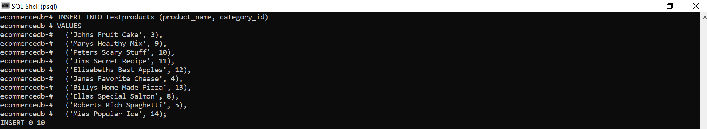

# Cars

We will create a table called cars, that is not associated with this tutorial. But we will use it in another example.

## CREATE TABLE cars

The following SQL statement will create a table named cars:

CREATE TABLE cars (  
  brand VARCHAR(255),  
  model VARCHAR(255),  
  year INT  
);

In the SQL Shell application on your computer the operation above might look like this:

## INSERT INTO cars

The following SQL statement will insert data in a table named cars:

INSERT INTO cars (brand, model, year)  
VALUES

('Ford', 'Mustang', 1964),

('Volvo', 'p1800', 1968),  
  ('BMW', 'M1', 1978),  
  ('Toyota', 'Celica', 1975);

If you write above statement in your SQL Shell, you will see that it returns INSERT 0 10. Which means that we have inserted 10 rows in our testproducts table.

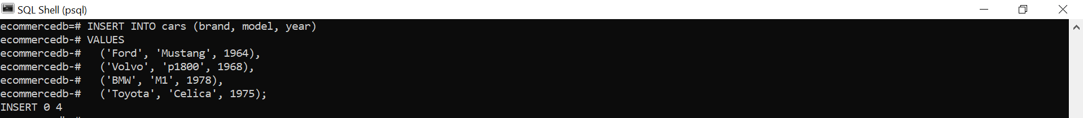

# See All Table List

To see all table which we are created. Execute the following command.

\dt

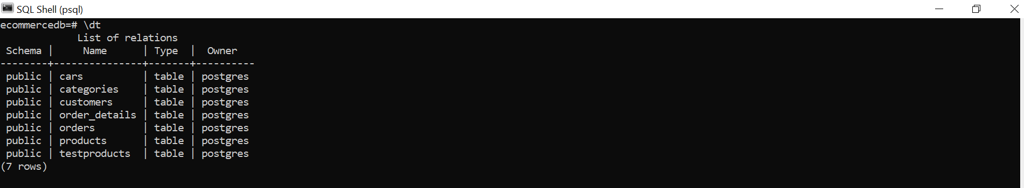

We can see that we have created total 7 tables in SQL Shell.

PostgreSQL Syntax (DML)

# Operators

## Operators in the WHERE clause

We can operate with different operators in the WHERE clause:

|  |  |
| --- | --- |
| **=** | Equal to |
| **<** | Less than |
| **>** | Greater than |
| **<=** | Less than or equal to |
| **>=** | Greater than or equal to |
| **<>** | Not equal to |
| **!=** | Not equal to |
| **LIKE** | Check if a value matches a pattern (case sensitive) |
| **ILIKE** | Check if a value matches a pattern (case insensitive) |
| **AND** | Logical AND |
| **OR** | Logical OR |
| **IN** | Check if a value is between a range of values |
| **BETWEEN** | Check if a value is between a range of values |
| **IS NULL** | Check if a value is NULL |
| **NOT** | Makes a negative result e.g. NOT LIKE, NOT IN, NOT BETWEEN |

## Equal To

The = operator is used when you want to return all records where a column is equal to a specified value:

Return all records where the brand is 'Volvo':

SELECT * FROM cars  
WHERE brand = 'Volvo';

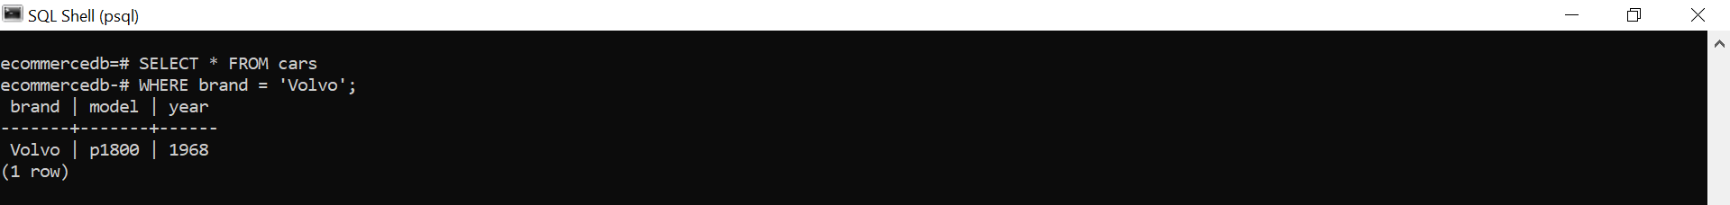

## Less Than

The < operator is used when you want to return all records where a column is less than a specified value.

Return all records where the year is less than 1975:

SELECT * FROM cars  
WHERE year < 1975;

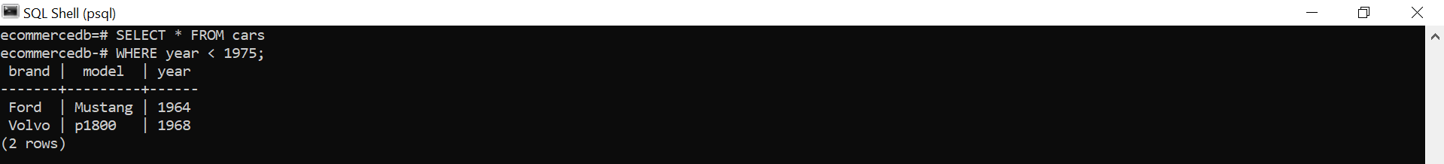

## Greater Than

The > operator is used when you want to return all records where a column is greater than a specified value.

Return all records where the year is greater than 1975:

SELECT * FROM cars  
WHERE year > 1975;

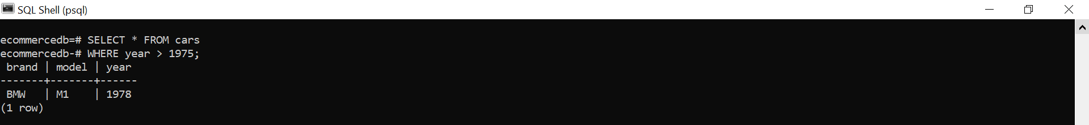

## Less Than or Equal To

The <= operator is used when you want to return all records where a column is less than, or equal to, a specified value.

Return all records where the year is less than or equal to 1975:

SELECT * FROM cars  
WHERE year <= 1975;

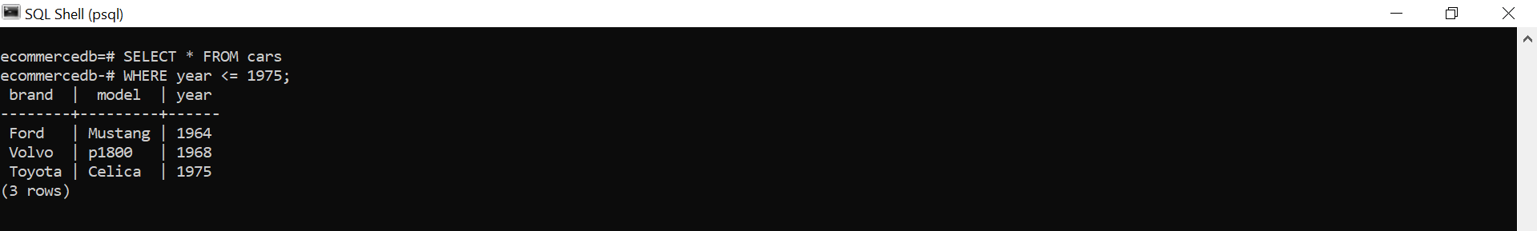

## Greater Than or Equal to

The >= operator is used when you want to return all records where a columns is greater than, or equal to, a specified value.

Return all records where the year is greater than or equal 1975:

SELECT * FROM cars  
WHERE year >= 1975;

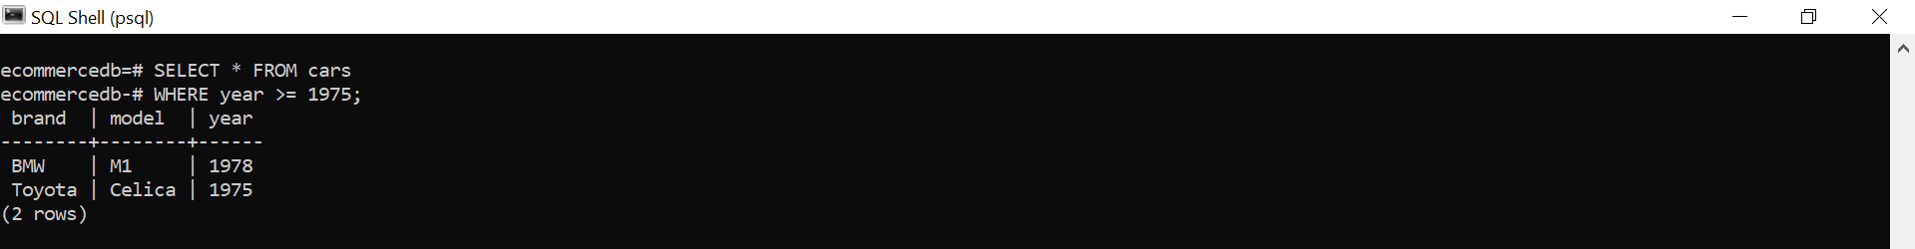

## Not Equal To

The <> operator is used when you want to return all records where a column is NOT equal to a specified value:

Return all records where the brand is NOT 'Volvo':

SELECT * FROM cars  
WHERE brand <> 'Volvo';

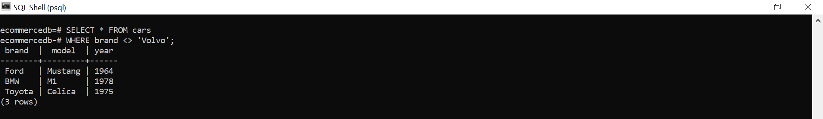

Or you can follow this statement. It returns the same output, but its syntax is slightly different.

SELECT * FROM cars  
WHERE brand != 'Volvo';

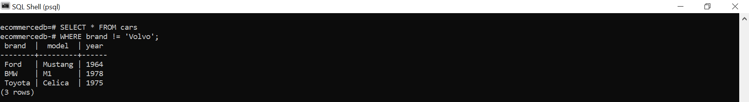

## LIKE

The LIKE operator is used when you want to return all records where a column is equal to a specified pattern.

The pattern can be an absolute value like 'Volvo', or with a wildcard that has a special meaning.

There are two wildcards often used in conjunction with the LIKE operator:

* The percent sign %, represents zero, one, or multiple characters.
* The underscore sign _, represents one single character.

Return all records where the model STARTS with a capital 'M':

SELECT * FROM cars  
WHERE model LIKE 'M%';

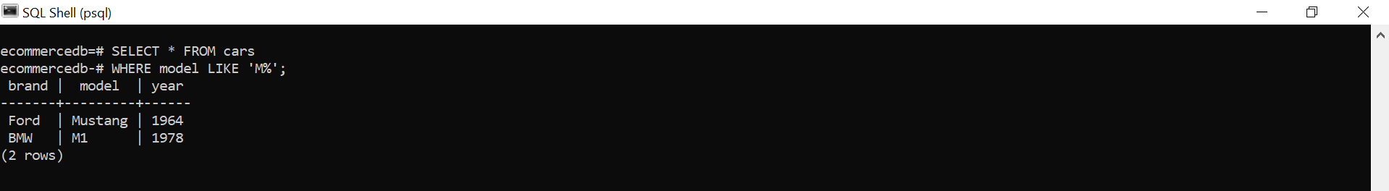

**Note:** The LIKE operator is case sensitive.

## ILIKE

Same as the LIKE operator, but ILIKE is case insensitive.

Return all records where the model starts with a 'm':

SELECT * FROM cars  
WHERE model ILIKE 'm%';

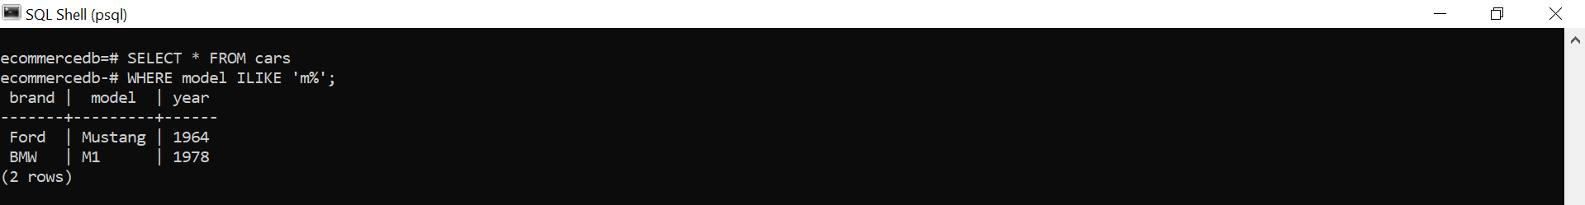

## AND

The logical AND operator is used when you want to check more that one condition:

Return all records where the brand is 'Volvo' and the year is 1968:

SELECT * FROM cars  
WHERE brand = 'Volvo' AND year = 1968;

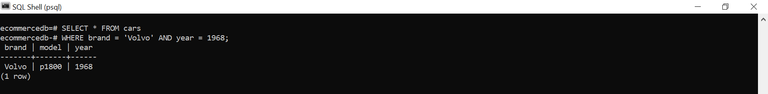

## OR

The logical OR operator is used when you can accept that only one of many conditions is true:

Return all records where the brand is 'Volvo' OR the year is 1975:

SELECT * FROM cars  
WHERE brand = 'Volvo' OR year = 1975;

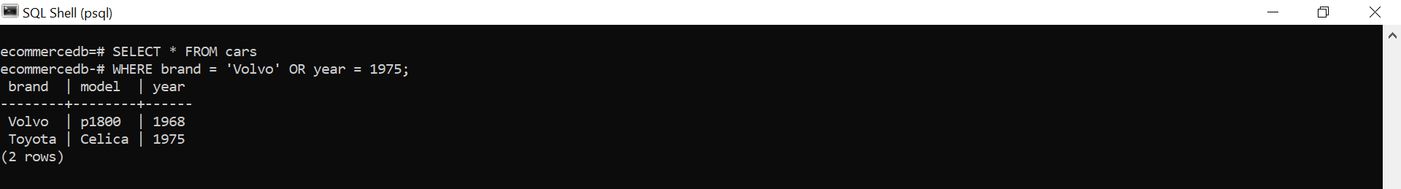

## IN

Return all records where the brand is present in this list: ('Volvo', 'Mercedes', 'Ford'):

SELECT * FROM cars  
WHERE brand IN ('Volvo', 'Mercedes', 'Ford');

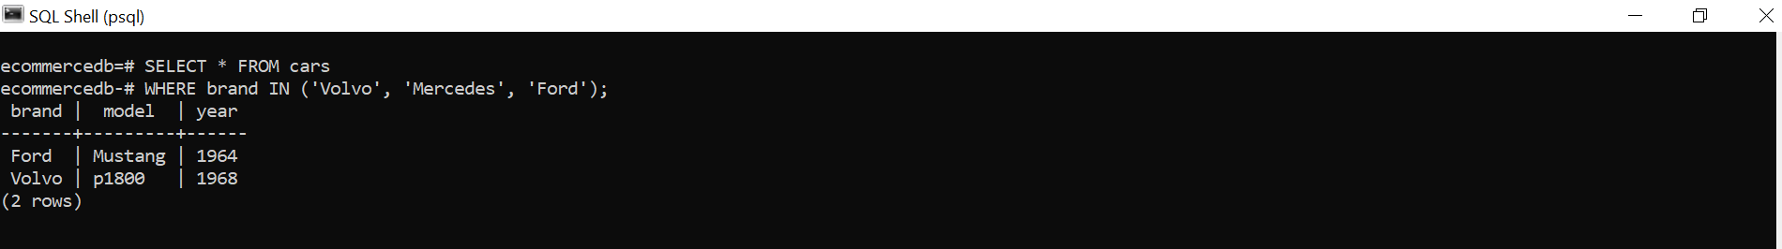

## BETWEEN

The BETWEEN operator is used to check if a column's value is between a specified range of values:

Return all records where the year is between 1970 and 1980:

SELECT * FROM cars  
WHERE year BETWEEN 1970 AND 1980;

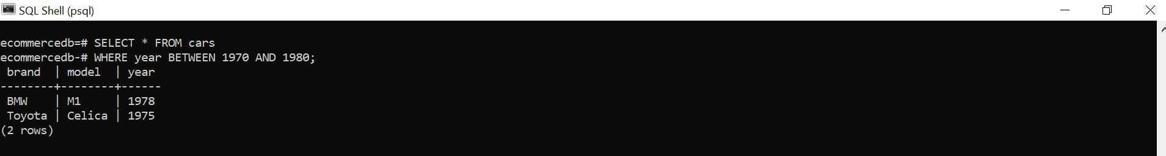

The BETWEEN operator includes the from and to values, meaning that in the above example, the result would include cars made in 1970 and 1980 as well.

## IS NULL

The IS NULL operator is used to check if a column's value is NULL:

Return all records where the model is NULL:

SELECT * FROM cars  
WHERE model IS NULL;



## NOT

The NOT operator can be used together with LIKE, ILIKE, IN, BETWEEN, and NULL operators to reverse the truth of the operator.

### NOT LIKE

Return all records where the brand does NOT start with a capital 'B' (case sensitive):

SELECT * FROM cars  
WHERE brand NOT LIKE 'B%';

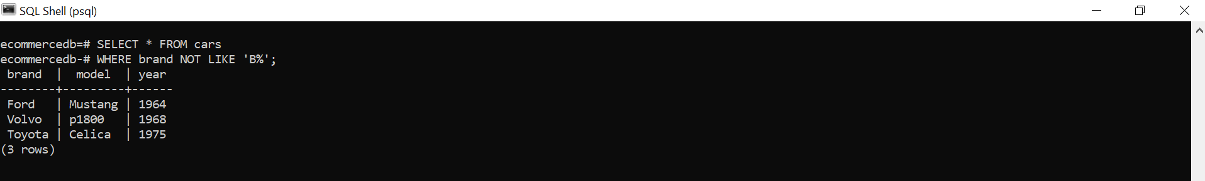

### NOT ILIKE

Return all records where the brand does NOT start with a 'b' (case insensitive):

SELECT * FROM cars  
WHERE brand NOT ILIKE 'b%';

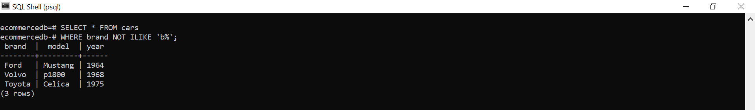

### NOT IN

Return all records where the brand is NOT present in this list: ('Volvo', 'Mercedes', 'Ford'):

SELECT * FROM cars  
WHERE brand NOT IN ('Volvo', 'Mercedes', 'Ford');

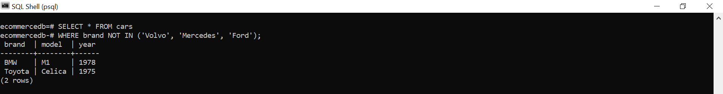

### NOT BETWEEN

Return all records where the year is NOT between 1970 and 1980:

SELECT * FROM cars  
WHERE year NOT BETWEEN 1970 AND 1980;

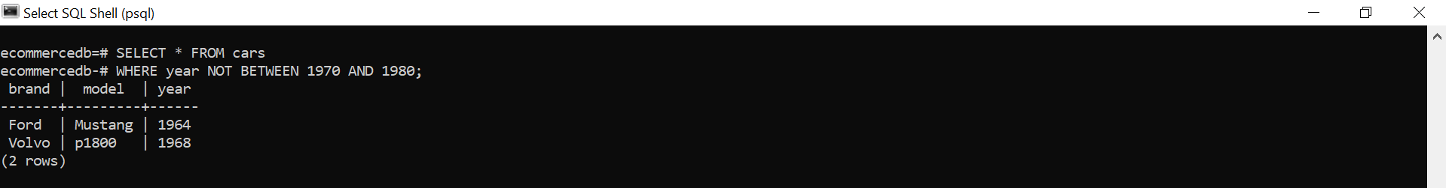

**Note:** The NOT BETWEEN operator excludes the from and to values, meaning that in the above example, the result would not include cars made in 1970 and 1980.

### IS NOT NULL

Return all records where the model is NOT null:

SELECT * FROM cars  
WHERE model IS NOT NULL;

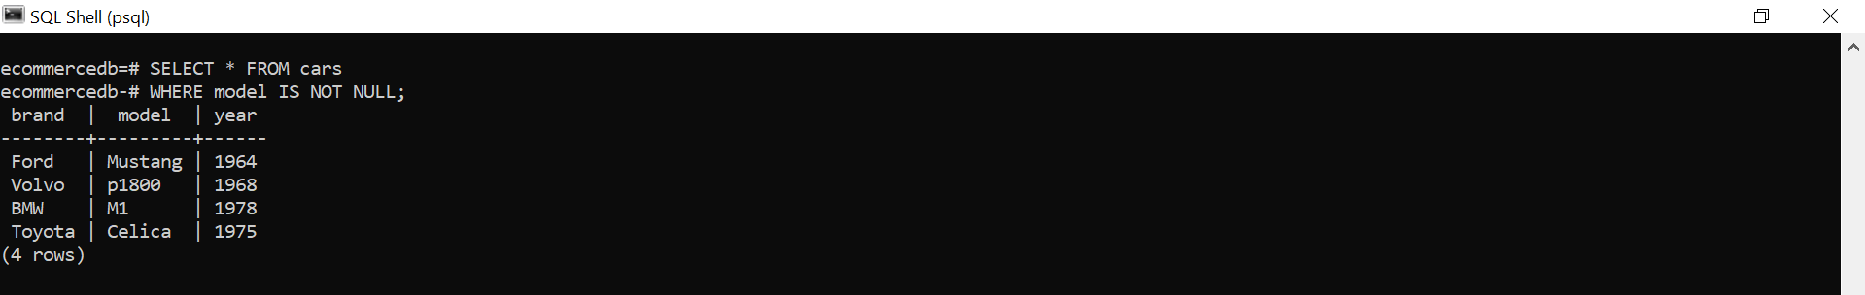

The cars table has no columns with NULL values, so the example above will return all 4 rows.

# SELECT

## Select Data

To retrieve data from a data base, we use the SELECT statement.

## Specify Columns

By specifying the column names, we can choose which columns to select:

SELECT customer_name, country FROM customers;

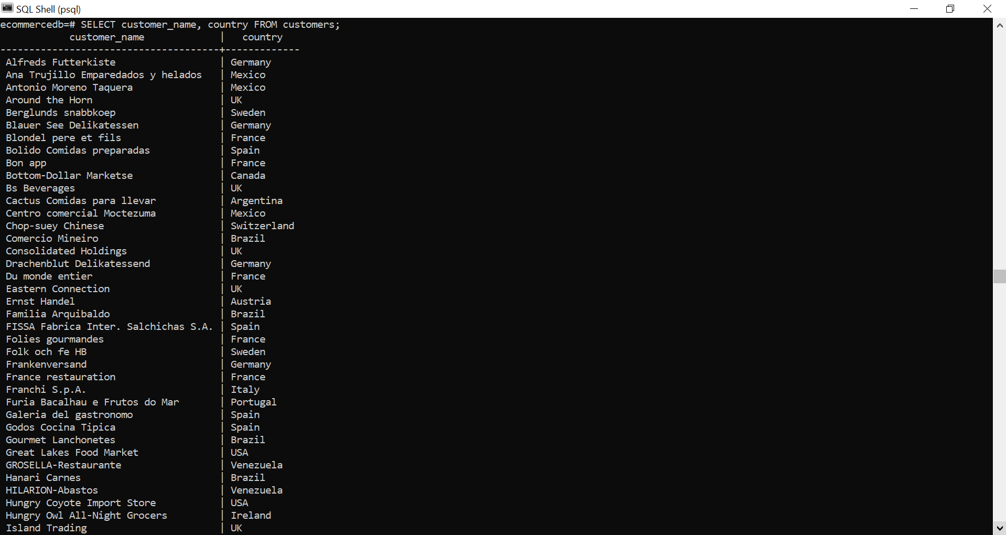

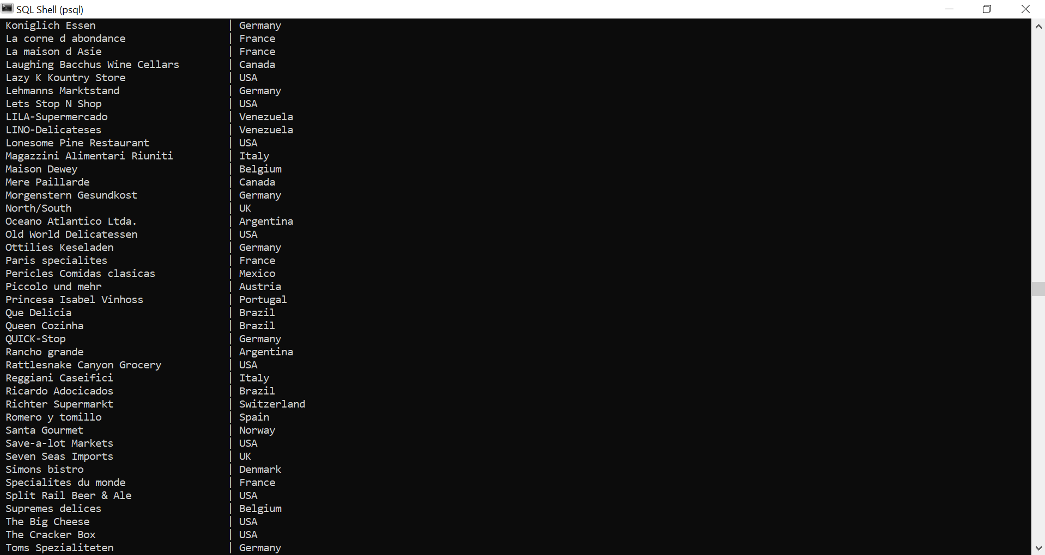

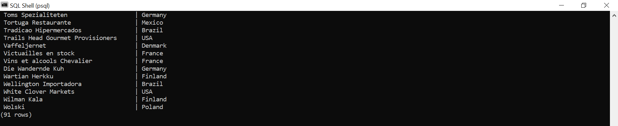

This query returns 91 rows of specific columns.

## Return ALL Columns

Specify a * instead of the column names to select *all* columns:

SELECT * FROM testproducts;

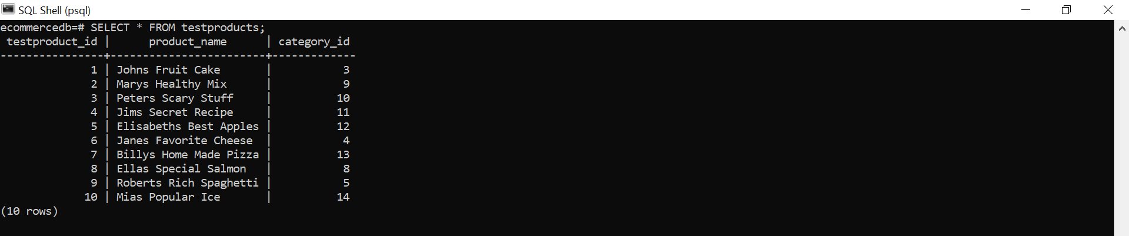

# SELECT DISTINCT

## The SELECT DISTINCT Statement

The SELECT DISTINCT statement is used to return only distinct (different) values.

Inside a table, a column often contains many duplicate values and sometimes you only want to list the different (distinct) values.

SELECT DISTINCT country FROM customers;

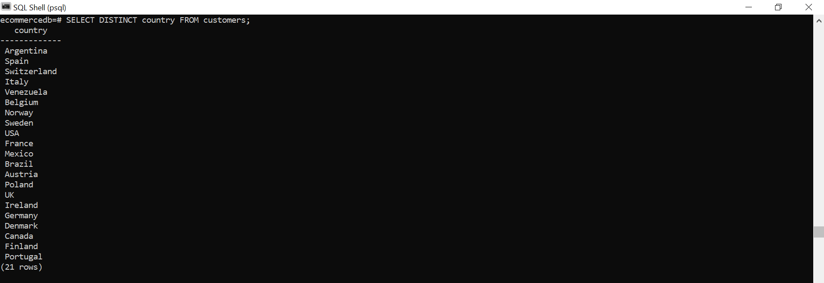

Even though the customers table has 91 records, it only has 21 different countries, and that is what you get as a result when executing the SELECT DISTINCT statement above.

## SELECT COUNT(DISTINCT)

We can also use the DISTINCT keyword in combination with the COUNT statement, which in the example below will return the number of different countries there are in the customers table.

Return the number of different countries there are in the customers table:

SELECT COUNT(DISTINCT country) FROM customers;

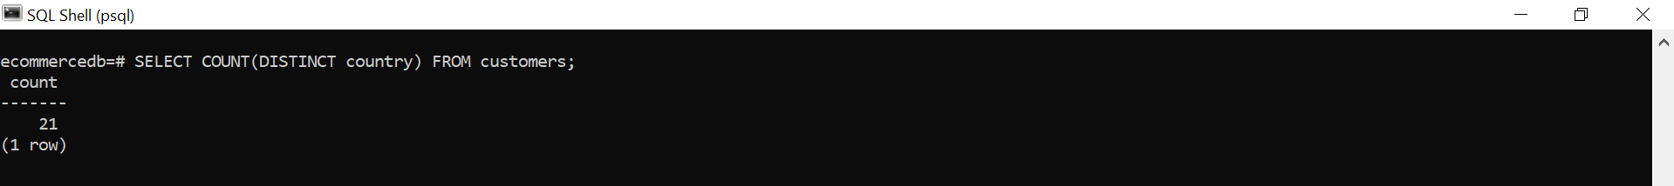

# WHERE - Filter Data

## Filter Records

The WHERE clause is used to filter records.

It is used to extract only those records that fulfill a specified condition.

If we want to return only the records where city is London, we can specify that in the WHERE clause:

SELECT * FROM customers  
WHERE city = 'London';

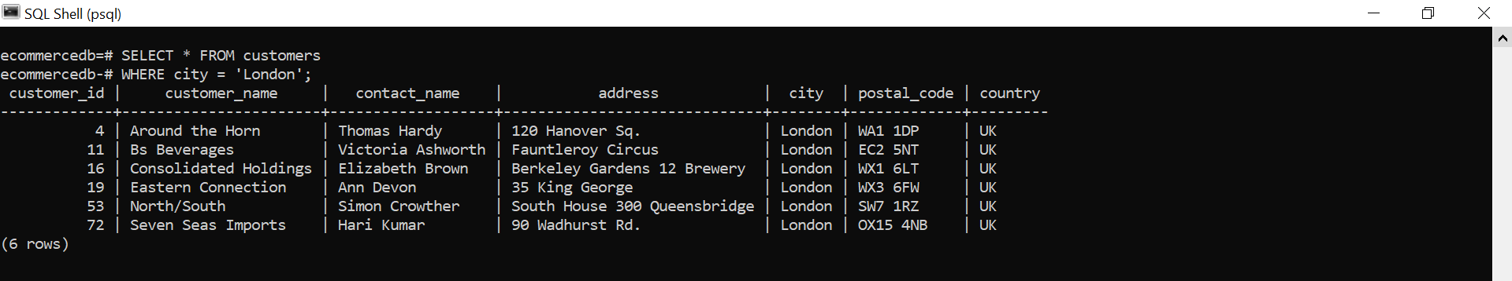

## Text Fields vs. Numeric Fields

PostgreSQL requires quotes around text values.

However, numeric fields should not be enclosed in quotes:

SELECT * FROM customers  
WHERE customer_id = 19;

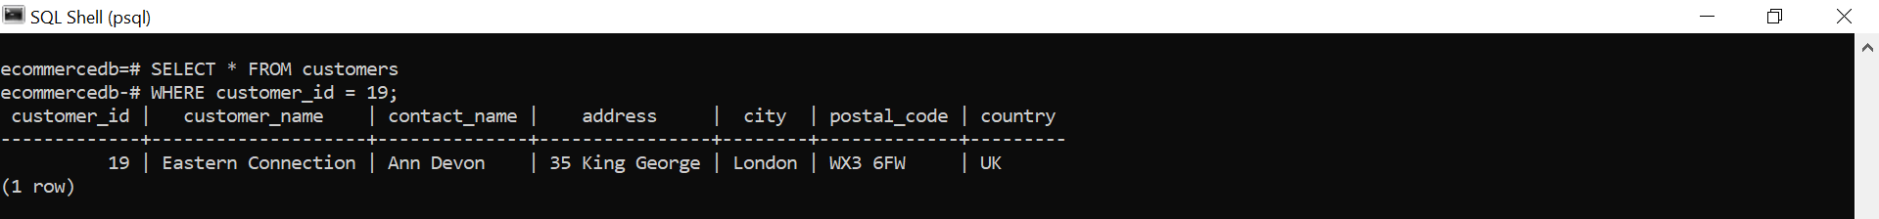

**Note:** Quotes around numeric fields will not fail, but it is good practice to always write numeric values without quotes.

## Greater than

Use the > operator to return all records where customer_id is greater than 80:

SELECT * FROM customers  
WHERE customer_id > 80;

**Note:** Quotes around numeric fields will not fail, but it is good practice to always write numeric values without quotes.

# ORDER BY

## Sort Data

The ORDER BY keyword is used to sort the result in ascending or descending order. The ORDER BY keyword sorts the records in ascending order by default. To sort the records in descending order, use the DESC keyword.

Sort the table by price:

SELECT * FROM products  
ORDER BY price;

When we execute this statement, then we will see it like this. We know that products table has 77 rows, all rows will be returned.

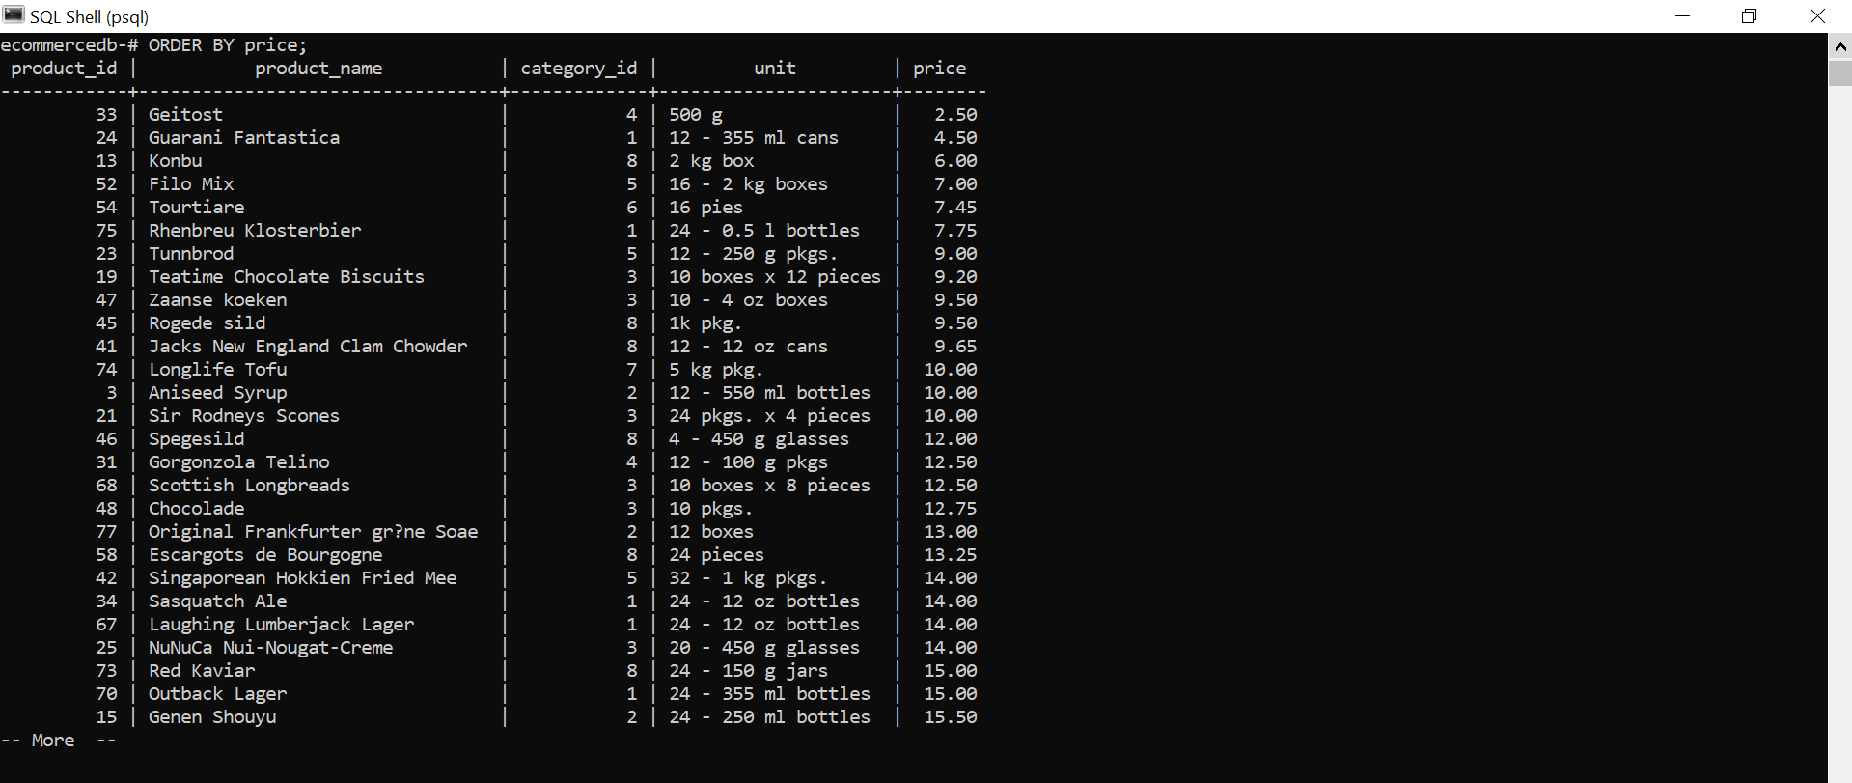

## DESC

The ORDER BY keyword sorts the records in ascending order by default. To sort the records in descending order, use the DESC keyword

Sort the table by price, in descending order:

SELECT * FROM products  
ORDER BY price DESC;

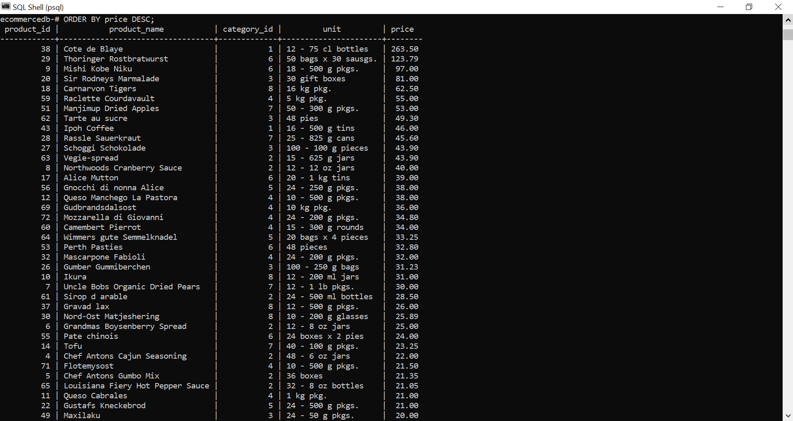

## Sort Alphabetically

For string value the ORDER BY keyword will order alphabetically:

Sort the table by product_name:

SELECT * FROM products  
ORDER BY product_name;

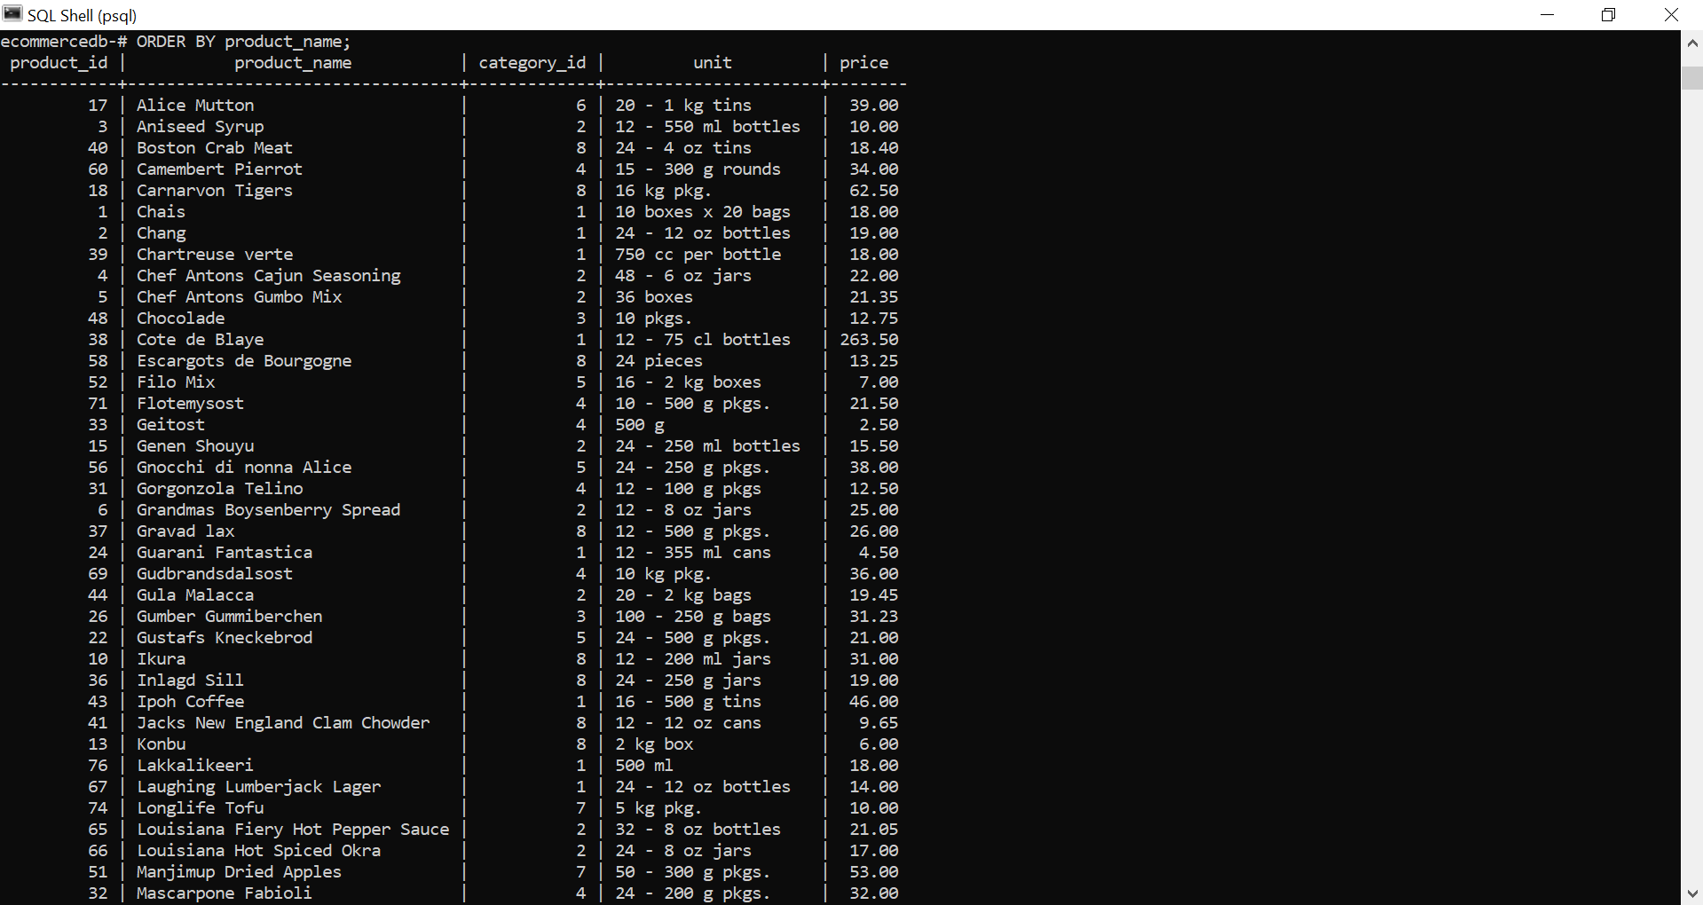

## Alphabetically DESC

To sort the table reverse alphabetically, use the DESC keyword:

SELECT * FROM products  
ORDER BY product_name DESC;

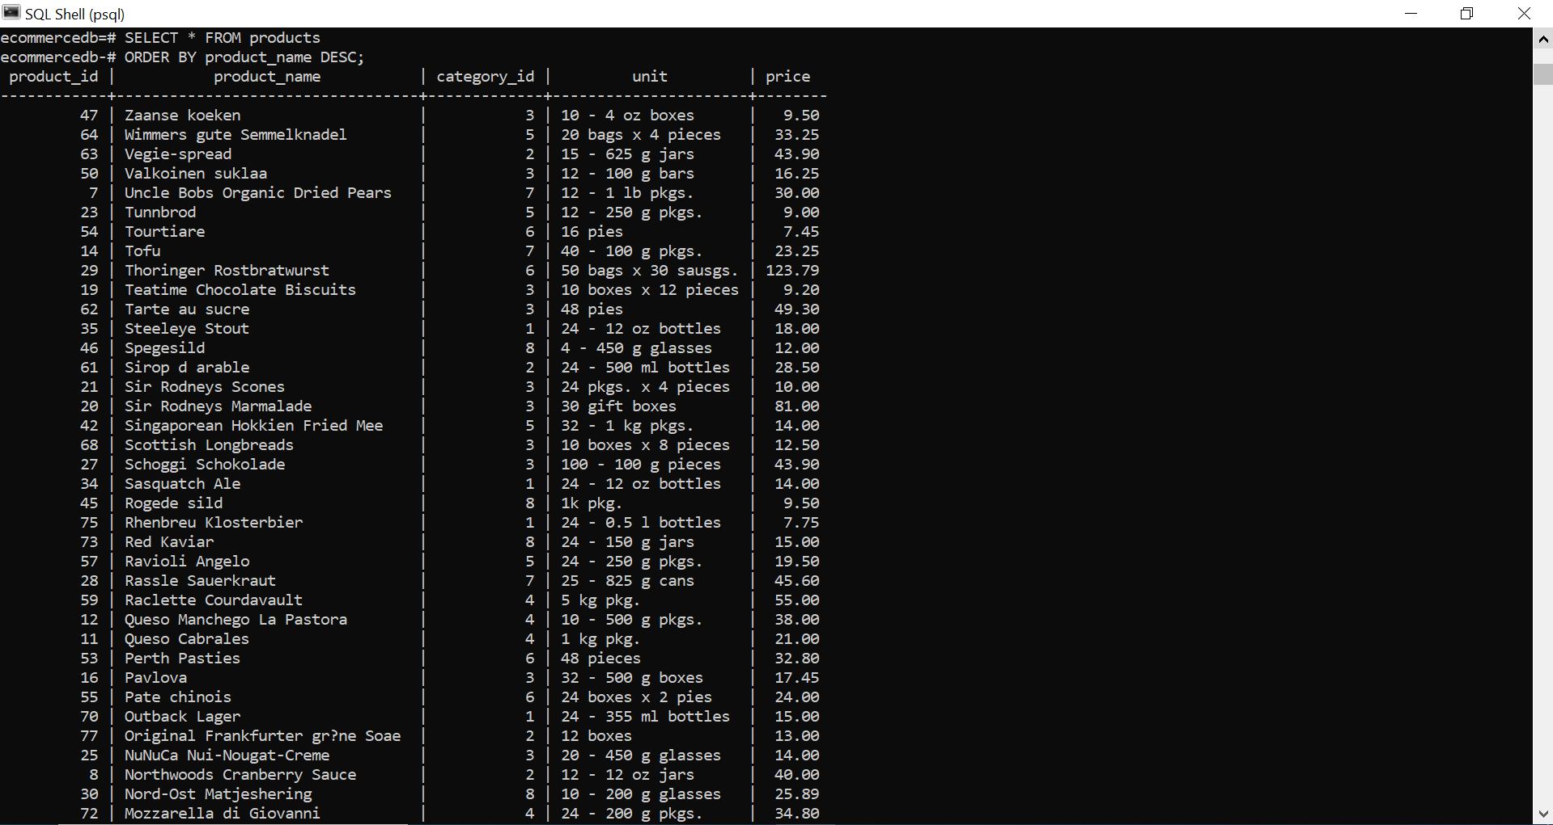

# LIMIT

## The LIMIT Clause

The LIMIT clause is used to limit the maximum number of records to return.

Return only the 20 first records from the customers table:

SELECT * FROM customers  
LIMIT 20;

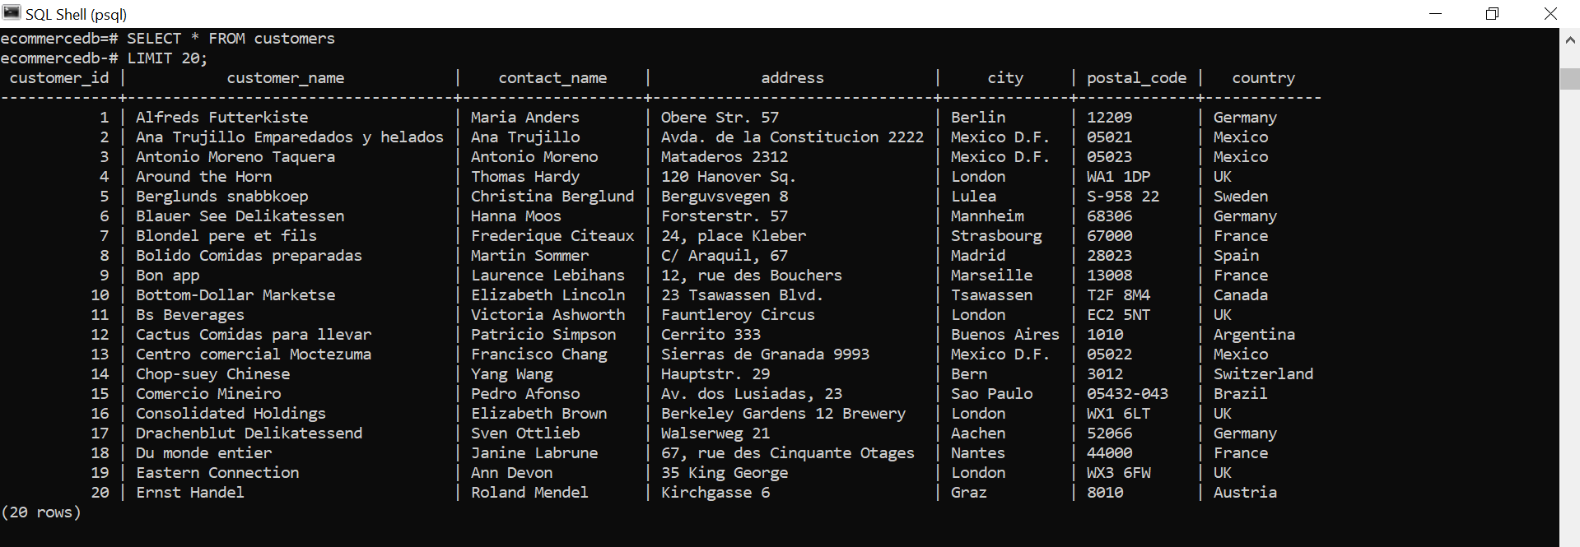

## The OFFSET Clause

The OFFSET clause is used to specify where to start selecting the records to return.

If you want to return 20 records, but start at number 40, you can use both LIMIT and OFFSET.

Return 20 records, starting from the 41th record:

SELECT * FROM customers  
LIMIT 20 OFFSET 40;

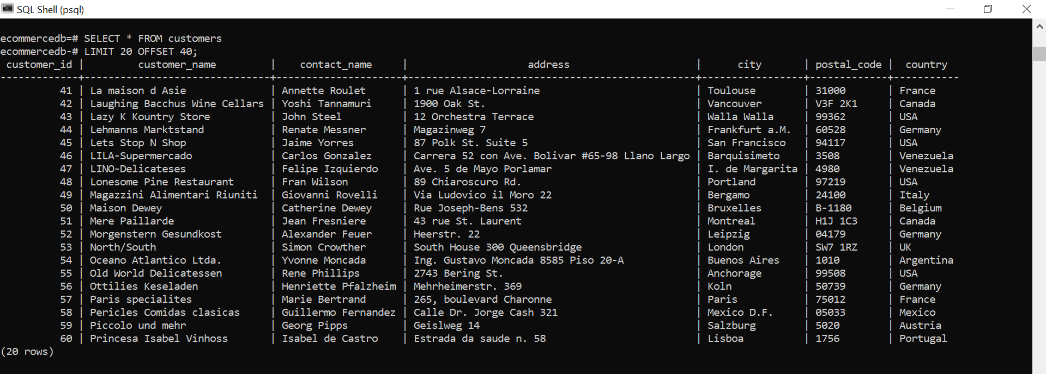

**Note:** The first record is number 0, so when you specify OFFSET 40 it means starting at record number 41.